MONITORING AND EVALUATION PLAN

FOR THE NEZ PERCE TRIBAL HATCHERY:

ACTION PLAN

Prepared by

Jay A. Hesse
Nez Perce Tribe
Department of Fisheries Resources Management
Lapwai, Idaho 83540

and

Steven P. Cramer
S.P. Cramer & Associates, Inc.
300 SE Arrow Creek Lane
Gresham, Oregon 97080

Prepared for Bonneville Power Administration
Project 8335000

May 2000

EXECUTIVE SUMMARY

This Monitoring and Evaluation (M&E) Action Plan describes the implementation of a comprehensive monitoring and evaluation program for Phase 1 of Nez Perce Tribal Hatchery (NPTH). The plan is designed to sample fish populations in the main-stem Clearwater River and its tributaries over the next 15 to 20 years to determine whether desired results are being achieved, and to enable adaptive management. The M&E program examines the performance and status of hatchery and natural fish, species interactions and impacts to non-targeted fish populations, sustainability of harvest, and communication and application of findings (Figure ES1). The action plan covers multiple aspects of chinook salmon (Oncorhynchus tshawytcsha) life history in all treatment streams. Phase 1 treatment streams are Meadow Creek (Selway River), Lolo Creek, and Newsome Creek for spring chinook salmon, the lower reaches of the South Fork Clearwater and Selway rivers for early-fall chinook salmon, and the main-stem Clearwater River below the Lolo Creek for fall chinook salmon. Outcomes in these treatment streams will also be compared to those in similar non-treatment (reference) streams and other hatchery programs to help distinguish treatment effects from the effects of environmental variation between years.

Critical uncertainties described in Steward (1996) and the following nine main management questions guided the development of activities and sub-activities in this M&E Action Plan.

- Can Nez Perce Tribal Hatchery produce adequate return rates to achieve program objectives?
- Do the NATURES rearing components make enough difference in post-release survival and return rates to warrant the added limitations compared to conventional hatcheries?
- Can Nez Perce Tribal Hatchery strategies be improved to achieve program goals more rapidly?
- Can self-sustaining natural populations be established from hatchery fish?
- Can we determine how to adjust supplementation rates as natural populations rebuild?
- Does the NPTH program foster genetic adaptation in target populations?
- Are intra- and inter-species specific abundance and behaviors altered by the NPTH program?
- Can harvest rate and gear type be predictively managed to optimize NPTH operation?
- Can adult return be accurately predicted for NPTH streams?

Seven primary data collection activities and four small-scale experiments are associated with quantification of performance criteria (Tables ES1 and ES2). The scope of the M&E is designed to address RASP (1992), IHOT (1995), NPPC (1999), and a Level II analysis as described in Steward (1996; NMFS 1999 Biological Opinion requirement).

Nez Perce Tribal Hatchery Monitoring and Evaluation Goal:
Monitor and evaluate results of the Nez Perce Tribal Hatchery so that operations can be adaptively managed to optimize hatchery and natural production, sustain harvest, and minimize ecological impacts.

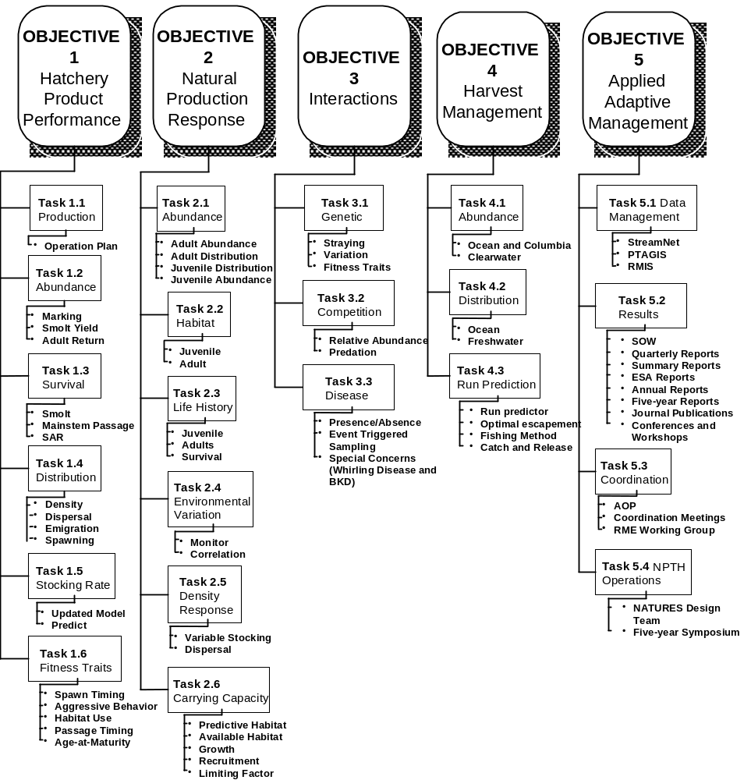

Figure ES1. Abridged step-down plan of NPTH M&E Action Plan goal, objectives, tasks, and activities.
Table ES1. Primary monitoring activities, including duration, to be conducted under the Nez Perce Tribal Hatchery Monitoring and Evaluation Program with associated evaluation products.

Monitoring Activity  - Duration  - Stock | Evaluation Products
PIT Tagging  - Ongoing  - All Stocks (Hatchery & Natural) | Estimate and 95% confidence interval of survival from release (or natural parr) to emigration.
PIT Tagging  - Ongoing  - All Stocks (Hatchery & Natural) | Estimate and 95% confidence interval of survival (egg-to-smolt and release -to-smolt) to LGR or other mainstem dams.
PIT Tagging  - Ongoing  - All Stocks (Hatchery & Natural) | Estimate the percentage of fish barged from LGR and other mainstem dams from each treatment group.
PIT Tagging  - Ongoing  - All Stocks (Hatchery & Natural) | Estimate of difference in survival to Lower Granite Dam between spring chinook salmon presmolts that overwinter in the treatment stream and presmolts that overwinter in the Clearwater or Snake rivers.
PIT Tagging  - Ongoing  - All Stocks (Hatchery & Natural) | Population estimates and 95% confidence intervals of hatchery and wild juvenile chinook salmon passing the trap as fry, parr, presmolts, and smolts.
PIT Tagging  - Ongoing  - All Stocks (Hatchery & Natural) | Estimate and 95% confidence interval for the number of smolts produced from each stream.
PIT Tagging  - Ongoing  - All Stocks (Hatchery & Natural) | Median, 20th percentile, and 80th percentile travel times (days) and arrival at detector dams in the Snake and Columbia rivers.
PIT Tagging  - Ongoing  - All Stocks (Hatchery & Natural) | Estimated and 95 % confidence interval of survival during mainstem passage from LGR to JDD for each treatment group.
Weir Operation and/or Spawning Ground Surveys  - Ongoing  - All Stocks | Hatchery and natural escapement at weirs.
 | Counts of hatchery and natural chinook, by age, taken for brood stock.
 | Percentage that each age composes of the returns, by sex, to each stream.
 | Time-frequency of arrival at brood collection points.
 | Differential survival rate between subyearling and yearling smolts for early-fall chinook in South Fork Clearwater River.
 | Estimates of the minimum percentage of spawners that strayed from their home stream for each release strategy in each stream.
 | Percentage that NPTH strays compose of spawners in non-target streams
 | Total redds in each reach surveyed
 | Time frequency of redd construction in each reach surveyed.
 | Percentage of total redds contained in discrete stream sections.
 | Estimated number of hatchery and natural spawners in each reach surveyed (Mark-recapture of fish from weirs).
 | Estimates of age and sex-specific maturity rates for each race, and possibly each treatment stream
 | Annual estimates of the percentage of carcasses that are less than 80% spawned in each stream.
 | Differential survival rate between subyearling and yearling smolts for fall chinook.
 | Estimates of the minimum percentage of spawners that strayed from their home stream for each release strategy in each stream.
 | Percentage that NPTH strays compose of spawners in non-target streams
 | Change in spawning time and age at maturity across generations of natural chinook in stream where NPTH strays constitute at least 10% of all spawners.
Snorkeling & Seining  - 10 years  - All Stocks  Table 2. Continued. | Annual(seasonal) estimates of parr/m2 in pool, riffle, pocket water and run habitats, by reach, of each treatment and reference stream for spring chinook.
 | Densities (fish/m2) by 2 inch size increments for each species in each study stream.
 | Confirmed species identification, and percentage of fish in each sample area that are composed of each species
 | Frequency that specific types of competitive behaviors are observed for each species immediately following release of hatchery fish.
 | Frequency of predatory attacks on juvenile chinook salmon are observed immediately following release of hatchery fish.
 | Mean number and mean size of juvenile chinook salmon consumed per predator of each species on the day and at the location that hatchery fish are released.
Screw Trapping  - Ongoing  - Spring Chinook | Time-frequency distribution of emigration.
Screw Trapping  - Ongoing  - Spring Chinook | Mean and 95% confidence interval, regression of mean length for each life stage and Julian day.
Screw Trapping  - Ongoing  - Spring Chinook | Estimate of the ratio of spring chinook salmon presmolt (fall) to smolt (spring) migrants passing the rotary-screw trap from each brood.
Screw Trapping  - Ongoing  - Spring Chinook | Difference in fall presmolt passage at the upper and lower traps in Lolo Creek.
Screw Trapping  - Ongoing  - Spring Chinook | Estimate of parr abundance, based on marked-to-unmarked ratio of fish arriving at the screw trap.
Screw Trapping  - Ongoing  - Spring Chinook | Estimate of survival from parr to smolting in each treatment stream.
Screw Trapping  - Ongoing  - Spring Chinook | Estimate of survival from emigration to Lower Granite Dam (McNary).
Habitat Surveys  - 10 years  - Spring Chinook | Measurements of surface area, mean depth, substrate composition, large woody debris, gradient and overhead cover in each habitat unit under low flows conditions.
Habitat Surveys  - 10 years  - Spring Chinook | Comparison of weekly water temperatures and flows within and between streams.
Habitat Surveys  - 10 years  - Spring Chinook | Measurements channel form, gradient, substrate composition, mean riffle depth, surface area, and cover score, and water temperature in reaches surveyed for spawning.
Habitat Surveys  - 10 years  - Spring Chinook | Weekly water temperatures at the time and location of spawning and egg incubation within each stream.
Genetic Analysis  - Ongoing  - All stocks and Hatcheries | Annual gene frequencies for populations of natural spawners in each study stream.
Genetic Analysis  - Ongoing  - All stocks and Hatcheries | Difference in gene frequencies between natural juveniles and natural adults of the same brood in each study stream.
Genetic Analysis  - Ongoing  - All stocks and Hatcheries | Annual gene frequencies for populations of chinook salmon in each NPTH hatchery treatment, including Lyons Ferry Hatchery.
Harvest Monitoring  - Ongoing  - All Stocks | Estimated fraction of chinook salmon harvested by age and race each year (1) in the ocean and (2) within the Columbia River
Harvest Monitoring  - Ongoing  - All Stocks | Estimated number of chinook salmon harvested by age and race each year within the Clearwater River subbasin.
Harvest Monitoring  - Ongoing  - All Stocks | Estimated difference in hatchery :natural ratios in the catch for specific times, locations or gears within the Clearwater Basin.
Harvest Monitoring  - Ongoing  - All Stocks | Estimated mortality rate prior to spawning on fish that are caught and released by fisheries in the Clearwater Basin.

Table ES2. Initial small-scale experiments, and duration, to be conducted under the Nez Perce Tribal Hatchery Monitoring and Evaluation Program and associated evaluation products.

Small-Scale Experiments | Evaluation Products
NATURES Post Release Survival  - 5 years - 1 generation  - Spring Chinook | Estimated mean difference in mainstem passage survival (LGR to JDD ) between NATURES and conventionally reared juvenile chinook salmon.
 | Estimated mean difference in survival to LGR between NATURES and conventionally reared juvenile chinook salmon.
 | Estimated mean difference in survival to LGR between acclimated and direct released juveniles that are conventionally reared.
Aggressive Behavior Trials  - 15 years - 3 generations  - All Stocks | Annual mean and variance for scores in mirror image stimulation trials.
 | Comparison of aggressive behavior between semi-natural, NATURES components, conventional, hatchery best management practices rearing.
Temperature Egg Survival  - 3 years  - Early-Fall Chinook | Comparison of mean egg survival between early, mid, and late spawning of the founding brood for early-fall chinook salmon.
Carrying Capacity/Dispersion  - 5 years  - Spring Chinook -Meadow Creek | Total and standardized densities of hatchery and natural parr 500 m reaches.
 | Correlation of standardized density for hatchery parr per 500 m reach to distance from stocking location.
 | Comparison of the mean number of parr/m2, by habitat unit type, between test reaches and between sample dates.
 | Change in density distribution of hatchery parr between 1 and 6 weeks after release in Meadow Creek.
 | Comparison of the number of migrants captured in the screw trap from each density treatment.
 | Comparison of mean fork length achieved by September 1 between test reaches.

The M&E Action Plan calls for coded-wire tagging (CWT) all hatchery fish, but without an adipose clip, so that hatchery fish can be distinguished with a detector wand wherever fish are sampled as juveniles, as harvest, or as adult returns. Recoveries of these CWTs through a full brood cycle will enable use of cohort analysis to estimate survival rates, harvest rates, and maturity rates for all release groups. Multiple pass spawning surveys or redd counts will be conducted during the spawning season in all areas where adults are expected to return, and adults will be counted as they enter hatcheries or pass the weirs at the mouth of Lolo Creek, Newsome Creek and South Fork Clearwater. This sampling is designed to estimate timing of migration and spawning, distribution and abundance of spawners, and physical features that may influence spawner distribution. Straying will be monitored through tag recoveries from the extensive spawning surveys throughout the Clearwater River and Snake River basin by other agencies.

Juvenile rearing distribution and habitat use, as well as ecological interactions, will be monitored through snorkel surveys that systematically cover 20% of the three treatment streams for spring chinook salmon, and seining surveys at 10 stations in each treatment area for early-fall and fall chinook salmon. During snorkel surveys, counts will be maintained by habitat unit, habitat features will be measured, and associations of rearing densities with habitat features will be analyzed. All species of fish will be counted by habitat unit during snorkel surveys, and species identification will be confirmed during seining surveys. Seining surveys will be completed once monthly during May - September in each treatment and reference stream (all races) to monitor increase in length of juvenile chinook salmon, sample scales and implant PIT tags. Immediate responses of resident fish at the time of hatchery fish releases will be monitored by underwater observation at the time of stocking, and predatory attacks on juvenile chinook salmon will be counted. Carrying capacity for rearing of parr will be re-evaluated based on observations of density dependent growth, spatial distribution of juvenile densities, and habitat preferences observed during the monitoring and evaluation.

Timing and abundance of juvenile emigrants will be determined from catches in rotary screw traps fished in Lolo Creek, Newsome Creek, and Meadow Creek. Representative groups of each release strategy from each facility will be PIT tagged to enable tracking of juvenile emigration, and estimation of smolt numbers leaving each stream, passage survival, and growth between release and any subsequent capture point. Timing, size and abundance of both hatchery and natural emigrants will be estimated at screw traps and at Snake and Columbia river dams.
Growth, survival, gene frequencies, life history traits, and behavioral traits will be monitored annually for hatchery fish from each treatment. Gene frequencies will be determined through DNA analysis. Growth rates, in-hatchery survival, adult migration time, spawning time, and age-at-maturity will be recorded for each treatment. Representative groups from each treatment will be subjected to standardized tests of agonistic behavior each year. Routine sampling for disease presence will also continue each year. Special experiments will be performed to rear distinct groups of spring chinook salmon with conventional and NATURES rearing techniques at the same facility, in order to compare post-release survival between rearing techniques. In separate experiments, release densities of 20%, 100% and 200% of parr capacity will be tested with outplants of parr into three stream sections of Meadow Creek.

Harvesting will be monitored and techniques for predicting run size will be developed so that harvest of potential adult surpluses can be optimized. Harvest in the ocean and Columbia River will be sampled by existing programs of state agencies, while creel surveys in the Clearwater River subbasin will be implemented by the Tribe to estimate numbers of fish caught, hatchery:natural composition, number caught-and-released, and relationships of catch rate to fishing regulations and hatchery release strategies. In order to plan stocking rates and harvest regulations, stock-recruitment functions for natural production will be estimated, functions to predict run strength will be developed, and annual monitoring results will be used to upgrade the accuracy of these functions.

Findings from all monitoring and evaluation activities will be communicated regularly to resource comanagers through several formats. Tag placement, recoveries, and hatchery releases will be reported regularly to regional databases. Work plans and progress reports will be distributed annually, and a comanager review meeting will be held annually. Ongoing coordination and review with the NATURES design team will be maintained.

ACKNOWLDEGEMENTS

We wish to thank the Nez Perce Tribe Department of Fisheries Resources Management personnel: Paul Kucera, Ed Larson, Dave Johnson, Sherman Sprague, Bill Arnsberg, Nancy Hoefs, and Ryan Johnson for their guidance and review during the development of this document. Ted Williams of S.P. Cramer & Associates was key in development of figures and document formatting. Andre Talbot, Doug Hatch, and Chris Beasley with Columbia River Inter-Tribal Fish Commission provided valuable review and comment. We would also like to thank the Independent Science Review Panel (ISRP) members for their review and comments. Ken Kirkman, Bonneville Power Administration and Ken Ferjansic, Fish Pro Inc. provided helpful support.

TABLE OF CONTENTS

EXECUTIVE SUMMARY ii

ACKNOWLDEGEMENTS ix

TABLE OF CONTENTS x

LIST OF TABLES xiii

LIST OF FIGURES xiv

INTRODUCTION 1
PURPOSE AND SCOPE 1

OVERVIEW OF NPTH PROGRAM 2
NEZ PERCE TRIBAL HATCHERY APPROACH 2
BACKGROUND REPORTS 2
PRODUCTION PROGRAM 3
Central Incubation and Rearing Facility 3
Incubation and Rearing Conditions 3
Satellite Acclimation Sites 4
STATUS AND LIFE HISTORIES OF CLEARWATER SUBBASIN CHINOOK SALMON 8
Spring Chinook Salmon 9
Fall Chinook Salmon 10
Early-fall Chinook Salmon 11

APPROACH TO MONITORING AND EVALUATION 13

PHASE 1 MONTIORING AND EVALUATION ACTIONS 18

Objective 1. Determine if program targets for contribution rate of hatchery fish are being achieved and can be improved. 20

Task 1.1 Monitor the in-hatchery survival and rearing conditions of NPTH fish by treatment and rearing strategy. 20
Task 1.2 Estimate the number of smolts and adults produced by each treatment in each NPTH stream. 22
Task 1.3 Estimate survival from egg-to-smolt, release-to-smolt, mainstem passage survival, and smolt-to-adult survival for various treatments in each NPTH stream. 28
Task 1.4 Determine the effects of rearing and release treatments on the dispersal of juveniles and returning adults to occupy available habitat in the target streams. 32
Task 1.5 Estimate the continuing stocking rates needed in each stream to sustain natural production. 37
Task 1.6 Monitor inherited traits in hatchery-reared fish and population characteristics that may indicate a genetic change toward domestication, or loss of fitness for natural production. 42

Objective 2. Determine the increases in natural production that results from supplementation of chinook salmon in the Clearwater River subbasin, and relate them to limiting factors. 44

Task 2.1 Determine where, when and how much natural production is occurring in target and reference streams. 44
Task 2.2 Determine the relationship of habitat features to varying levels of use by each race of chinook salmon. 50
Task 2.3 Measure life history traits that may reflect limitations to natural production. 54
Task 2.4 Determine the influence of environmental variation on natural production. 61
Task 2.5 Conduct stocking density experiments to determine the capacity for spring chinook salmon rearing parr in defined reaches of a test stream. 62
Task 2.6 Revise estimates of carrying capacity based on findings from tasks 2.1-2.5. 64

Objective 3. Estimate ecological and genetic impacts to fish populations. 65

Task 3.1 Determine if there is evidence of genetic change through introgression into chinook salmon populations in non-target streams. 65
Task 3.2 Determine if there is evidence that non-target fish populations in treatment streams are influenced by competition or predation interactions with the supplemented populations. 68
Task 3.3 Determine if there is evidence that non-target fish populations in treatment streams are influenced by disease transmission from the supplemented populations. 72

Objective 4. Determine how harvest opportunities on spring, early-fall, and fall chinook salmon can be optimized for tribal and non-tribal anglers within Nez Perce Treaty lands. 75

Task 4.1 Estimate total harvest mortality on hatchery and natural chinook salmon from the NPTH treatment streams. 76
Task 4.2 Determine the influence of release strategies on fish availability to harvest in NPTH treatment streams. 78
Task 4.3 Develop run prediction and harvest monitoring to allow harvest of only the surplus fish in NPTH 79

Objective 5. Effectively communicate monitoring and evaluation program approach and findings to resource managers 81

Task 5.1 Facilitate effective data management and dissemination. 81
Task 5.2 Communication of Results and Transfer of Technology. 83
Task 5.3 Develop and maintain open communications with all resource managers (Coordination and Meetings). 85
Task 5.4 Facilitate Nez Perce Tribal Hatchery program review. 87

REFERENCES CITED 89

LIST OF TABLES

Table ES1. Primary monitoring activities, including duration, to be conducted under the Nez Perce Tribal Hatchery Monitoring and Evaluation Program with associated evaluation products…………………………………………….v

Table ES2. Initial small-scale experiments, and duration, to be conducted under the Nez Perce Tribal Hatchery Monitoring and Evaluation Program and associated evaluation products…………………………………………..vii

Table 1. Summary of rearing and release strategies for chinook salmon under Phase 1 of Nez Perce Tribal Hatchery. 3

Table 2. Summary of past fish sampling through 1999 in NPTH treatment and control streams in the Clearwater River subbasin. 3

Table 3. Stocking data for anadromous salmonids released into NPTH treatment and reference streams in the Clearwater River subbasin from 1991 through 1999. 3

Table 4. Idaho Supplementation Studies treatment and control streams in the Clearwater River subbasin. Indented streams are tributaries of the stream immediately above. (After Walters et al. 1999). 3

Table 5. Stream sections to be surveyed for chinook salmon redds and carcasses for NPTH M&E and the ISS Program. 3. Some survey years included a reduction or increase in effort depending on flow conditions and run strength. Adapted from Walters et al. (1999). Streams in bold are surveyed under the NPTH M&E program. 3

Table 6. Downstream and upstream boundaries of snorkel surveys to estimate parr densities, including streams surveyed by the ISS Program. Effort has been reduced to 2 - 6 transects per listed stream section following the general parr monitoring approach of IDFG. 3

LIST OF FIGURES

Figure ES1. Abridged step-down plan of NPTH M&E Action Plan goal, objectives, tasks, and activities……………………………………………………… iv

Figure 1. Clearwater River subbasin map with Nez Perce Tribal Hatchery facilities and production……………………………………………………………7

Figure 2. Abridged step-down plan of NPTH M&E Action Plan goal, objectives, tasks, and activities. Full description and further breakdown of tasks into activities and subactivities are presented in later diagrams. 3

Figure 3. Step-down diagram of activities for Tasks 1.1 and 1.2. 3

Figure 4. Step-down diagram of activities for Task 1.3. 3

Figure 5. Step-down diagram of activities for Task 1.4. 3

Figure 6. Step-down diagram of activities for Task 1.5 and 1.6. 3

Figure 7. Step-down diagram of activities for Task 2.1. 3

Figure 8. Step-down diagram of activities for Task 2.2. 3

Figure 9. Step-down diagram of activities for Task 2.3 and 2.4. 3

Figure 10. Step-down diagram of activities for Task 2.5 and 2.6. 3

Figure 11. Step-down diagram of activities for Task 3.1. 3

Figure 12. Step-down diagram of activities for Task 3.2. 3

Figure 13. Step-down diagram of activities for Task 3.3. 3

Figure 14. Step-down diagram of tasks and activities to complete Objective 4. 3

Figure 15. Step-down diagram of activities for Task 5.1 and 5.2. 3

Figure 16. Step-down diagram of activities for Task 5.3 and 5.4. 3

MONITORING AND EVALUATION PLAN
FOR THE NEZ PERCE TRIBAL HATCHERY:
ACTION PLAN

INTRODUCTION

PURPOSE AND SCOPE

This report describes Monitoring and Evaluation (M&E) activities to be implemented during the Phase 1 of Nez Perce Tribal Hatchery (NPTH), and serves as a supplement to the original M&E plan developed by Steward (1996). The original M&E plan by Steward covered full implementation of NPTH as described in the final EIS (BPA, BIA, and NPT 1997). In an effort to reduce initial costs of NPTH construction to fit the Power Planning Council's Step Three review approval, the Tribe has adopted a phased approach that substantially reduces fish production and investment in facilities during Phase 1. Future facility expansion will be initiated in Phase 2 when performance goals (biological triggers) are reached that demonstrate the program strategies are capable of achieving the program goals. The phases and their components may be modified as we gain knowledge from the M&E activities. This M&E Action Plan incorporates the reduced scope of facilities and adds operational detail for a Level II implementation of the NPTH M&E Plan described by Steward (1996).

Monitoring and evaluation of the entire NPTH program will provide adaptive management guidance at multiple life stages for both hatchery and natural fish segments as prescribed by the M&E Action Plan. Supplementation benefits to be evaluated under the proposed M&E program include increases in the distribution, abundance, and harvest of hatchery and natural chinook salmon (Oncorhynchus tshawytcsha) populations in the Clearwater River subbasin. To measure these benefits, changes in the abundance of chinook salmon in the mainstem Clearwater River and its tributaries will be monitored over the next 15 to 20 years. In addition to measuring project-related benefits, the M&E program is designed to provide information on the capacity of the natural environment to support chinook salmon production, give early warning of adverse impacts caused by the project on resident biota, and track trends in environmental quality, management, and policy that may affect the project's success.

OVERVIEW OF NPTH PROGRAM

NEZ PERCE TRIBAL HATCHERY APPROACH

The Nez Perce Tribal Hatchery responds directly to a need to mitigate for naturally-reproducing salmon in the Clearwater River subbasin. The overall goal is to produce and release fish that will survive to adulthood, spawn in the Clearwater River subbasin and produce viable offspring that will support future natural production and genetic integrity. Several underlying purposes of fisheries management will be maintained through this program:

- Protect, mitigate, and enhance Columbia River subbasin anadromous fish resources.
- Develop, reintroduce, and increase natural spawning populations of salmon within the Clearwater River subbasin.
- Provide long-term harvest opportunities for Tribal and non-Tribal anglers within Nez Perce Treaty lands within four generations (20 years) following project completion.
- Sustain long-term fitness and genetic integrity of targeted fish populations.
- Keep ecological and genetic impacts to non-target populations within acceptable limits.
- Promote Nez Perce Tribal Management of Nez Perce Tribal Hatchery Facilities and production areas within Nez Perce Treaty lands (BPA et al. 1997).

BACKGROUND REPORTS

Previous reports that describe various aspect of the NPTH program include:

- Nez Perce Tribal Hatchery Master Plan and Appendices (Larson and Mobrand 1992).
- Genetic Risk Assessment of the Nez Perce Tribal Hatchery Master Plan (Cramer and Neeley 1992).
- Selway Genetic Resource Assessment (Cramer 1995).
- Supplement to the Nez Perce Tribal Hatchery Master Plan (Johnson et al. 1995).
- Monitoring and Evaluation Plan for the Nez Perce Tribal Hatchery (Steward 1996).
- Nez Perce Tribal Hatchery Program Final Environmental Impact Statement (BPA et al. 1997).
- Hatchery Genetic Management Plan (Kincaid 1998).
- Nez Perce Tribal Hatchery Benefit Risk Analysis (CRITFC 1999).

PRODUCTION PROGRAM

Nez Perce Tribal Hatchery is a supplementation program that will rear and release spring, fall, and early-fall stocks of chinook salmon (see following Status and Life Histories of Clearwater Subbasin Chinook Salmon section). Two life stages of spring chinook salmon will be released: parr and presmolts. Fall and early-fall chinook salmon will be released as subyearling smolts. The hatchery treatments (life stage, number, date and location of fish to be released) from NPTH facilities in Phase 1 are summarized in Table 1. Hatchery treatment refers to a release group of fish with a unique life stage and release location. Exceptions included small-scale experiments and the potential for two release groups of fall chinook salmon at Alltoment 1705. Complete description of the production program is provided in the Nez Perce Tribal Hatchery Program Final Environmental Impact Statement (BPA et al. 1997). Locations of production facilities and streams to be supplemented are shown in Figure 1.

Hatchery production will utilize a Central Incubation and Rearing Facility (CIRF) and six satellite acclimation sites. Nez Perce Tribal Hatchery will use innovative Natural Rearing System (NATURES) techniques. NATURES techniques raise fish in conditions similar to those experienced in natal streams. Juvenile fish that look and behave like naturally produced fish; resulting in increased post-release survival. Fish will be released in under-seeded stream or river habitat and will return to spawn in the natural habitat rather than return solely to be spawned in a hatchery. Spring chinook salmon outplanting numbers will be adjusted in relation to natural production levels and stream carrying capacity.

Central Incubation and Rearing Facility

The CIRF is located at Allotment 1705 on the Clearwater River at rkm 33 (Figure 1). The CIRF functions as the hub for the NPTH production program. All egg incubation and early rearing is done at Allotment 1705. Semi-natural S-channel rearing of spring chinook salmon parr, early rearing of spring chinook salmon presmolts, and rearing and release of fall chinook salmon subyearlings occurs at the Allotment 1705 CIRF (Table 1). Spring chinook salmon parr will be transported via truck and helicopter for direct release into Meadow creek in late-June or early-July.

Incubation and Rearing Conditions

Three approaches to NATURES rearing will be applied. Desired NATURES incubation and rearing components were established by the NATURES Design Team (multi-agency group of fish culture and NATURES research experts). A detailed summary of the NATURES Design Team can be found in the NPTH Final Design May 3, 1999 submittal package. Table 1 references the following rearing approach being applied to each group of fish.
Semi–Natural: Spring chinook salmon to be released as parr will be incubated at Allotment 1705 and reared in semi-natural S-channels. The incubation and S-channel rearing conditions include: low density (0.1lb/cf/in), variable temperature (diurnal and seasonal temperature patterns provided), natural substrate, in-stream cover, shading, natural photo-period, variable depth, exercise (0.5 fps; 1-2 body lengths per second), natural food (insect) attraction.

NATURES Components: Spring chinook salmon to be released as presmolts will be incubated at Allotment 1705 and reared at satellite acclimation sites. Incubation and rearing conditions include: low density (0.1lb/cf/in), variable temperature, cryptic substrate coloration, natural photo-period (indoors), and exercise (1-2 body lengths per second).

Hatchery Best Management Pratices (BMP): Fall and early-fall chinook salmon will be incubated at Allotment 105 and reared at acclimation facilities. Rearing of fall chinook salmon will involve: low density, cryptic substrate coloration, and natural photo-period. Phase 1 rearing of early-fall chinook salmon will be done in temporary /portable tanks.

Satellite Acclimation Sites

Six satellite rearing/acclimation sites will be utilized in the NPTH program. Extended rearing and acclimation is designed to enhance juvenile imprinting and adult return to river reaches associated with satellites.

Sweetwater Springs satellite provides extended rearing for 200,000 early-fall chinook salmon that will acclimated at Cedar Flats (Table 1). Outdoor circular portable tanks provide cryptic substrate coloration, shading, natural photo-period exposure, with low density rearing (0.1lb/cf/in). Early-fall chinook salmon will be reared at the Sweetwater Springs satellite from February through May, until transfer to the Cedar Flats acclimation facility.

The Yoosa/Camp Creek and Newsome Creek satellites facilitate rearing and acclimation of 150,000 and 75,000 spring chinook salmon presmolt releases, respectively (Table 1). Two ponds at Yoosa/Camp Creek and one pond at Newsome Creek allow rearing in an environment with natural substrate, variable temperature (direct river water), natural light with shade cover, periodic exercise, variable depth, predator training, natural food (bug attraction), and natural photo-period. Rearing and acclimation will start in May and continue through September/October. Spring chinook salmon presmolts will be volitionally released starting in September and concluding with a push-out of remaining fish in early-October.

North Lapwai Valley and Allotment 1705 facilities each provide two acclimation ponds for 500,000 fall chinook salmon subyearling smolts. The acclimation ponds provide natural substrate, natural photo-period, exposure to river water, and depth. Acclimation occurs during May and June (Table 1). Fall chinook salmon will be forced release from the acclimation ponds in June. Multiple release groups per location may be prescribed to facilitate size and time of release experiments.
Table 1. Summary of rearing and release strategies for chinook salmon under Phase 1 of Nez Perce Tribal Hatchery .

Stocks | Release  Life Stage | Release Stream | Incubation and Rearing Location | Incubation and Rearing Conditions | Acclimation Location | Acclimation Facilities | Release Type | Release  Date (start) | Size at Release | Release Number (maximum)
Spring Chinook | Parr | Meadow Creek (Selway) | Allotment 1705 | Semi-natural | None | None | Direct | June 15 -July 15 | 117/lb  (77mm) | 400,000
 | Pre-smolt | Lolo Creek | Allotment 1705 | NATURES Components | Lolo Creek (Yoosa/Camp) | Pond - Two  (May – September) | Volitional | Sept – Oct 15 | 34/1b  (117mm) | 150,00
 | Pre-smolt | Newsome Creek | Allotment 1705 | NATURES Components | Newsome Creek | Pond – One  (May – September) | Volitional | Sept – Oct 15 | 29/1b  (123mm) | 75,000
Fall Chinook | Sub-yearling (smolt) | Clearwater River | Allotment 1705 | Hatchery BMP | Allotment 1705 | Pond –Two  (February – June) | Forced | June 7 | 51/lb  (103mm) | 500,000
 | Sub-yearling (smolt) | Clearwater River | Allotment 1705 | Hatchery BMP | North Lapwai Valley | Pond –Two  (February – June) | Forced | May 31 | 56/1b  (99mm) | 500,000
Early Fall Chinook | Sub-yearling (smolt) | South Fork Clearwater River | Allotment 1705 | Hatchery BMP | Luke’s Gulch | Portable Circular Tanks –Five (March – June) | Forced | May 31 | 47/1b  (105mm) | 200,000
 | Sub-yearling (smolt) | Selway River | Allotment 1705 and Sweetwater Springs Satellite | Hatchery BMP | Cedar Flats | Portable Circular Tanks – Five  (April – June) | Forced | June 15 | 66/1b  (94mm) | 200,000

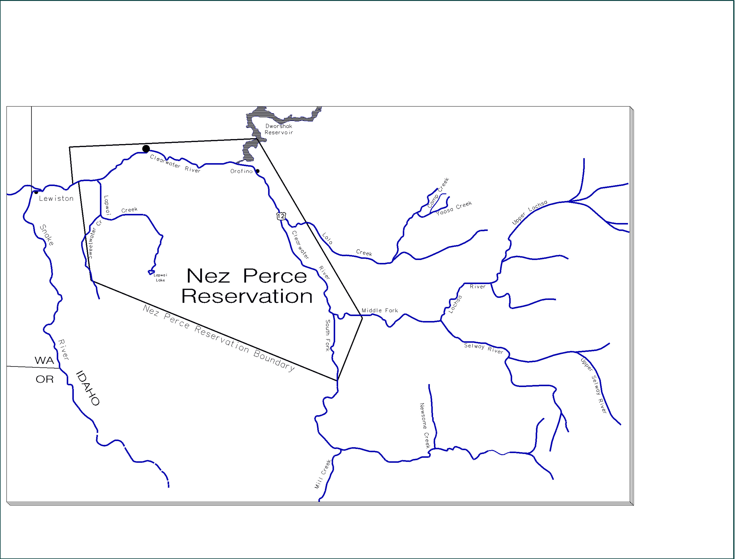
Acclimation Pond
150,000 Spring Chinook Presmolts
Rearing at 1705
Acclimation Pond
200,000 Early Fall Chinook Subyearling Smolts
Rearing at 1705
Acclimation Pond
75,000 Spring Chinook Presmolts
Rearing at 1705

Direct Stream Release
400,000 Spring Chinook Parr
Rearing at 1705
S - Channels
Acclimation Pond
500,000 Fall Chinook Subyearling Smolts
Rearing at 1705
Central Incubation for all sites
Rearing Facility for
Fall Chinook – North Lapwai Valley & 1705
Early Fall Chinook- Luke’s Gulch
Spring Chinook- Yoosa, Newsome, Meadow

Acclimation Pond
200,000 Early Fall Chinook Subyearling Smolts
Rearing at Sweetwater Springs

Fall Chinook Acclimation Pond
500,000 Fall Chinook Subyearling Smolts
Rearing Facility for Cedar Flats
Early Fall Chinook Subyearling Smolts
Adult Holding
Yoosa/Camp Creek
Meadow Creek
Allotment 1705
Newsome Creek
Luke’s Gulch
Cedar Flats
North Lapwai Valley
Sweetwater Springs
Fall Chinook
Early Fall Chinook
Spring Chinook

Figure 1. Clearwater River subbasin map with Nez Perce Tribal Hatchery facilities and production.

Luke’s Gulch and Cedar Flats each facilitate acclimation of 200,000 early-fall chinook salmon subyearling smolts. Five portable circular tanks at each site provide cryptic substrate coloration, shading, low density (0.1lb/cf/in), variable temperature (direct river water), and natural photo-period. Acclimation occurs during May and June (Table 1). Early-fall chinook salmon will be forced release from the acclimation ponds in June.

STATUS AND LIFE HISTORIES OF CLEARWATER SUBBASIN CHINOOK SALMON

The native runs of chinook salmon in the Clearwater River are believed to have been totally eliminated by the Lewiston Dam, built at RM 4 in 1927. Fulton (1970) stated the dam prevented passage during the 14 years 1927-1940, until a new fishway restored passage in 1940. Extensive efforts to reintroduce chinook salmon to the subbasin began in the 1960's and continued with annual releases of 0.4 to 1.4 million spring chinook salmon fry through 1982 in the Selway River (Cramer 1995). Hatchery spring chinook salmon were released in other portions of the Clearwater River subbasin only after 1971, and have been released intermittently in many streams of the subbasin since (BPA et al. 1997;NPT and IDFG 1990). Counts of spring chinook salmon at Lewiston Dam reached 3,467 fish in 1972. Lewiston Dam was removed in 1973, and the primary indices of chinook salmon abundance since then have been redd or carcass counts from spawning surveys. Redd counts have shown a sharp decline in abundance of spring chinook salmon in all streams of the Snake River basin between 1973 and 1980, and have remained at low levels since (Mathews and Waples 1991). Counts of spring chinook salmon redds in the Selway River since 1980 have averaged less than 20% of the peak number in 1973 (Cramer 1995). A total of 6,733,000 fall chinook were reintroduced by the IDFG into the upper Clearwater subbasin from 1960-1967, mainly through eyed-egg plants in artificial spawning channels along the Selway River near the Finn Ranger Station (Richards 1968). Counts of fall chinook at the Lewiston Dam increased from three in 1962 to a high of 122 in 1966, and back down to 90 in 1969. Due to insignificant returns of fall chinook, the reintroduction program was terminated in 1968 (Hoss 1970).

Although the indigenous chinook salmon in the Clearwater River subbasin were eliminated by Lewiston Dam, naturalized populations of spring chinook and fall chinook salmon have been reestablished in some portions of the subbasin as a result of reintroduction efforts. The extensive efforts to reestablish spring chinook salmon in the subbasin were summarized by Nez Perce Tribe (NPT) and Idaho Department of Fish and Game (IDFG; 1990), Cramer and Neeley (1992), and Cramer (1995). Because of the variety of stocks imported followed by the meager returns of adults, it is probable that the most recent fish stocked are the most closely related to any fish presently produced naturally. Genetic analyses confirm that natural spring chinook salmon in the Clearwater River subbasin are derived from Snake River stocks (Mathews and Waples 1991).

Spawning areas available to chinook salmon in the Clearwater River subbasin range in elevation from 215 m (700 ft) up to over 1,540 m (5,000 ft). This wide range of altitudes also means there is a wide range of stream temperatures, that would have supported different races of chinook salmon in different portions of the subbasin during pre-settlement conditions. McIntyre and Reisenbichler (1988) recorded temperatures at 35 stations in various streams within the Clearwater and Salmon River subbasins during 1985-1987, and found that stream temperatures through fall and winter were highly related to elevation. Thus, differences in altitude within the Clearwater River subbasin would have led to a cline in spawning time related to altitude, with spring chinook salmon spawning in the upper subbasin, fall chinook salmon spawning lowest in the subbasin, and summer/early-fall chinook salmon spawning in-between.

Spring Chinook Salmon

Spring chinook salmon spawn in numerous large tributaries of the subbasin, principally at elevations above 770 m (2,500 ft). Spring chinook salmon adults enter the Snake River during late April to mid-June at age 3 to 6. They typically hold in deep pools or in cover through the summer and spawn in August through early September. Spring chinook salmon indigenous to the Snake River basin tend to spawn earlier and higher in the basin than summer (early-fall) and fall races (Chapman et al. 1991). The temporal progression of spawning from the coolest areas earliest to the warmest areas latest is an obvious adaptation to the longer time required for egg incubation in colder water.

Nearly all adult spring and summer chinook salmon that return to the Snake River basin result from fish that smolted as yearlings in April-May (Mathews and Waples 1991). Although these fish smolt as yearlings, many also make in-basin migrations as fry or as fall parr. Fry generally emerge from the gravel in late April and May. Fry dispersal was well documented in the Selway River during studies of chinook salmon re-introductions (Cramer 1995). A second downstream migration of fish in the upper portion of the rearing areas again occurs in the fall as juveniles seek winter habitat (Hesse et al. 1995). These migration patterns during juvenile residency were found by Bjornn (1978) to be highly consistent during 1964-1973 in Big Springs Creek and the Lemhi River, where 60-70% of outmigrants were fry, 16-22% were parr in the fall, and 9-21% were smolts in the spring.

Downstream migration in the fall out of headwater rearing areas is a widely observed characteristic of the spring chinook salmon life history (Richards and Cenera 1989; Hillman et al. 1987). Some fish overwinter in interstitial spaces between large substrate in their natal streams. This type of habitat may be limited, especially in streams where sediments fill the spaces between cobbles. In streams with sediment impacts, about 80% of the subyearlings move downstream in the fall to find desirable substrate (Chapman et al. 1991; Hillman et al. 1987; Richards and Cenera 1989). Richards and Cenera (1989) found that abundance of chinook salmon parr in October had declined to 17% of that during the summer in a Salmon River tributary. Hillman et al. (1987) report that 80% of the subyearling chinook salmon emigrated from Red River in October, when temperatures were 4-8C, and moved downstream to other more favorable habitats in the mainstem of the South Fork Clearwater River.

Little is known about the distribution of Snake River spring chinook salmon in the ocean, because few are ever caught in ocean fisheries. Analyses of Coded-Wire Tag (CWT) recoveries from Snake River spring chinook salmon during the intensive ocean fisheries of the 1980's indicated that harvest rate of these fish in the ocean was less than 1% (Berkson 1991).

Key points regarding natural run status and supplementation treatments follow:
- Historically present throughout the Snake River basin, however construction of the Lewiston and Harpster dams (now removed) extirpated endemic stocks within the Clearwater subbasin. Current returns of spring chinook salmon have been re-established with various sources of hatchery broodstock and are not listed under the Endangered Species Act (ESA).
- Streams to be supplemented during Phase I with spring chinook salmon include Lolo Creek, Newsome Creek, and Meadow Creek (Selway) (Figure 2).
- Existing hatchery production will continue at Clearwater Anadromous Fish Hatchery, Dworshak National Fish Hatchery, and Kooskia National Fish Hatchery.

Fall Chinook Salmon

Spawning of fall chinook salmon in the Clearwater River subbasin occurs principally in the mainstem below the confluence with the North Fork Clearwater River (Garcia et al. 1999). Fall chinook salmon redds have been counted each year since 1988 by helicopter, and have recently increased from a range of 4-36 during 1988-1995, to 78 in 1998 and 184 in 1999. Hatchery fish released in the Clearwater River first returned as adults in 1999, with 43% of carcasses in 1999 determined to be hatchery fish (personal communication, Bill Arnsberg, Nez Perce Tribal Fisheries). Peak spawning was originally in November, but there have been an increasing number of redds counted in October, even as early as October 5 (Garcia et al. 2000; personal communication, Bill Arnsberg, Nez Perce Tribal Fisheries).

Adult fall chinook salmon enter the Columbia River in August and reach the Snake River in September and October. Spawning of fall chinook salmon at Lyons Ferry Hatchery peaks in mid November (Bugert et al. 1989). Juvenile fall chinook salmon generally emigrate as subyearlings in the mid-summer. Emigration of subyearling chinook salmon past Lower Granite Dam (LGR) generally peaks about mid July, and the average period during which 80% of subyearlings pass LGR extends from June 24 to August 26 (DeHart 1999).

Unlike Snake River spring chinook salmon, the fall chinook salmon contributed at high rates to ocean and in-river fisheries during the 1980's. Berkson (1991) estimated the harvest rate on Lyons Ferry fall chinook salmon in the mid 1980s was 48% in the ocean and an additional 55% in the Columbia River. Further, Busack (1991) found from harvest data that there were clear differences between Snake River and upper Columbia River fall chinook salmon distributions in the ocean. Busack analyzed the recoveries of CWT's in the ocean fisheries for the year classes 1978 to 1984 and found that Snake River fall chinook salmon were consistently caught in a more southerly distribution than upper Columbia stocks. Catches of Snake River fall chinook salmon occurred about 20-50% off Washington, Oregon and California and less than 5% off Alaska. Upper Columbia fall chinook salmon were caught about 20-30% off Alaska and less than 10% from Washington, Oregon and California.

Key points regarding natural run status and supplementation treatments follow:
- Currently present in the Clearwater River and considered by NMFS to be part of the Snake River Ecological Significant Unit and have been listed under the ESA since 1992.
- The lower mainstem Clearwater River will be supplemented with fall chinook salmon (Figure 1).
- Existing stocking from Lyons Ferry Hatchery will continue in the mainstem Clearwater River below the North Fork confluence.

Early-fall Chinook Salmon

We use the term early-fall chinook salmon to refer to fish that spawn principally in October, and would have a life history similar to that of “summer” chinook salmon in the mid-Columbia (October spawning and subyearling smolts), but not to the Snake River summer chinook salmon (late August-early September spawning and yearling smolts). Temperature data indicate that late September and early-October would be the most favorable spawning times in much of the Clearwater River subbasin, whereas spawning before or after that time might lead to high egg mortality from thermal stress in many years (Cramer 1995). Hatchery records in the Grande Ronde subbasin in the early 1900's indicate that spawning of chinook salmon extended from early September all of the way through October (Van Dusen 1903 and 1905). Evermann (1896) presented data on catches and spawning of chinook salmon in the Snake River indicating that peak spawning occurred during middle October in 1894.

There are no known populations of early-fall chinook salmon remaining in the Snake River basin that spawn through October, but temperature data indicate that late September and early October would be the favorable spawning times in the lower Selway, Lochsa, South Fork Clearwater, and mainstem Clearwater (above the North Fork confluence) rivers. Because of Dworshak Reservoir on the North Fork of the Clearwater River, temperature of the mainstem Clearwater River below the North Fork is 2-5C cooler during July-September and 1-2C warmer during November through March than the mainstem above the North Fork (Arnsberg et al. 1992), and is therefore the only section of river in the Clearwater River subbasin suited to November spawning chinook salmon (Cramer 1995). Cramer (1995) presented evidence that spawning of chinook salmon, in order to coincide with thermal optimums for egg survival, must occur sufficiently early in the fall for eggs to develop to eyeing before water temperatures drop below 4-5C, but sufficiently late in the year that water temperatures have dropped below the upper tolerance limits of freshly spawned eggs (approximately 14C; Beacham and Murray 1990). These temperature conditions would be met by spawning that occurs between late September through mid-October for most streams of the subbasin at elevations below 770 m (2,500 ft). Although the October spawning segment of the run has been nearly eliminated, the genetic potential to reproduce it may still be contained in the genome, and could be reexpressed through natural selection or selective breeding with Snake River stock.

The juvenile life history of chinook salmon that spawned in October was not documented, and can only be deduced. Cramer (1995) concluded that the race of October-spawning chinook salmon would likely have smolted as subyearlings, because high stream temperatures at the elevation they were adapted to would have promoted rapid growth in the spring, but stressful rearing conditions during the summer. October spawning chinook salmon in the mid-Columbia smolt primarily as subyearlings. Thus, it is expected that early-spawning fall chinook salmon to be developed in the Clearwater River from the Lyons Ferry stock will be predominantly subyearling migrants. Additionally, their migration patterns in the ocean and vulnerability to ocean fisheries are also likely to parallel those of Lyons Ferry fall chinook salmon.

Key points regarding natural run status and supplementation treatments follow:
- Currently considered extirpated from Clearwater River subbasin.
- Early-fall life history will be reestablished by stocking Lyons Ferry stock in suitable early fall habitats, thus allowing natural selection to occur. Use historically present Lyons Ferry brood letting natural selection develop an earlier spawning stock.
- Early-fall chinook salmon supplementation will be developed in the South Fork Clearwater River and the Selway River (below Selway Falls).
- Determination of early-fall chinook salmon program performance will be based on returns of naturally produced (unmarked) fish to the South Fork Clearwater and Selway rivers.

APPROACH TO MONITORING AND EVALUATION

Approaches to monitoring benefits and impacts from NPTH were thoroughly discussed by Steward (1996). Steward recommended that pre and post-operational monitoring also include paired treatment and control streams to achieve greatest statistical power for detecting treatment effects. Elements of the pre-vs-post and treatment-vs-control design have been incorporated into the Phase 1 M&E Plan wherever those elements offer reasonable advantage to assessing NPTH benefits and impacts. Pre-operational sampling has been under way for several years, and began as early as 1974 for some program elements, and as late as 1995 for others (Table 2). Results from pre-operational sampling revealed much about logistical challenges and repeatability of results for various sampling locations and methods, so the lessons learned have been applied to modifying the sampling plan to achieve more useful results in the post-operational period. Thus, some sampling efforts in the Phase 1 operation period cannot be matched directly with sampling in the pre-operation period, and vice versa. Further, stocking of hatchery chinook salmon in treatment streams has preceded construction of the Phase 1 facilities (Table 3). This stocking has occurred opportunistically at variable rates between years, depending on the availability of brood fish. Efforts to evaluate these supplementation treatments has been included in the Idaho Salmon Supplementation Program (Walters et al. 1999).

Although the concept of a control stream appears valuable, there are no true control streams available in the subbasin; so we use the term “reference stream” as an adaptation of the control stream concept. A true control stream would have the same characteristics as the treatment stream, but not receive the treatment being applied to the treatment stream. In the Clearwater River subbasin, there are many unique aspects of each tributary watershed that cause them to differ from one another, and most of the larger watersheds in the subbasin have been stocked with chinook salmon or steelhead over the last two decades.

Deviations from the true “control stream” concept may eliminate the statistical advantages to a treatment-vs-control design, because the statistical advantage is only achieved if all factors influencing treatment success are varying in parallel between the treatment and control streams. Intermittent stocking of spring chinook salmon from various Snake River basin hatcheries has been variable between streams, and all streams of the basin have been dependent on that stocking for a founding source of their reintroduced spring chinook salmon populations. Even if this external influence were equivalent for all streams, monitoring of chinook salmon populations in streams throughout the Columbia Basin indicates that variation is often poorly correlated between nearby streams. For example, a recent study of fall chinook salmon populations in the Columbia Basin by Skalski et al. (1996), indicated that the ocean distribution of all 34 stocks that were compared were significantly (P<0.05) different from the Priest Rapids test group. More surprisingly, Skalski et al. (1996) found that even the nine replicate release groups of the same brood (1987) from the same hatchery (Priest Rapids) had significantly different (P<0.01) ocean distributions from one another. Skalski et al. calculated the outcomes of using each of five stocks with the closest ocean distribution to the Priest Rapids stock as a reference stock to control for variable ocean survival in his analysis of smolt migration survival for the Priest Rapids stock. Skalski et al. found that whichever reference stock was chosen determined the outcome of the multiple regression explaining smolt survival, and that no two reference stocks yielded the same choice of best explanatory variables.

Table 2. Summary of past fish sampling through 1999 in NPTH treatment and reference streams in the Clearwater River subbasin.

Stream | Adult Escapement |  |  | Hatchery Influence | Genetics | Juvenile production and survival |  |  |  |  |  |  | Habitat
 | Weir (CHS) | Redd Counts (foot and or helicopter) | Stocking (BY) |  | Juvenile Density (snorkel) | Presmolt Yield (fall screw trap) | Smolt Yield (spring screw trap) | Emigration Survival (PIT tags in natural fish) | Habitat Survey | Carrying Capacity | Aerial Photo | Temperature | Flow
Lolo Creek | 96-99 | 87 -99 | 97 | 96-99 | 93-99 | 93-99 | 93-99 | 93-99 | 93, 98 | SDM | – | 92-99 | USGS
NewsomeCreek | 95 -99 | 87 -99 | 92, 93, 97 | 97, 98 | 92-99 | 95-99 | 98, 99 | 95-99 | -- | SDM | 99 | 94-99 | No (limited staff gauge)
Meadow Creek | 97 | 93-99 | 92, 93, 97 | -- | 93, 94, 95, 96, 97, 98 | 93-99 | 94-99 | 93-99 | 97 | SDM | 97 | 91-93 | No (limited staff gauge)
South Fork Clearwater | -- | 88-99 | -- | -- | -- | -- | -- | -- | 94 | Yes | -- | Yes | USGS
Selway | – | 88-99 | 93, 97 | -- | -- | -- | -- | -- | 94 | Yes | -- | Yes | USGS
Clearwater | -- | 88-99 | 95, 96, 97, 98, 99 | 98, 99 | 89, 90 | -- | -- | H: 95-99  W:96-99 | 90, 95 | Yes | 80's | 88-99 | USGS

 | Adult Escapement |  |  | Hatchery Influence |  |  | Genetics | Emigration | Habitat
Stream | Weir | Redd Counts | Stocking (BY) | Brood Collection | Juvenile Density | Survival | Survey
Snake | LGR | 87-99 | 94, 95 | -- | -- | 95-99
Boulder | -- | 95, 98, 99 | 93, 97 | -- | -- | -- | 93-94
Warm Springs | -- | 95, 98, 99 | 93, 97 | -- | -- | --
Mill | -- | 94-99 | 97 | -- | 94-99 | --
Eldorado | 97-99 | 92-99 | 91 | -- | 93-99 | -- | 93
Johns | -- | 94-99 | -- | -- | -- | --
Ten Mile | -- | 95-99 | -- | -- | -- | --
Fish | -- | -- | -- | -- | 93-99 | -- | 93
Brushy Fork | 98-99 | 74-99 | -- | -- | 93-99 | -- | 93
Crook River | 74-99 | 80-99 |  |  | 93-99 | --
American | -- | 92-99 |  | -- | 93-99 | –

Table 3. Stocking data for anadromous salmonids released into NPTH treatment and reference streams in the Clearwater River subbasin from 1991 through 1999 .

 | Outplanting | Release | Brood | Release | Life |  |  |  | Rearing
River | Location | Year | Year | Date | Stage | # Fish | Adclip (Y/N) | CWT (Y/N) | Location
Clearwater River | Big Canyon Acclimation Facility | 1996 | 1995 | 6/6-7/10 | Subyearling | 7,143 | N | Pit tagged | Lyons Ferry Hat
Clearwater River | Big Canyon Acclimation Facility | 1997 | 1995 | 04/14-5/15 | Yearling | 199,399 | Y | Y | Lyons Ferry Hat
Clearwater River | Big Canyon Acclimation Facility | 1997 | 1996 | 6/2-7/8 | Subyearling | 30,069 | N | Pit tagged | Lyons Ferry Hat
Clearwater River | Big Canyon Acclimation Facility | 1997 | 1996 | 6/10-6/13 | Subyearling | 252,705 | Y | BWT | Lyons Ferry Hat
Clearwater River | Big Canyon Acclimation Facility | 1998 | 1996 | 4/13-4/16 | Yearling | 61,172 | Y | Y | Lyons Ferry Hat
Clearwater River | Big Canyon Acclimation Facility | 1998 | 1997 | 6/2-7/7 | Subyearling | 31,000 | N | Pit tagged | Lyons Ferry Hat
Clearwater River | Big Canyon Acclimation Facility | 1999 | 1997 | 4/12-4/15 | Yearling | 153,719 | Y | Y | Lyons Ferry Hat
Clearwater River | Big Canyon Acclimation Facility | 1999 | 1997 | 4/26-4/28 | Yearling | 74,732 | Y | Y | Lyons Ferry Hat
Clearwater River | Big Canyon Acclimation Facility | 1999 | 1998 | 6/3 | Subyearling | 347,105 | N | Y 200K | Lyons Ferry Hat
Clearwater River | Big Canyon Acclimation Facility | 1999 | 1997 | 6/1-7/6 | Subyearling | 31,000 | N | Pit tagged | Lyons Ferry Hat
Clearwater River | Eldorado Creek | 1991 | 1989 |  | Smolt | 199,456 |  |  | Dworshak
Clearwater River | Eldorado Creek | 1992 | 1990 |  | Smolt | 183,000 |  |  | Dworshak
Clearwater River | Lolo Creek | 1997 | 1997 | 07/22 | Adult | 219 | Y | Unknown | Dworshak
Clearwater River | Lolo Creek | 1997 | 1997 | 07/21 | Adult | 255 | Y | Unknown | Dworshak
Clearwater River | Lolo Creek | 1999 | 1997 | 03/30 | Smolt | 150,000 | N | Y | Clearwater
Clearwater River | Lolo Creek | 1999 | 1998 | 7/19-21 | Parr | 250,285 | N | Y | Sweetwater Sp
Lochsa River | Boulder Creek | 1994 | 1993 | 07/21 | Parr | 75,764 | Y | N | SWS
Lochsa River | Boulder Creek | 1998 | 1997 | 07/08 | Parr | 84,860 | N | N | CAFH
Lochsa River | Boulder Creek | 1999 | 1997 | 4/6-7 | Smolt | 104,280 | N | Y | Clearwater
Lochsa River | Crooked Fork Creek | 1992 | 1991 | 9/5 | Parr | 7,800 | Y |  | CAFH
Lochsa River | Warm Springs Creek | 1994 | 1993 | 07/21 | Parr | 18,687 | Y | N | SWS
Lochsa River | Warm Springs Creek | 1998 | 1997 | 07/09 | Parr | 22,650 | N | Y | CAFH
Lochsa River | White Sands Creek | 1994 | 1993 | 07/19 | Parr | 165,957 | Y | N | SWS
S.F. Clearwater River | American River | 1995 | 1993 | 4/5 - 10 | Smolt | 221,449 | Y | Y | CAFH
S.F. Clearwater River | Mill Creek | 1997 | 1997 | 07/16 | Adult | 101 | Y | Unknown | Rapid River
S.F. Clearwater River | Mill Creek | 1999 | 1998 | 07/29 | Parr | 60,200 | N | Y | Dworshak
S.F. Clearwater River | Mill Creek | 1999 | 1997 | 03/19 | Smolt | 40,000 | N | Y | Clearwater
S.F. Clearwater River | Newsome Creek | 1991 | 1990 |  | Parr | 165,588 |  |  | Dworshak
S.F. Clearwater River | Newsome Creek | 1994 | 1994 |  | Adult | 250 |  |  | Rapid River
S.F. Clearwater River | Newsome Creek | 1995 | 1993 |  | Smolt | 200,000 |  |  | Rapid River
S.F. Clearwater River | Newsome Creek | 1997 | 1997 | 07/16 | Adult | 181 | Y | N | Rapid River
S.F. Clearwater River | Newsome Creek | 1997 | 1997 | 07/12 | Adult | 99 | Y | N | Rapid River
S.F. Clearwater River | Newsome Creek | 1999 | 1997 | 03/19 | Smolt | 74,638 | N | Y | Clearwater
S.F. Clearwater River | Newsome Creek | 1999 | 1998 | 07/29 | Parr | 50,200 | N | Y | Dworshak
Selway River - Lower | Meadow Creek | 1994 | 1993 | July | Parr | 417,000 | RV | N | CAFH
Selway River - Lower | Meadow Creek | 1997 | 1997 | 08/26 | Adult | 300 | Y | N | Rapid River
Selway River - Lower | Meadow Creek | 1997 | 1997 | 08/25 | Adult | 301 | Y | N | Rapid River
Selway River - Lower | Meadow Creek | 1999 | 1998 | 8/3-5 | Parr | 177,722 | N | Y | Dworshak
Selway River - Lower | Meadow Creek | 1999 | 1997 | 3/22-26 & 3/30-31 | Smolt | 300,021 | Y | N | Clearwater
Selway River - Lower | Meadow Creek - Upper | 1997 | 1997 | 10/31 | Eyed Eggs | 30,000 | N/A | N/A | Dworshak
Selway River - Lower | Meadow Creek - Upper | 1997 | 1997 | 10/30 | Eyed Eggs | 120,000 | N/A | N/A | Dworshak
Selway River - Lower | Meadow Creek - Upper | 1997 | 1997 | 11/05 | Eyed Eggs | 130,000 | N/A | N/A | Dworshak
Selway River - Lower | Selway River - Lower | 1994 | 1993 | 07/18 | Parr | 116,687 | Y | N | SWS
Selway River - Lower | Selway River - Lower | 1997 | 1997 | 08/27 | Adult | 300 | Y | N | Rapid River
Selway River - Lower | Selway River - Lower | 1997 | 1997 | 08/28 | Adult | 100 | Y | N | Rapid River
Selway River - Lower | White Cap Creek | 1998 | 1997 | 07/30 | Parr | 124,140 | N | N | SWS

Recognizing the weaknesses of treatment-vs-control comparisons in the Clearwater River subbasin, the M&E design for Phase 1 depends on other techniques for detecting treatment effects, but still incorporates some reference streams that appear reasonably similar to the NPTH treatment streams. Sampling of several biological parameters will proceed on these reference streams. Further, different streams or hatcheries may be used as a reference for different parameters of interest. The purpose of incorporating a reference population into an analysis is to account for variation that is extraneous to the treatment. As an example, we will use the more abundant CWT recoveries from other Snake River basin hatcheries as reference populations to estimate harvest rates in the ocean and Columbia River. Several of the reference streams conceived by Stewart (1996) have since been ruled out, either because stocking has been initiated in those streams or no chinook salmon have returned there in recent years. Reference streams included in this Phase 1 M&E Plan are as follows:

Stock | Reference Populations | Reference Factor
Spring | American River, Brushy Fork/Crooked Fork | Natural Chinook Production, Ecological Impacts
 | Hatchery Aggregate | Ocean Survival, Harvest Rates
 | Eldorado, Fish creeks | Ecological Impacts
Early-Fall | Lower Lochsa River | Ecological Impacts
Fall | Lyons Ferry Hatchery | Ocean Survival, Harvest Rates

The reference streams designated for comparison of either “natural chinook production” or “ecological impacts” will not receive releases of hatchery chinook salmon, so they can serve as reference examples of what might happen without intentional supplementation. Only streams that consistently have natural chinook salmon spawners can serve as references for natural chinook production, while those designated for ecological impacts may or may not have natural chinook salmon spawners. Eldorado Creek, Fish Creek, and the lower Lochsa River have usually not had chinook salmon spawners during the past 5 years, so they can only be used as references for ecological impacts. American River, Brushy Fork/Crooked Fork Creek generally do have natural spring chinook salmon returning to spawn, and can be used as references for natural chinook salmon production, as well as ecological impacts. However, these streams are near others that will be stocked by ISS, so they may receive some stray hatchery fish. It would be desirable to account for hatchery fish entering these reference streams, and a weir below Brushy Fork and Crooked Fork creeks (adjacent to Powell Fish Facility) can be used to sort some fish entering those creeks. However, the weir cannot function under some high flow conditions that occur in the spring, so a complete count cannot be made. Thus, hatchery strays are likely to enter any of the reference streams, and spawner surveys will have to be structured to determine the extent that hatchery fish contribute to natural spawning. If straying is substantial into any of the reference streams, then data from those streams can still be used as a type of treatment consisting of a lower stocking density. There are no streams with unsupplemented natural populations of early-fall or fall chinook salmon, so there are no reference streams for natural production of those stocks.

The ISS Program (Walters et al. 1999) has identified additional streams of the Clearwater River subbasin that are intended as control streams for that program (Table 4). Those control streams include several of the reference streams identified for NPTH M&E, but the ISS Program had included the American River as a treatment stream, and had not included Fish Creek as either a treatment or control (Fish Creek is a control stream for the Steelhead Supplementation Studies). Supplementation of the American River was only accomplished with smolt releases in one year (1995), and NPT is coordinating with IDFG to designate the American River as a reference stream for natural production. The American River is desirable as a reference stream because of its similarity to Newsome Creek.

Table 4. Idaho Supplementation Studies treatment and control streams in the Clearwater River subbasin . Indented streams are tributaries of the stream immediately above. (After Walters et al. 1999).

Stream | Treatment (T) or  Control (C) | Responsible  Cooperator
Lolo Creek (including Yoosa Cr.) | T (presmolt) | NPT
Eldorado Creek | C | NPT
Newsome Creek | T (presmolt) | NPT
Crooked River | T (presmolt) | IDFG
American River | T (smolt) | IDFG
Red River | T (presmolt) | IDFG
Clear Creek | T (smolt) | USFWS
White Cap Creek | C | IDFG
Pete King Creek | T (parr) | USFWS
Squaw Creek | T (parr) | NPT
Papoose Creek | T (smolt) | NPT
Colt Killed Creek | T (parr) | IDFG
Big Flat Creek | T (parr) | IDFG
Crooked Fork Creek | C | IDFG
Brushy Fork Creek | C | IDFG

Because of weaknesses in the treatment-vs-control, pre operation-vs-post operation design for detecting NPTH benefits and impacts, the monitoring plan focuses on discovering cause-vs-effect relationships for the factors driving adult chinook salmon production, including experimental manipulations of several factors. Once cause-vs-effect relationships are established, then effects can be estimated from the magnitude of change in causal factors. For example, if natural smolt production can be related to the number of parent spawners, then the contribution that naturally spawning hatchery fish make to smolt abundance can be estimated. In a 12 year study of flow augmentation effects on chinook salmon in the Rogue River, Cramer et al. (1985) found that the most important changes in chinook salmon populations were estimated from cause-vs-effect relationships, rather than from the comparisons of pre-vs-post operation. The M&E Plan here calls for intentional manipulation of several treatments to increase the ability for accurately estimating treatment effects and distinguishing them from the effects of environmental variation. Such intentional manipulations were recommended by Skalski et al. (1996) as a superior alternative to using a design of treatment-vs-reference stocks in their study to estimate environmental effects on smolt survival.

PHASE 1 MONTIORING AND EVALUATION ACTIONS

In this section, we describe types and location of sampling to be conducted during
Phase 1, as well as the data and analysis products that will be used to achieve the objectives. The sequence in which sampling is described follows a step-down of logic that dictates the need for the sampling. This sequence begins with the goal of the M&E Plan, divided into five objectives, and then each objective is divided into tasks, activities, and subactivities. Both the objectives and tasks focus on the “Why” of sampling, and the activities and subactivities transition to the “How” of sampling. An abridged hierarchy of objectives, tasks, and activities is shown in Figure 2. Full description of the M&E actions is organized under headings corresponding to the objectives, tasks, activities and subactivities.

The goal and objectives to be achieved by this M&E Action Plan are as follows:

GOAL: MONITOR AND EVALUATE RESULTS OF THE NEZ PERCE TRIBAL HATCHERY SO THAT OPERATIONS CAN BE ADAPTIVELY MANAGED TO OPTIMIZE HATCHERY AND NATURAL PRODUCTION, SUSTAIN HARVEST, AND MINIMIZE ECOLOGICAL IMPACTS.

Objective 1. Determine if program targets for contribution rate of hatchery fish are being achieved and can be improved (Hatchery Product Performance).

Objective 2. Determine the increases in natural production that results from supplementation of chinook salmon in the Clearwater River subbasin, and relate them to limiting factors (Natural Production Response).

Objective 3. Estimate ecological and genetic impacts to other fish populations (Interactions).

Objective 4. Determine how harvest opportunities on spring, early-fall, and fall chinook salmon can be optimized for tribal and non-tribal anglers within Nez Perce treaty lands (Harvest Management).

Objective 5. Effectively communicate monitoring and evaluation program approach and findings to resource managers (Applied Adaptive Management).

Nez Perce Tribal Hatchery Monitoring and Evaluation Goal:
Monitor and evaluate results of the Nez Perce Tribal Hatchery so that operations can be adaptively managed to optimize hatchery and natural production, sustain harvest, and minimize ecological impacts.

Figure 2. Abridged step-down plan of NPTH M&E Action Plan goal, objectives, tasks, and activities. Full description and further breakdown of tasks into activities and subactivities are presented in later diagrams.

Objective 1. Determine if program targets for contribution rate of hatchery fish are being achieved and can be improved.

Information gathered under this objective is intended to evaluate how well the supplementation techniques are working and whether certain practices can be modified to improve benefits achieved. The program goals include both developing self-sustaining natural populations of chinook salmon and minimizing impacts to other fish populations. The innovative facilities and operating protocols that were designed to help NPTH succeed have only been tested in a limited number of situations, but the program success depends on achievement of higher release-to-adult survival rates than conventional hatcheries have achieved in the Snake River basin during the last decade. Thus, there are important questions relative to the NPTH program achieving its goals. Sampling under this objective is designed to resolve the following management questions:

- Can Nez Perce Tribal Hatchery produce adequate return rates to achieve program objectives?

- Do the NATURES rearing components make enough difference in post -release survival and return rates to warrant the added limitations compared to conventional hatcheries?

- Can Nez Perce Tribal Hatchery strategies be improved to achieve program goals more rapidly?

The sampling to resolve these questions and achieve Objective 1 is divided among six tasks as shown in Figures 3 through 6. A full description of each task follows.

Task 1.1 Monitor the in-hatchery survival and rearing conditions of NPTH fish by treatment and rearing strategy.

In-hatchery monitoring guidelines have been established by the Integrated Hatchery Operations Team (IHOT 1995). Formalization of the in-hatchery monitoring will be developed as part of the NPTH Annual Operations Plan (AOP). The AOP is to be developed after final design of NPTH facilities has been completed. Documentation of fish performance and rearing conditions will follow IHOT (1995) protocols and include: egg-take, egg-to-fry, and egg-to-release survival rates; broodstock management, fecundity, egg size; daily mortality; rearing densities and loading factors; calculation of growth rate; monthly fish health examinations of dead and live fish; and the size, condition, number, date, and location of release (Figure 3).

Activity 1.1.1 Develop NPTH annual operation plan.

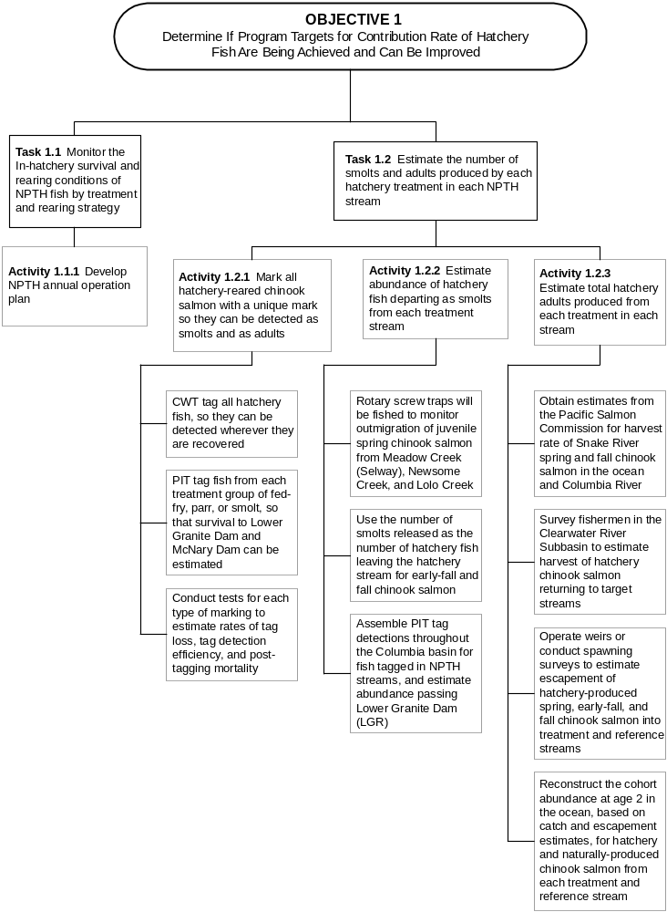
Figure 3. Step-down diagram of activities for Tasks 1.1 and 1.2.

Task 1.2 Estimate the number of smolts and adults produced by each treatment in each NPTH stream.

The NPTH supplementation strategies are intended to produce a sufficient number of smolts to rebuild naturally reproducing populations and support harvest. The planning for facility sizing and numbers of fish to be released was based on assumptions about the number of smolts and adults that would result, on average, from each supplementation strategy. Accordingly, these numbers need to be evaluated to determine whether adjustment of the supplementation strategies is needed to meet program objectives. This evaluation will be completed through three activities (Figure 3) described below.

Activity 1.2.1 Mark all hatchery-reared chinook salmon with a unique mark so they can be detected as smolts and as adults.

Different types of marks will be used to serve different purposes, but with the backup that all hatchery-reared fish will receive a Coded-Wire Tag (CWT). Additionally, Passive Integrated Transponder (PIT) tags, other tags, and adipose clips will be used on some fish for specialized purposes, as described in the following three subactivities. New marking techniques will be evaluated to obtain a mark that has the least amount of impact to the fish.

Subactivity 1.2.1.1 CWT tag all hatchery fish, so they can be detected wherever they are recovered. All hatchery fish will be marked with CWT’s, but not adipose fin-clipped, so a wand detector can be used to distinguish them from wild fish. The CWT will make all hatchery fish distinguishable from natural fish, if a fish can be examined individually. Such opportunities will be available whenever juveniles are captured by seining or at traps, and whenever adults are recovered as harvest, passing weirs, entering hatcheries, or as carcasses. This will require the personnel conducting the various field sampling tasks carry the hand-held wands that detect CWT’s, and that all fish captured be checked with the CWT wand.

Product: All fish released from NPTH will be implanted with CWTs.

Subactivity 1.2.1.2 PIT tag fish from each treatment group of parr, presmolts, or smolts, so that survival to Lower Granite Dam and McNary Dam can be estimated. A group of PIT-tagged fish will be included with each release group that represents a particular strategy in a particular stream. Detections of these PIT-tagged fish as they pass screw traps and dams in the Snake and Columbia rivers will enable estimation of emigration timing, travel time (smolt releases only), and survival for that strategy. Detection probability for PIT- tagged spring chinook salmon yearlings passing Lower Granite Dam (LGR) often ranges from 20% to 45% (Smith et al. 1998), and for fall chinook salmon subyearlings ranges from 40% to 60%( Muir et al.1999). Further, survival of smolts migrating from Snake River tributaries to LGR is typically 75-85% for yearling spring chinook salmon (Smith et al. 1998) and 50-60% for subyearling fall chinook salmon (Muir et al. 1999). Thus, for PIT-tagged chinook salmon leaving NPTH treatment streams, we might expect 15-40% yearling smolts and 20-35% of subyearling smolts to be detected as they pass LGR. Given the possibility that Lower Granite Dam will not be long term evaluation point, select release groups will be marked with more PIT tags to estimate survival to McNary Dam and establish baseline survival to McNary for NPTH fish.

Given these high detection rates, releases of 1,000 PIT-tagged smolts will produce sufficient detections at LGR for application of the SURPH.1 model (Smith et al. 1994) used by National Marine Fisheries Service (NMFS) to estimate passage survival. Walters et al. (1999) reported that detection rates of parr and pre-smolts (fall migrants) from the Clearwater River subbasin were about one fourth and one half, respectively, of that for chinook salmon PIT-tagged as smolts. Based on these expected recovery rates, we set tagging goals for PIT tags of 3,000 parr, 2,000 pre-smolts or 1,000 smolts per spring chinook salmon treatment stream and replicated groups of 2,500 for fall and early-fall chinook salmon treatments each season. If a particular release strategy includes dispersal of hatchery fish to multiple release points within a stream, then the PIT-tagged fish will be evenly divided in proportion to all fish released at each point. Groups of 8,000 smolts will be necessary to confidently estimate survival to McNary Dam.

Product: Representative PIT tag group released with each treatment in each stream.

Subactivity 1.2.1.3. Conduct tests for each type of marking to estimate rates of tag loss, tag detection efficiency, and post-tagging mortality. Rates of CWT loss will be determined from the number of readable CWT’s recovered from hatchery fish that are adipose fin clipped. Rates of PIT tag shedding will be determined from experiments coordinated with other entities using PIT tags in the Snake River basin each year, such that results can be pooled. Most likely this will require holding of 50-100 PIT-tagged juveniles in a raceway or pond for up to 12 months. Periodically, samples of at least 100 tagged fish will be held for 48 hours to estimate delayed mortality from handling stress. Efficiencies for detecting either PIT tags or CWT’s when fish are captured as juveniles at traps or by seining will be evaluated on at least four occasions annually for each sampling method, by having a team member that is not recording data secretly include 50 tagged fish in the samples of all fish being checked. Efficiencies for detecting CWT’s in unmarked adults will be performed at the hatcheries where fish can be thoroughly examined and run through multiple checks to see if CWT’s are being missed. Initially, a hand wand will be used in the same way applied to spawning surveys, and then all fish be subjected to a more thorough second examination with another CWT detector. Results from the first and second checks will be compared to estimate the percentage of CWT’s missed during the first examination.
Product: (1) Estimate of delayed mortality after either PIT or CWT tagging.
(2) Estimated percentage of sampled fish with PIT tags or CWT’s that are correctly identified as having a tag.
(3) Estimated percentage of tag or mark retention.

Activity 1.2.2 Estimate abundance of hatchery fish departing as smolts from each treatment stream.

The number of hatchery fish that emigrate from each stream will be determined from either the expanded catches in the rotary screw trap fished near the stream mouth, or from the number of fish released as smolts. These are described as separate subactivities.

Subactivity 1.2.2.1 Rotary screw traps will be fished to monitor outmigration of juvenile spring chinook salmon from Meadow Creek (Selway), Newsome Creek, and Lolo Creek. These traps are manufactured by E.G. Solutions Inc., Corvallis, Oregon.

Trapping operations will begin as soon after January 1 as ice and flow conditions allow and when fish movement begins and continue through fall until freeze up. One or two traps at each location will be operated 24 hours a day, 7days/week during this period. Exceptions to this will occur on occasions when trap repair is necessary or high flows or debris load in the river precluded safe trap operation. Trap sites may modified with screen panels, sandbag walls, or other measures to improve trapping ability during high flow and debris times.

Processing procedures will be similar to those used by Ashe et al. (1995) and are as follows: (1) Fish will be anaesthetized in a MS-222 bath (3 mL MS-222 stock solution (100 g/L) per 19 L of water); (2) Each fish will be examined for existing marks (e.g. fin clips); (3) Fish will be scanned with a PIT tag scanner and coded-wire tag wand; (4) Up to 300 fish of each group of fish will be selected for trap efficiency trials; (5) A specified number of each species will be selected for PIT tag insertion; (6) All other fish will be enumerated and released 30-50 m downstream from the trap; (7) Mortality due to trapping will be noted and recorded.

This procedure will differ after hatchery releases when upwards of 20,000 fish may be captured in one night. On these occasions fish will be removed from the live box and released through a remote PIT tag scanner into the river. Catch estimates will be made by random sub-sampling 10% of the total number of the fish released for species number and species composition. Fish will be held in net pens until being processed.

Mark-recapture tests with juvenile chinook salmon at about weekly intervals will be used to estimate trap efficiency for a range of flow conditions. Groups of fish will be marked with a PIT tag or clip on the distal portion of a fin, then held in covered live nets for approximately 12 h, transported upstream approximately 1 km, and released during evening hours. Wild and hatchery chinook salmon and wild steelhead smolts selected for trap efficiency trials will be measured (FL) to the nearest mm, and marked fish recovered in the traps will also be measured to detect size selectivity. Special efforts are made to conduct trials when changes in stream discharge occur.

Multiple regression methods will be used to establish the relationship of trap efficiency to physical variables and fish size. That relationship can be used to predict trap efficiency on any given day, so that catches can be expanded to an estimate of total fish passage (with a corresponding confidence interval) each day, week, or over the season. Traps will be fished in the same location each year, so that regression models used to predict trap efficiency can build on the additional tests conducted each year. Because daily fish passage estimates can be summed over any meaningful period of time, estimates of migrants will be divided by general life stage.

Product: (1) Population estimates and 95% confidence intervals of hatchery chinook salmon passing the trap as presmolts (September 1 through December 31), and smolts (January 1 to May 31).
(2) Time-frequency distribution of passage for each life stage.
(3) Mean and 95% confidence interval of mean length for each life stage or date.

Subactivity 1.2.2.2 Use the number of smolts released as the number of hatchery fish leaving treatment streams for early-fall and fall chinook salmon. All releases of early-fall and fall chinook salmon will be as subyearling smolts in June (see Table 1), so their emigration from the stream is expected to proceed directly following release. No traps will be operated in streams with these treatments. In these cases, the number of hatchery smolts will be taken as the estimated number of fish released. The dates that early-fall or fall smolts pass any of the mainstem dams will be detected from PIT-tagged fish, and can be used to verify that immediate migration occurred.

Product: Number of early-fall or fall chinook salmon smolts stocked in each treatment stream.

Subactivity 1.2.2.3 Assemble PIT tag detections throughout the Columbia basin for fish tagged in NPTH streams, and estimate abundance passing Lower Granite Dam (LGR). Numbers of PIT-tagged fish reaching LGR from each treatment stream, regardless of whether the stream has a rotary screw trap, will be estimated by two methods; the SURPH model (Smith et al. 1994) used by NMFS, and the methods of Cramer (1996a and 1996b). Due to sample size constraints, the SURPH model will be used to calculate a point estimate of total fish arriving at LGR. Methods described by Cramer (1996a and 1996b) will be used to estimate the number of PIT-tagged fish from NPTH streams that pass LGR each week. Weekly detection efficiencies at LGR can be estimated accurately from interrogations of all PIT-tagged chinook salmon passing down the Snake River. Detection rates for PIT tags are expected to be 30% to 50% at LGR, Lower Monumental, and McNary Dams, and additional detections will occur at several other dams. Thus, a substantial majority of surviving PIT-tagged chinook salmon should be detected as they pass Snake and Columbia River dams. The number of PIT-tagged hatchery fish reaching LGR from NPTH releases can be estimated, likely within 95% confidence intervals of ± 10%. PIT tag detections at mainstem dams will be downloaded from the PTAGIS database. All PIT tagged fish should be returned to the river and not placed on barges in order to achieve the most confident survival estimates possible and to characterize migration route (percentage of fish barged vs in-river) for overall treatment/release groups.

Product: (1) Estimate and 95% confidence interval for the number of smolts from each stream that reach LGR or other mainstem dams.
(2) Time frequency distribution of passage at LGR or other mainstem dams for each treatment group.
(3) Estimate the percentage of fish barged from LGR and other mainstem dams from each treatment group.

Activity 1.2.3 Estimate total hatchery adults produced from each treatment in each stream.

All hatchery-reared adults will bear CWT’s, so the number returning can be estimated whether they are recovered in fisheries, at hatcheries or on the spawning grounds. Sampling to estimate the abundance of adults produced will include operation of weirs, returns to hatcheries, creel surveys, and carcass surveys. Recovery data will be incorporated into a cohort analysis to estimate the virtual population at age 2 in the ocean. Thus, both the number of fish caught and the number that spawned will be included in the estimate of fish produced. This assembly of information will be accomplished through four subactivities.

Subactivity 1.2.3.1 Obtain estimates from the Pacific States Marine Fisheries Commission for harvest rate of Snake River spring and fall chinook salmon in the ocean and Columbia River. This subactivity deals only with the estimation of harvest rate (percentage of population harvested) in the ocean and Columbia River. Because CWT recoveries of NPTH chinook salmon from ocean and river catches are likely to be low for the next decade or more, we will use data on CWT recoveries from other Snake River basin hatcheries to estimate ocean and river harvest rate. These harvest rates are calculated each year by the Pacific Salmon Commission using cohort analysis of CWT groups. For spring chinook salmon, we will average the results for production CWT groups from Dworshak, Rapid River, and Clearwater Anadromous Fish hatcheries. For both early-fall and fall chinook salmon, we will use results of CWT groups from Lyons Ferry Hatchery. It will be desirable to separate the estimates for early-fall and fall chinook salmon as soon as recoveries of NPTH early-fall chinook salmon are sufficient. Until that time, the most similar stock to early-fall chinook salmon will be Lyons Ferry fall chinook salmon.

If CWT recoveries in the Columbia River are too low to estimate harvest rates even for Snake River hatcheries, we will use estimates for upriver stocks in aggregate, as developed by the Columbia River Compact, based on total landings and dam counts. This index of harvest rate can be useful, because harvest rates of upriver chinook salmon as they pass through zones 1-5 and zone 6 of the Columbia River are far more similar between upriver stocks than are harvest rates in the ocean (Cramer and Vigg 1996). This task will be more difficult if selective fisheries are instituted that require release of unmarked fish within the Columbia River, but the fishery is presently conducted with gill nets that do not enable live-release of unmarked fish. Most NPTH chinook salmon will not be externally unmarked, so a selective fishery would require that NPTH fish be released, the same as natural fish.

Product: Estimated fraction of chinook salmon harvested by age and race each year (1) in the ocean and (2) within the Columbia River.

Subactivity 1.2.3.2 Survey fishermen in the Clearwater River Subbasin to estimate harvest of hatchery chinook salmon returning to target streams. Creel surveys designed to estimate total catch of hatchery and natural fish will be implemented at the time that any fishing seasons for chinook salmon are permitted. Broad-based harvest of chinook salmon in the Clearwater River subbasin occurs irregularly and is dependant upon surplus hatchery returns to Dworshak, Kooskia, and Clearwater Anadromous fish. For NPTH program management, seasons will only be allowed in streams where returns are expected to exceed stream or hatchery capacity. The detailed sampling design of each creel survey will be developed when it becomes evident that a harvest season may be offered. It is difficult to predict now what time, location and gear restrictions will be applied to the initial fishing seasons. Surveys will be coordinated with IDFG creel survey efforts.

Product: Estimated number of chinook salmon harvested by age and race each year within the Clearwater River subbasin.

Subactivity 1.2.3.3 Operate weirs or conduct spawning surveys to estimate escapement of hatchery-produced spring, early-fall, and fall chinook salmon into treatment and reference streams. Spawner abundance will be estimated in all treatment and reference streams. Adult spring chinook salmon entering Lolo and Newsome creeks, and early-fall chinook salmon entering the South Fork Clearwater River will be counted at temporary weirs constructed across those streams. Each weir will have a fish trap so that all fish passing the weir can be counted, measured, scale and genetic tissue sample collected, examined for marks or tags, given a secondary mark, and released above the weir or transferred to a holding pond for broodstock.

Temporary weirs are excellent tools for monitoring adult escapement into streams where flows are typically under 1,000 cfs during the passage season. However, temporary weirs are generally not dependable when flows rise sharply and exceed 1,000 cfs. In the Lostine River, a tributary of the Wallowa River in Northeast Oregon, the Nez Perce Department of Fisheries Resources Management determined that in 1999, approximately 85% to 90% of the spring chinook salmon entered the Lostine River and migrated upstream during peak flows before the weir could be installed. Similar observations have been made on Catherine Creek, Upper Grande Ronde, and Imnaha River. These experiences have demonstrated that a temporary weir will likely be of limited value in Meadow Creek (Selway) or across the lower Selway River. A permanent weir has been designed for Meadow Creek (construction decision pending). We must plan for the likelihood that some fish will pass upstream during high flows in each stream when the weirs are not operating. Accordingly, a mark will be applied to each fish trapped at each weir so that marked-to-unmarked ratios during spawning ground surveys (Subactivity 1.4.4.2) can be used to estimate total population size of adults entering that stream.

In Meadow Creek and the Selway River, the abundance of spawners will be estimated from spawning ground surveys. Surveys will be conducted as described under Subactivities 1.4.4.1 and 1.4.4.2. Carcasses will be jaw-tagged and returned to the river, and redds will be marked during each of the three ground surveys per season in Meadow Creek and the Selway River. To estimate total escapement, the redd count will be multiplied by 3.2 fish per redd (Beamesderfer et al. 1997), as is used for the ISS Program (Walters et al. 1999). This estimated total escapement for a particular return year will be separated into brood year returns based on age composition determined from scale samples (Subactivity 2.3.2.1). Alternatively, mark-recapture estimates of spawner abundance will be developed from the recovery rate of jaw-tagged carcasses on the last two surveys of each season. This method, in which carcasses are jaw-tagged and returned to the stream, is widely used in California to estimate spawner abundance (Cramer 1990). Either a Petersen or a Schnabel estimate can be applied to the data (Ricker 1975), but with only two of the three surveys each year having tagged carcasses available for recovery, the Petersen estimate will most likely be used. Professional judgement of unique circumstances or averaging will be used to choose which of the two estimates to apply. Total return for each brood year will be calculated by summing the estimated escapement of each age group in different run years.

Spawner abundance in the mainstem Clearwater River up to the Lochsa Ranger Station on the Lochsa River. Low numbers of spawners in this large river channel make ground surveys ineffective. The redd count will be multiplied by 3.3 fish per redd (Garcia et al. 2000). Aerial surveys are described further under Subactivity 1.4.4.1.

Product: (1) Estimate of hatchery and natural escapement by age at weirs on Lolo Creek, Newsome Creek, Meadow Creek, and South Fork Clearwater.
(2) Estimated number of hatchery and natural spawners by age in Meadow Creek and lower Selway River.
(3) Estimated number of spawners in the mainstem Clearwater River.

Subactivity 1.2.3.4 Reconstruct the cohort abundance at age 2 in the ocean, based on catch and escapement estimates, for hatchery and naturally-produced chinook salmon from each treatment and reference stream. Cohort analysis will be used on data collected under this activity to reconstruct the virtual population at age 2 for each brood fish, so production and smolt-to-adult survival rate can be compared between years, regardless of changes in harvest rates. Cohorts can either be reconstructed for specific CWT groups, or for the full natural escapement as long as age-specific estimates have been developed for catch and escapement each year. Methods for cohort analysis are described by Cramer and Vigg (1996).

Product: Estimated full hatchery and natural population, prior to ocean harvesting, for each brood and treatment stream.

Task 1.3 Estimate survival from egg-to-smolt, release-to-smolt, mainstem passage survival, and smolt-to-adult survival for various treatments in each NPTH stream.

Estimates of survival rates are a critical component in the monitoring of release groups and in the evaluation of that performance in relation to program assumptions, model parameters, and performance standards (Figure 4). The production levels for individual release locations of spring and early-fall chinook salmon prohibit paired releases groups to be evaluated on smolt-to-adult survival rates. Fall chinook salmon releases are sufficient to provide an opportunity to conduct paired release experiments. Size and time of release studies of subyearling fall chinook salmon in the Clearwater River subbasin suggest that larger fish released earlier in the year have higher juvenile survival than smaller fish released later towards the summer (Muir et al. 1998). Studies to identify optimal size and time at release with paired release groups will be developed after initial fall chinook salmon production.

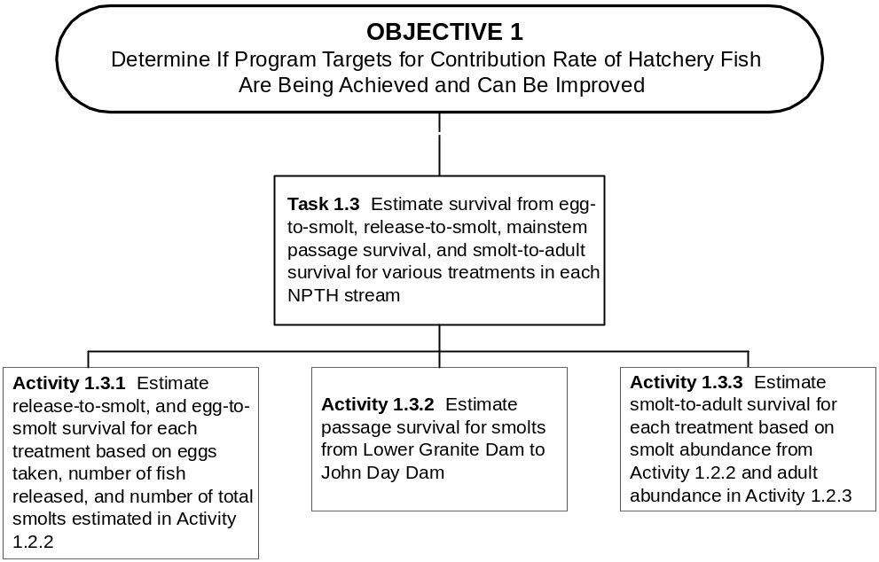

Figure 4. Step-down diagram of activities for Task 1.3.
Activity 1.3.1 Estimate release-to-smolt, and egg-to-smolt survival for each treatment based on eggs taken, number of fish released, and number of total smolts estimated in Activity 1.2.2.

One important premise of the NATURES approach to rearing juvenile chinook is that post-release survival will increase compared to that for conventionally-reared hatchery fish. Most of the difference in survival between NATURES and conventional juveniles is likely to occur within the treatment streams where current, depth and substrate vary dramatically along the stream length. Therefore, a working hypothesis is that NATURES-reared fish will exhibit higher post-release survival to Lower Granite Dam than conventionally-reared fish. Ideally, survival comparisons would be made on adult returns, however production capacity limits the ability to produce paired conventional and NATURES release groups of sufficient size to determine statistically significant return rates.

Survival of juveniles to Lower Granite Dam will be estimated from the total number of PIT-tagged fish estimated to arrive at Lower Granite Dam (subactivity 1.2.2.3) and the number of PIT-tagged fish released. Survival from egg-to-smolt can also be calculated from the number of eggs used to produce the juveniles that were released. Survivals will be estimated separately for each treatment group, so treatment effects on survival can be compared.

The primary test of the working hypothesis will be determined by the rearing and release of small lots of conventionally raised fish along with the NPTH NATURES production. Facilities to rear small numbers of chinook salmon in a conventional manner at the 1705 facility will be constructed. Approximately 30,000 spring chinook salmon would be reared in a conventional manner. NPTH conventional production for research purposes would utilize the same brood source as general NPTH production. Conventional rearing conditions would be developed that resemble conditions at CAFH and DNFH. Rearing densities, and rearing containers would be similar.

Replicated groups of 2,000 presmolts or 3,000 parr will be produced and PIT tagged to compare post-release survival to stream mouths and through the mainstem dams (Lower Granite and McNary dams). Replication will primarily be across years. Limited replication within years will be included in Lolo Creek (two replicates) and Meadow Creek (three replicates). Lolo Creek and Newsome Creek presmolt releases will incorporate test groups of NPTH NATURES acclimated vs acclimated conventional as well as NPTH NATURES acclimated vs conventional direct stream release. Meadow Creek would only test NPTH NATURES direct stream vs conventional direct stream release. Survival will be determined as in subactivity 1.2.2.3.

A secondary test of the working hypothesis will be a comparison of juvenile survival (mainstem dams) for Newsome Creek NPTH presmolt releases and Red River Idaho Salmon Supplementation presmolt releases. Conventionally-reared spring chinook salmon will be reared in the Clearwater Anadromous Hatchery and released in Red River. Size of fish and release times will not be coordinated between streams, but will reflect typical practices. Each replicate group will include 2,000 PIT-tagged presmolts. The number of replicates will be determined by space availability.

Arrangements will be made to release PIT-tagged fall chinook salmon groups from conventional hatcheries at similar times, sizes, and locations to several of the NPTH treatment groups. Conventionally-reared fall chinook salmon will be obtained from Lyons Ferry Hatchery. Numbers of PIT-tagged fish representing conventional hatcheries should be about 1.5 times greater than recommended for NPTH fish (Subactivity 1.2.1.2), because NPTH fish are expected to survive at a greater rate. Thus, groups of 3,000 PIT-tagged fish will be released from conventional hatcheries, and groups of 2,000 PIT-tagged fish will be released with NPTH treatment groups. Replication of these comparisons will be achieved by repeating the experiment for 3-5 years, but may also be achieved by replicate releases in the same year if rearing space permits.

Product: (1) Estimated mean difference in survival to LGR between NATURES and conventionally reared juvenile chinook salmon.
(2) Estimated mean difference in survival to LGR between acclimated and direct released juveniles that are conventionally reared.
(3) Estimated egg-to-smolt and release -to-smolt survival for each treatment group.

Activity 1.3.2 Estimate passage survival for smolts from Lower Granite Dam to John Day Dam.

Passage survival of smolts through the mainstem Snake and Columbia rivers may vary independently of NPTH treatments, so this parameter will be estimated in order to account for its effects on adult returns. Passage survival will be estimated by PIT tag detections from LGR to John Day Dam (JDD). These are the two most distant dams from one another for which PIT tag detection probabilities can be estimated. Detection probabilities at LGR can be estimated from follow-up interrogations at numerous dams downstream, and detection probabilities at JDD can be estimated from follow-up detections at Bonneville Dam and in the estuary. Methods described by Cramer (1996a and 1996b) can be used to estimate those detection probabilities from the combination of all PIT-tagged chinook salmon from the Snake River. Weekly detections of NPTH fish passing LGR and JDD can be expanded to full passage estimates by applying the weekly estimates of detection probability at those dams. Survival will be estimated as the number of fish reaching JDD divided by the number that passed LGR.

In the impounded Snake and Columbia rivers, juveniles migrate through deep open water so hatchery experience may have less effect during passage through the mainstems than through treatment streams. Nevertheless, it will be important to test for the possibility that NATURES-reared juveniles survive differently than conventionally-reared juveniles. Separate estimates of passage survival will be calculated for each treatment group, because passage survival may vary with passage timing. Passage survival from NPTH treatment groups will then be compared to same set of reference groups described in the previous subactivity. It would also be desirable to compare the early-fall and fall chinook salmon from NPTH to those released as subyearlings from Lyons Ferry Hatchery. Lyons Ferry Hatchery releases most fall chinook salmon as yearling smolts (in recent years only to increase returning adults), but it may be possible to secure a small number of fish for experimental release as subyearling smolts. Replication will be achieved across years.
Product: (1) Estimated mean survival during mainstem passage from LGR to JDD for each treatment group.
(2) Estimated mean difference in mainstem passage survival (LGR to JDD) between NATURES and conventionally reared juvenile chinook salmon.

Activity 1.3.3 Estimate smolt-to-adult survival for each treatment based on smolt abundance from Activity 1.2.2 and adult abundance in Activity 1.2.3.

Smolt-to-adult survival is strongly influenced by factors that are independent of supplementation practices, so estimates of this parameter are needed to understand how extraneous factors, such as variation in ocean survival or variation in mainstem passage survival may have influenced the number of surviving adults. The most reliable estimator of smolt-to-adult survival will be the virtual population at age 2 (subactivity 1.2.3.4) divided by the estimated number of smolts passing LGR (subactivity 1.2.2.3). The number of surviving adults can be expressed in a variety of forms including the number of adults reaching the Clearwater River, total catch plus spawner escapement, or virtual population at age 2. Each of these abundance estimates requires that the age of adult fish be determined wherever they are recovered, so that fish of each age can be assigned to the proper brood. For hatchery fish, the CWT’s will reveal their brood year. We recommend that virtual population at age 2 be used as the best index of adult production, because inter-annual variation in age at maturity or catch will alter the number of years that natural mortality can deplete adult numbers which finally get counted. Population estimates at age 2 provide weighted measures that account for mortality that is known to occur. The most reliable estimate of smolt abundance will be for numbers arriving at Lower Granite Dam in the case of spring chinook salmon (released as parr and presmolts), and numbers released in the case of early-fall and fall chinook salmon (released as subyearling smolts).

Product: Estimates of smolt-to-age 2 adult survival for each treatment group

Task 1.4 Determine the effects of rearing and release treatments on the dispersal of juveniles and returning adults to occupy available habitat in the target streams.

A key assumption for designing the numbers of fish to be released from NPTH into treatment streams is that fish will disperse after release to evenly fill the available high quality habitat for chinook salmon. However, the available habitat is spread over hundreds of miles of stream, and the methods for stocking fish so that they disperse to all of this habitat is uncertain. Dispersal rates are likely to differ between fish released as parr compared to those released as presmolts. Fish released as smolts (fall and early-fall chinook) are expected to migrate following release. In order to assess the dispersal of parr following release, the density distribution of juvenile chinook salmon will be surveyed in Meadow Creek (the only location of parr releases), and experiments with fish uniquely marked for different locations of release will be performed in Meadow Creek. Additionally, movements of juveniles will be detected at screw traps, and dispersal of adults upon return will be assessed through spawning surveys. These pieces of information comprise four activities under this task (Figure 5).
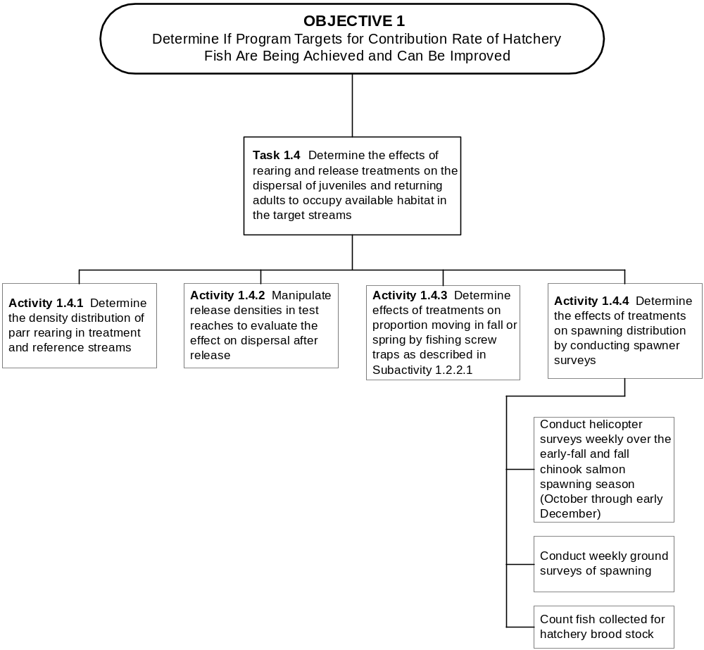

Figure 5. Step-down diagram of activities for Task 1.4.
Activity 1.4.1 Determine the density distribution of parr rearing in treatment streams.

It is likely that the rearing density of hatchery spring chinook salmon will not be evenly distributed in the treatment stream where parr are released, but rather will be most concentrated in the areas of release. On the other hand, juvenile early-fall and fall chinook salmon are expected to migrate upon release. The rearing density of juvenile spring chinook salmon over the length of a treatment stream will be assessed through snorkel surveys, as described for Subactivity 2.1.3.2. This activity will only apply to Meadow Creek, because that is the only treatment that involves release of parr. Snorkelers will not be able to distinguish hatchery from natural chinook salmon, so the density of hatchery fish will be assessed from the relative density of chinook salmon in the vicinity of release sites, and from the hatchery:natural composition of chinook salmon catches in seining samples described for Subactivity 2.3.1.1.

Product: Density distribution in Meadow Creek of hatchery chinook salmon after their release as parr.

Activity 1.4.2 Manipulate release densities in test reaches to evaluate the effect on dispersal after release.

In Meadow Creek, special experiments will be performed to evaluate dispersal of chinook salmon from specific release sites. These experiments will be performed simultaneously with those described for Activity 2.5.1. That activity calls for parr releases in three stream sections 500 m long and separated by at least 500 m, with the releases to be 200%, 100% and 20% of capacity in the three sections, as estimated by the Power Planning Council’s Smolt Density Model. Under the activity described here, follow-up seining will be performed at 10 sites per mile for 1 mile above the uppermost release site and 4 miles below it. This effort will be repeated one week after stocking, and again 6 weeks after stocking. All fish captured will be scanned for CWT’s and carefully examined for panjet marks. The proportion that fish from each release site composed of the catch at each seining site will be determined. Because seine catches may not be an accurate reflection of fish densities in an area, the proportion that each release group composed of the catch within 500 m reaches will be multiplied by the average density of chinook salmon in the reach, as determined by snorkel surveys. This calculation will give an estimate of density from each release group in each of sixteen 500 m sections. Before densities are compared between reaches, they will be standardized to the expected density at full seeding, given the habitat features in that reach (see Activity 2.2.1). Regression analysis will be used to test whether there is a decreasing standardized density of hatchery fish with distance away from the release point, and if so, what that rate is relative to distance.

Product: (1) Total and standardized densities of hatchery and natural parr in 16 reaches of 500 m.
(2) Change in density distribution of hatchery parr between 1 and 6 weeks after release in Meadow Creek
(3) Correlation of standardized density for hatchery parr per 500 m reach to distance from stocking location

Activity 1.4.3 Determine effects of treatments on proportion moving in fall or spring by fishing screw traps as described in Subactivity 1.2.2.1.

The proportion of each treatment that emigrates as either fall presmolts or spring smolts from Lolo, Newsome or Meadow creeks will be determined from recoveries of CWT and PIT tagged fish in the screw traps on those streams. Actual captures of these fish will be expanded by the estimated trap efficiency at time of capture, so that total passage of marked groups is estimated for each the fall and the spring. The ratio of fall to spring migration will be estimated for each treatment in each stream, and variation in the ratio between treatments will be analyzed first for whether the ratio is consistent, and second for any factors of the treatment or environment that might correlate to differences in the ratio.

Two traps will be operated in Lolo Creek, one at km 41 and the other at km1, so the percentage of fish overwintering between the traps can be estimated. The upper trap will be operated through the fall, and fish PIT tagged there (up to 4,000) may be detected as they pass the lower trap either that fall or the next spring. Total passage in the fall will be estimated from expansion of trap catches, so the remainder that are not estimated to have passed the lower trap in the fall will be assumed to have overwintered between the two traps.

Product: (1) Ratio of fall passage to spring passage in each stream with a rotary screw trap
(2) Multiple regression on fish densities and environmental variables that may account for inter annual variation in the fall:spring passage ratio
(3) Difference in fall presmolt passage at the upper and lower traps in Lolo Creek.

Activity 1.4.4 Determine the effects of treatments on spawning distribution by conducting spawner surveys.

In order for supplementation to achieve the intent of filling available habitat for natural production, spawning of hatchery fish should be dispersed throughout the available habitat. This desired result may be difficult to achieve, because access points for stocking the treatment streams are limited. Recoveries of CWT’s from spawning surveys will be used to characterize the density distribution of spawners from each treatment in each stream. Differences between treatments, streams and years in the dispersal of spawners, relative to the release locations, will be examined for possible correlations to factors of the treatment or the environment.

Spawning will be surveyed over the entire area of suitable habitat, and surveys will be repeated at least three times (about 1 week apart) during the typical spawning period. Reaches where fish choose to spawn may be related to time of spawning, temperature, substrate size, etc. with later maturing fish tending to spawn further downstream. If spawning is not well dispersed, possible causes will be investigated. These will include location and method of stocking, weir impact, stream temperatures at time of spawning, and gravel quality. If spawners are keying in to areas where temperatures are desirable at the time of their spawning, we may find that the inherited time of spawning from the founding population determines the stream reach that will have suitable temperatures at the time of spawning. In order to detect these effects survey areas will be subdivided to look at redds/km within survey sections over time.

Subactivity1.4.4.1 Conduct helicopter surveys weekly over the early-fall and fall chinook salmon spawning season (October through early December). In the Clearwater mainstem from the mouth up to the Lochsa Ranger Station on the Lochsa River, aerial surveys by helicopter will be used to count early-fall and fall chinook salmon redds weekly. Flights will be made at about 200' above the water, and the observers will count the number of new redds, live fish and carcasses. Each redd is marked on a map. Aerial redd count surveys are conducted in cooperation with state and federal agencies so that duplication of effort is eliminated.

In order to distinguish the proportions of hatchery and natural fish constructing the redds that are counted, examination of carcasses on the ground is necessary. Carcasses sighted from the air are identified as to location and retrieved later if possible with the use of jet or drift boats. Retrieved carcasses will be measured (hypural length), examined for marks and tags, scale sampled, examined for percentage spawned, and cut in half to avoid re-counting. Measurements and samples taken here will provide data on hatchery/natural composition, brood year composition, percent spawned, age and size at ocean entry, disease incidence and gene frequencies. Recoveries of CWT’s from these carcasses will be especially important to distinguish contributions of NPTH fish from those of ongoing releases of Lyons Ferry Hatchery fall chinook salmon in the mainstem near the mouth of Big Canyon Creek.

Product: (1) Total redds and estimated number of spawners in each reach surveyed
(2) Time frequency distribution of redd construction in each reach surveyed.

Subactivity 1.4.4.2 Conduct weekly ground surveys of spawning. Redds and carcasses will be counted from foot or boat surveys in spawning areas from late July to mid-September for spring chinook salmon and from early October through mid-November for early-fall chinook salmon. Streams to be surveyed include all treatment and reference streams, as listed in Table 6. Ground surveys in the mainstem Clearwater River and Lochsa River will only be opportunistic to recover carcasses observed during aerial counts, as described in the previous subactivity. New redds will be marked and counted, live fish counted, and carcasses will be recovered and processed. Redds will be marked with flagging that records date, identification number, and is color-coded for each survey period. Marking redd locations with flags (colored washers or rocks in large streams) and recording notes on each redd has been beneficial in areas where multiple redds occurred. Processing of carcasses will include measurement of hypural length, examination for marks and tags, scale sampling, examination for percentage spawned, jaw tagging, and return to the flowing river. Recovery of jaw-tagged carcasses on subsequent surveys will be used for mark-recapture estimates of spawner abundance.

Product: (1) Percentage of total redds contained in discrete stream sections.
(2) Time-frequency distribution of redds within each stream section.

Subactivity 1.4.4.3 Count fish collected for hatchery brood stock. Hatchery adults collected at weirs or by other methods for hatchery broodstock must also be accounted for. Accordingly, all fish collected for hatchery broodstock by any method will be measured (hypural length), examined for marks and tags, and scale sampled. Numbers of fish entering hatchery ladders will be counted at least weekly and tagged so that time of entry can be compared quantitatively between years, and possible treatments for time of return can be evaluated.

Product: (1) Time-frequency distribution of arrival at brood collection points.
(2) Counts of hatchery chinook salmon, by age, taken for brood stock.

Task 1.5 Estimate the continuing stocking rates needed in each stream to sustain natural production.

A primary strategy of the NPTH program is to allow building of natural production to the stream’s capacity by constraining stocking levels to no more fish than needed to fill the capacity that natural fish are not using. To achieve this balancing of hatchery and natural production requires information feedback each year on where and how much the naturally-produced fish are filling the habitat. Production of fish in the hatchery begins with the taking of broodstock, so decisions on production levels must be made at least the summer before there is any data on the actual density distribution of juvenile rearing in the season that stocking will occur. Two activities will be completed to satisfy these planning needs (Figure 6).

Table 5. Stream sections to be surveyed for chinook salmon redds and carcasses for NPTH M&E and the ISS Program. Some survey years included a reduction or increase in effort depending on flow conditions and run strength. Adapted from Walters et al. (1999). Streams in bold are surveyed under the NPTH M&E program.

 | Downstream | Upstream
Stream | Boundary | Boundary | km
Clearwater River | Mouth | Selway River | 157.0
North Fork Clearwater R. | Mouth | Dworshak Dam | 3.5
Lochsa River | Mouth | Boulder Creek | 42.0
Lolo Cr. | Bradford Bridge | Yoosa Creek | 16.7
Yoosa Cr. | Mouth | Camp Creek | 4.4
Eldorado Cr. | Mouth | Snow Creek | 3.5
Meadow Cr. (Selway) | Mouth | Headwaters 4 mile Creek | 68.0
Lower Selway R. | Mouth | Meadow Creek | 31.0
S.Fk. Clearwater R. | Mouth | Harpster | 21.0
Newsome Cr. | Mouth | Mule Creek (2.2 km above town of Newsome) | 15.1
Crooked R. | Mouth | West Fork Crooked River confluence | 20.9
American R. | Mouth | long meadow above Limber Luke Cr. | 34.6
Red R.^{b} | Mouth | headwaters near Shissler Creek | 43.0
Clear Cr. | Mouth | end of road, 16.1 km upstream of mouth | 16.1
White Cap Cr. | Mouth | migration barrier | 19.8
Pete King Cr. | Mouth | end of Forest Service Road No. 453 | 8.0
Squaw Cr. | Mouth | confluence of E. Fk. and W. Fk. Squaw Cr. | 6.0
Papoose Cr. | Mouth | confluence of E. Fk. and W. Fk. Papoose Cr. | 3.0
Colt Killed Cr. | Big Flat Cr. | Garnet Creek | 11.5
Big Flat Cr. | Mouth | 8.3 km upstream from mouth | 8.0
Crooked Fork Cr.^{d} | Mouth | just above Hopeful Creek | 29.5
Brushy Fork Cr.^{e} | Mouth | migration barrier above Spruce Creek | 21.5
^{b} Includes South Fork Red River from the mouth to Trapper Creek. Only 23.6 km of stream sampled in 1991.
^{d} Includes Hopeful Creek.
^{e} Includes Spruce Creek.

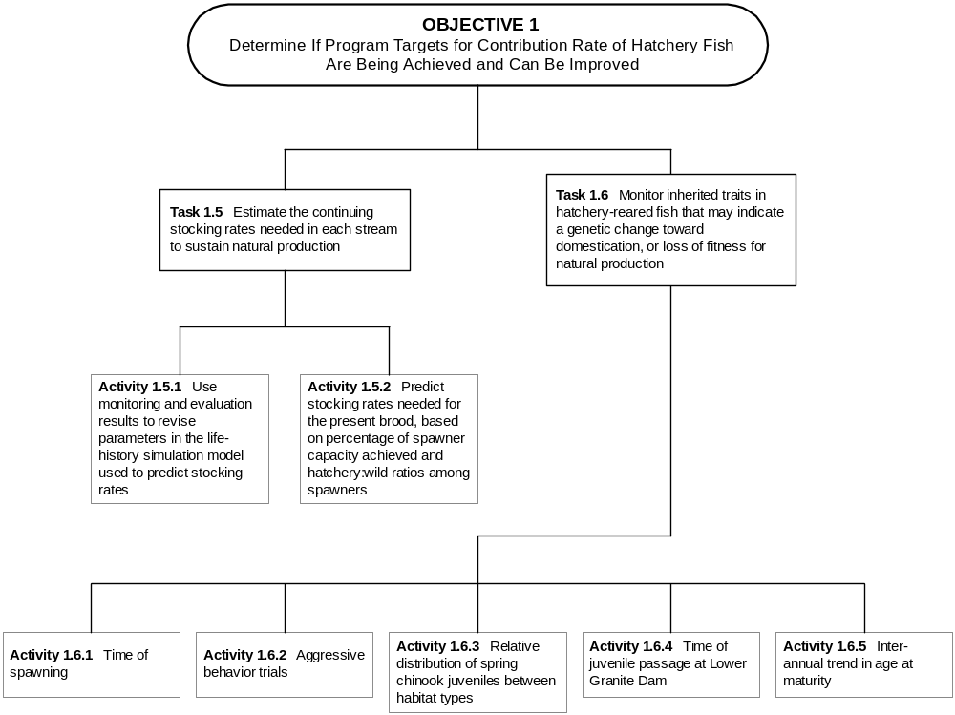

Figure 6. Step-down diagram of activities for Task 1.5 and 1.6.
Activity 1.5.1 Use monitoring and evaluation results to revise parameters in the life-history simulation model used to predict stocking rates.

Initial plans for stocking rates in the Clearwater River subbasin were based on a set of assumptions regarding survival rates and carrying capacity. Those assumptions need to be updated as we gain new information on observed survival rates, carrying capacity, and fish dispersal into the available habitat (including mainstem areas). This activity simply identifies the analysis exercise of synthesizing the new information gained on these model parameters, and updating the model to reflect our more accurate understanding of reality. Some of the parameters assumed in the model are as listed below. Currently an assumption of constant and equal over-winter ocean survival is used for all groups of salmon and across years. This method is constant with the assumptions used by the Pacific Salmon Commission for management of ocean harvest. It would be desirable to have direct measurements of over-winter survival for individual stocks of fish and between different ages groups. This activity is beyond the scope of this M&E program, but is recommended as an area of needed study on a regional level. An estimate of in-ocean over-winter survival is necessary, but using an assumed value can be a source of significant error/uncertainty. The combined effect of these parameters is that predicted return/smolt to hatchery averages between 0.2-0.25%, similar to that experienced at Rapid River and Dworshak (CIS 1992).

Parameter Spring Chinook Fall Chinook
Smolt-to-Age 2 Survival = 6.0% 0.80%
Upstream Adult Survival = 66.0% 66.0%
Prespawning Adult Survival = 90.0% 90.0%
Parr-to-Presmolt Survival = 72.0% NA
Post Release Survival = 65.0% 50.0%
Presmolt-to-Smolt Survival = 30.0% NA
Lolo Ck Parr Capacity = 234,989 NA
Newsome Ck Parr Capacity = 71,367 NA
Mill Ck Parr Capacity = 40,000 NA
Boulder Ck Parr Capacity = 98,889 NA
Warm Spr Ck Parr Capacity = 25,303 NA
Meadow Ck Parr Capacity = 497,182 NA

Fall and Early-Fall Spawner Capacity
Lower Selway 400
South Fork Clearwater 850
Lower Clearwater 10000
Clearwater above North Fork 1000
Middle Fork Clearwater 500
Clearwater-Lochsa 325

Spring Chinook Salmon
 | Maturity | Harvest Rates |  |  | Spawner | Ocean
 | Rate | Ocean | River | %Females | Survival
Age 2 | 1% | 0% | 10% | 0% | 60%
Age 3 | 5% | 0% | 10% | 0% | 70%
Age 4 | 70% | 1% | 10% | 60% | 80%
Age 5 | 100% | 1% | 10% | 60% | 90%

Fall Chinook Salmon
 | Maturity | Harvest Rates |  |  | Spawner | Ocean
 | Rate | Ocean | River | %Females | Survival
Age 2 | 9% | 2% | 0% | 0% | 60%
Age 3 | 19% | 14% | 13% | 27% | 70%
Age 4 | 68% | 34% | 24% | 60% | 80%
Age 5 | 100% | 34% | 13% | 60% | 90%

Many of these parameters will be estimated directly for NPTH chinook salmon from actual sampling data collected through the M&E program. For example, all of the survival rates in freshwater will be estimated through the M&E program. Additionally, the carrying capacity for parr can be estimated in Task 2.6. Maturity and harvest rates will be estimated through the same cohort analysis from which the virtual population at age 2 is estimated. Thus, most of the assumed parameters can be replaced with direct estimates for NPTH chinook salmon as they are completed. This will be done as new data become available, and parameter estimates will be taken as the average across years that replicate estimates are completed.

Product: Revised parameters in the life-history simulation model.

Activity 1.5.2 Predict stocking rates needed for the present brood, based on percentage of spawner capacity achieved and hatchery:wild ratios among spawners.

In order to stock streams only to their carrying capacity, the number of fish released must be adjusted as the number of naturally-produced chinook salmon changes. Further, stocking rates must meet multiple criteria that require advance prediction of hatchery and wild fish abundance. In order to meet these criteria and others, known data will be input along with assumed parameters into the supplementation simulation model to predict appropriate stocking rates for the next season.

Because the actual number of parr required to fill out the vacant carrying capacity is not known at the time that broodstock are taken, the number of naturally produced parr that will be present must be predicted at the time of brood collection (a year in advance of actual capacity estimates). Abundance of natural parr for the next fall will be predicted from the abundance of spawners this fall. On streams with weirs, numbers of returning adults can be counted and hatchery:natural ratios determined well in advance of the spawning season. In streams without weirs, natural spawner abundance and the number of parr they will produce will be predicted from numbers of redds counted.
Product: Updated simulations predicting appropriate stocking rates each year in each treatment stream.

Task 1.6 Monitor inherited traits in hatchery-reared fish and population characteristics that may indicate a genetic change toward domestication, or loss of fitness for natural production.

Direct measurement of fitness is not possible. As a result, monitoring of multiple secondary parameters of fitness, at both a population and individual scale, is undertaken to provide a comparison between hatchery and wild fish (Figure 6). Monitoring of fecundity and egg size is monitored under Task 1.1. Measurement of the variance in fecundity and egg size between individual fish of different age and size groups will be maintained. Juvenile emigration timing (Tasks 1.4 and 2.3), age-at-return, sex ratio, and timing and location of spawning of both the hatchery brood and fish in the streams will be tracked at the population (stream) level. Genetic stock structure in relation to fitness is monitored under Task 3.1. In all cases, a change in individual fitness-related parameters does not directly indicate a decrease in fitness. However, monitoring of multiple indices and their overall relation to population dynamics (near and long term) does provide useful insight to the overall operations and impact of the production program. The effects of hatchery practices (release location and timing, product quality, etc) and current environmental conditions will be linked to fitness evaluations. Indices will be monitored annually.

Activity 1.6.1 Time of spawning.

Heritability of time of spawning is thought to be high, and divergence under selection can occur within 2-3 generations. Time of spawning for chinook salmon is strongly influenced by inheritance, so any inter-generational change in spawning time is likely to reflect a genetic change. Spawning time at hatcheries will be monitored as the dates of 20%, median, and 80% of spawning completion for the number of females spawned. Any long-term changes will also be compared to reference populations in the Snake River basin to confirm that observed trends are an effect of NPTH.

Product: Annual values for the dates of 20%, median, and 80% of all females spawned.

Activity 1.6.2 Aggressive behavior trials.

Holtby et al. (1993) cited a number of studies that found differences in aggressive behavior between hatchery and wild juveniles, and they urged that protocols be developed for the measurement of aggressiveness. They went on to describe tests on juvenile coho with mirror image stimulation (MIS), and found that scores for behaviors during MIS trials were highly correlated with results from paired fish dominance tests. Later, Berejikian et al. (1996) used MIS trials to demonstrate that hatchery steelhead fry were more aggressive than their wild counterparts, even when both were reared in a common environment. Berejikian et al. (1996) concluded from these differences that six to seven generations of propagation in a hatchery had genetically altered the steelhead such that fry were consistently more aggressive than fry from the natural population. Further, Berejikian (1995) found that steelhead fry from the same hatchery population were less able to survive predation than their wild counterparts in trials with prickly sculpin (Cottus asper). This example indicates that MIS trials may be a useful tool for assessing NATURES rearing benefits on domestication selection as expressed by aggressive behavior. Inheritance of aggressive behavior has been demonstrated among coho (Rosenau and McPhail 1987), and chinook salmon (Taylor 1988), albeit at very low levels.

Spring and fall chinook salmon reared at each NPTH facility will be tested for changes in aggressive behavior over time by subjecting 50 fry from each rearing strategy (semi-natural, NATURES components, conventional, hatchery best management practices) to standardized trials of Mirror Image Stimulation (MIS) each year. Individual fry will be tested in an aquarium in which a mirror will be placed on one side, and responses to the fish’s own image in the mirror will be recorded for a set trial time (3 minutes). Three types of behavior will be measured (1) swim against mirror, (2) lateral display, and (3) wigwag (behaviors defined by Holtby et al. 1993). The dependent variable will be the duration of each behavior during the three minute trial. Methods will be as described by Berejikian et al. (1996).

Product: (1)Annual mean and variance for scores in with mirror image stimulation trials.
(2) Comparison of aggressive behavior between semi-natural, NATURES components, conventional, hatchery best management practices rearing.

Activity 1.6.3 Relative distribution of spring chinook juveniles between habitat types.

Snorkeling will provide information on habitat use by juvenile chinook salmon in Meadow Creek, the only stream where parr will be stocked. We expect with multiple regression to find a set of variables that account for most of the observed variation in division of habitat use (i.e. the variables that control habitat preference). These relationships can be monitored over time to detect any change in preferences that might be associated with inherited behaviors. Any changes in treatment streams will be compared to reference streams to confirm that the effect resulted from NPTH.

Product: Annual mean values of relative densities dispersed between pools, riffles, pocket water, and runs.

Activity 1.6.4 Time of juvenile passage at Lower Granite Dam.

The PIT tag monitoring performed each year with each treatment group will provide an opportunity to evaluate whether there are inter-generational changes in the time that juveniles pass dams in the Snake and Columbia rivers. Such changes could reflect genetic change, if no change is observed among other Snake River populations.

Product: Annual values for the dates of 20%, median, and 80% of juvenile passage at detector dams in the Snake and Columbia rivers.

Activity 1.6.5 Inter-annual trend in age at maturity.

Heritability of age at maturity is relatively high in chinook salmon, and may reflect changes resulting from domestication or artificial selection. Age at maturity is strongly influenced by inheritance among chinook salmon, so this trait can be used as one indicator of long-term genetic change from domestication selection. The simple percentage of fish arriving at spawning areas is influenced by harvest rates, so the test statistic for changes needs to be the age-specific maturity rate. That rate is the percentage of fish alive at that age that mature at that age, and the rate is estimated through cohort analysis. Cohort analyses will be accomplished for each brood of hatchery fish, as described under Activity 1.2.3. Again, any changes observed in the treatment groups would be compared against trends found in reference groups from other Snake River chinook salmon populations to determine the likelihood that the change is genetic.

Product: Estimates of age and sex-specific maturity rates for each race, and possibly each treatment stream (if CWT recovery rates are sufficient). These rates will be estimated for each brood.

Objective 2. Determine the increases in natural production that results from supplementation of chinook salmon in the Clearwater River subbasin, and relate them to limiting factors.

One of the primary benefits to be derived from NPTH is the restoring of full natural production of chinook salmon to the treatment streams. Sampling under this objective is intended to measure those benefits and refine our understanding of carrying capacity and other factors that limit program success. Sampling under this objective is designed to resolve the following management questions:

- Can self-sustaining natural populations be established from hatchery fish?

- Can we determine how to adjust supplementation rates as natural populations rebuild?

Task 2.1 Determine where, when and how much natural production is occurring in target and reference streams .

A major premise for constructing NPTH is that habitat for chinook salmon is abundant, but nearly vacant in the Clearwater River subbasin. Further, it is assumed that stocked hatchery fish of Snake River ancestry will seek out and fill up this habitat, and reproduce naturally. However, the available habitat is spread over hundreds of miles of stream, and the methods for stocking fish so that they disperse to all of this habitat is uncertain. There may also be environmental factors that will result in more fish being produced from one portion of a stream than another. Studies of anadromous salmonid rearing in well seeded streams indicate that habitat use by fish is patchy (Hankin and Reeves 1986), and that juveniles use different habitats as they grow and as stream temperatures change. Sampling under this task comprises five activities (Figure 7) and is intended to determine how evenly the production of wild chinook salmon is spread throughout the available habitat, and how that distribution changes with time and life stage of fish using the stream within a given year. Additionally, this sampling will monitor the changes in natural production of parr, smolts and adults across years.
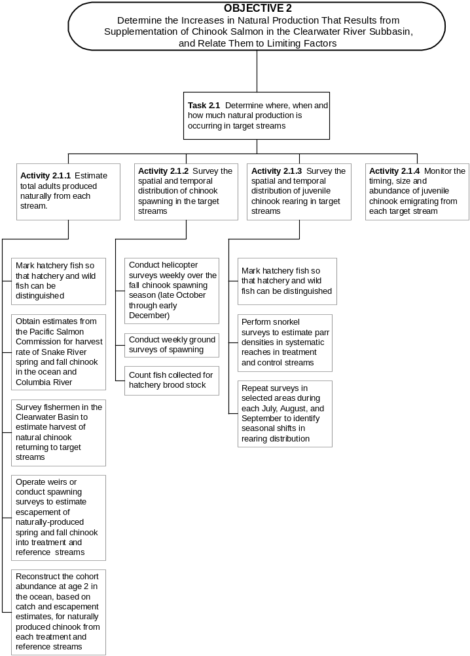

Figure 7. Step-down diagram of activities for Task 2.1.
Activity 2.1.1 Estimate total adults produced naturally from each stream.

Methods for estimating adult returns will vary by stream, as described by subactivity.

Subactivity 2.1.1.1 Mark hatchery fish so that hatchery and wild fish can be distinguished. Marking of hatchery fish was also listed under Activity 1.2.1, and is listed here again to emphasize that marking of hatchery fish is needed for broodstock management and to estimate abundance of natural fish as well as hatchery fish. It is, in fact, the need to accurately estimate wild fish that creates the greatest justification for marking all hatchery fish. Hatchery fish may easily become numerically dominant under some situations within the treatment streams, so a small proportion of unmarked hatchery fish could greatly confound the estimation of contributions to catch and spawner escapement by natural fish. All methods for estimating abundance naturally produced fish also depend on the ability to distinguish natural and hatchery fish. Accordingly, all hatchery fish will be marked with coded-wire tags (CWT’s), but not adipose fin-clipped, so a wand detector can be used to distinguish them from wild fish.

Subactivity 2.1.1.2 Obtain estimates from the Pacific States Marine Fisheries Commission for harvest rate of Snake River spring and fall chinook salmon in the ocean and Columbia River. (Same as Subactivity 1.2.3.1)

Subactivity 2.1.1.3 Survey fishermen in the Clearwater River Subbasin to estimate harvest of natural chinook salmon returning to target streams. (Same as Subactivity 1.2.3.2).

Subactivity 2.1.1.4 Operate weirs or conduct spawning surveys to estimate escapement of naturally-produced spring and fall chinook salmon into treatment and reference streams. (Same as Subactivity 1.2.3.3).

Subactivity 2.1.1.5 Reconstruct the cohort abundance at age 2 in the ocean, based on catch and escapement estimates, for naturally-produced chinook salmon from each treatment and reference stream. (Same as Subactivity 1.2.3.4).

Activity 2.1.2 Survey the spatial and temporal distribution of chinook salmon spawning in the target streams.

We need to determine how well the spawners are dispersing throughout the available spawning habitat. Spawning surveys to detect dispersal of hatchery fish were described under Activity 1.4.4, and the sampling under that activity is the same as required to detect dispersal of natural spawners under this activity. A full description of the sampling is not repeated here, but a summary of each subactivity is given as a reminder of the sampling that is planned.

Subactivity 2.1.2.1 Conduct helicopter surveys weekly over the early-fall and fall chinook salmon spawning season (October through early December). These surveys will cover the Clearwater mainstem from the mouth up to the Lochsa Ranger Station on the Lochsa River, the lower Selwary River up to Selway Falls, and the lower South Fork Clearwater River.
Product: (1) Total redds and estimated number of spawners in each reach surveyed
(2) Time frequency distribution of redd construction by reach surveyed.
Subactivity 2.1.2.2 Conduct weekly ground surveys of spawning. Redds and carcasses will be counted from foot or boat surveys in spawning areas from late July to mid-September for spring chinook salmon and from early October through mid-November for early-fall chinook salmon. Streams to be surveyed include all treatment and reference streams, as listed in Table 5. Ground surveys in the mainstem Clearwater River and Lochsa River will only be opportunistic to recover carcasses observed during aerial counts, as described in the previous subactivity.

Product: (1) Percentage of total redds contained in discrete stream sections.
(2) Time-frequency distribution of redds within each stream section.

Subactivity 2.1.2.3 Count fish collected for hatchery brood stock. Natural adults collected at weirs or by other methods for hatchery broodstock must also be accounted for. Accordingly, all fish collected for hatchery broodstock by any method will be measured (hypural length), examined for marks and tags, and scale sampled. Numbers of fish entering hatchery ladders will be counted at least weekly and tagged so that time of entry can be compared quantitatively between years, and possible treatments for time of return can be evaluated.

Product: (1) Time-frequency distribution of arrival at brood collection points.
(2) Counts of natural chinook, by age, taken for brood stock.

Activity 2.1.3 Survey the spatial and temporal distribution of juvenile chinook salmon rearing in target streams.

Subactivity 2.1.3.1 Mark hatchery fish so that hatchery and wild fish can be distinguished. All fish will be marked with CWT’s prior to release, but will not be adipose fin-clipped. These marks will only be detectable when fish are captured and examined with detection equipment.

Subactivity 2.1.3.2 Perform snorkel surveys to estimate parr densities in systematic reaches of treatment and reference streams for spring chinook salmon. Snorkeling counts will be the main sampling tool used to determine densities (an index of abundance) of natural salmonids by habitat type (ie. pool, riffle, pocket water and run). Marks on hatchery fish will not be visible underwater, so the percentage of juveniles that are hatchery fish in discrete stream reaches will be determined from fish that are captured during seining under Subactivities 2.3.1.1 and 3.2.1.1. Hatchery juveniles from presmolt releases are expected to be rare during snorkel surveys in treatment streams for spring chinook salmon, because juveniles will be released in October after snorkel surveys are complete. Densities of other fish species will also be determined during snorkel surveys. The purpose of these surveys is not to estimate total juvenile abundance, but rather to determine how rearing densities are dispersed throughout the habitat that supplementation treatments are intended to fill. Streams in the Clearwater River subbasin generally have high transparency that allows snorkeling to be an effective tool for counting fish that rear through a full summer, and recording their association with habitat features. Streams to be surveyed, including those covered by the ISS Program, are listed in Table 6. Snorkeling will be performed at least once in each stream during mid-July through mid-September of each year.

Table 6. Downstream and upstream boundaries of snorkel surveys to estimate parr densities, including streams surveyed by the ISS Program. Effort has been reduced to 2 - 6 transects per listed stream section following the general parr monitoring approach of IDFG.

Stream | Downstream Boundary | Upstream Boundary | Strata  Length (km)
Lolo Cr. | Campground upstream of N. Fk. Mud Cr. | mouth of Yoosa Creek | 20.6
Yoosa Cr. | Mouth | Camp Creek | 4.4
Eldorado Cr. | Mouth | Dollar Creek Bridge | 7.9
Newsome Cr. | Mouth | 1.9 km above the town of Newsome | 14.8
Crooked R. | Adult weir | headwaters including E. and W. Fks. Crooked R. | 30.2
American R. | Mouth | headwaters (above corrals) | 34.6
Red R. | Mouth | headwaters near Shissler Creek | 43.0
Clear Cr. | Weir at Kooskia National Fish Hatchery | 0.2 km above confluence with S. Fk. Clear Creek | 20.0
Meadow Cr.,Selway | Mouth | Four Mile Creek | 67.0
White Cap Cr. | Mouth | migratory barrier | 19.8
Pete King Cr. | 75 m above mouth | end of Forest Service Road No. 453 | 8.0
Boulder Cr. | Mouth | Boulder Creek Hot Springs | 8.0
Warm Springs Cr. | Mouth | Warm Springs Creek Falls | 7.0
Fish Cr.
Squaw Cr. | Mouth | confluence of E. Fk. and W. Fk. Squaw Cr. | 6.0
Papoose Cr. | Mouth | confluence of E. Fk. and W. Fk. Papoose Cr. | 3.0
Colt Killed Cr. | Mouth | House Rock"-5 km above confluence with Big Flat Cr. | 31.1
Big Flat Cr. | Mouth | 5 km above mouth | 5.0
Crooked Fork Cr. | Mouth | 1 km upstream of Hopeful Cr. | 29.5
Brushy Fork Cr. | Mouth | migratory barrier above Spruce Cr. | 21.5

Snorkeling will not be used as a standard monitoring method for juvenile early-fall and fall chinook salmon, because those fish are expected to emigrate as subyearlings. Variation in subyearling emigration timing between years due to temperature and flow differences would confound interpretation of differences in density between years.

Surveys will cover stream reaches that are systematically spread over the length of stream for which supplementation is to be matched to carrying capacity. The cumulative length of these reaches will compose at least 20% of the total stream length. Each survey reach will be composed of contiguous stream segment that includes a minimum of 10 pools, and 10 riffles. Each diver will count all salmonids, by species, in 2-inch length increments (usually starting at 2-4 inches) within the lane of his visibility range, which usually will extend 1.5- 3.0 m (5-10ft) on each of his sides [3 to 6 m (10 to 20 ft) total width per lane]. Chinook salmon will be identified as sub-yearlings, yearlings, or adults. Visibility width of each lane will be recorded, so that fish densities are calculated per area of actual observation. Water clarity at the time of each survey will be recorded as the number of feet at which a fellow diver is clearly visible. Visibility must be 5 ft or greater for divers to confidently distinguish fish species underwater.
Survey teams will consist of 3 to 5 members. One member will carry equipment and record data while the other 2-4 members snorkel in an upstream direction to minimize disturbance of fish before they are counted. Fish counts and physical parameters variables will be recorded separately for each habitat unit (i.e. pool, riffle, pocket water or run). Snorkelers will move slowly but steadily upstream in an assigned lane, with one lane along each shoreline. The number of snorkelers is dependent upon visibility and width of the stream. Water temperature must be at least 13º C before snorkeling, because the proportion of fish hiding in the substrate begins to increase at lower temperatures.

Product: (1) Annual estimates of parr/m² in pool, riffle, pocket water and run habitats, by reach, of each treatment and reference stream for spring chinook.
(2) Multiple regression or multi-variate model relating parr density to spawner abundance and habitat features in each stream.

Subactivity 2.1.3.3 Repeat surveys in selected areas during each July, August, and September to identify seasonal shifts in rearing distribution. Snorkel surveys will be repeated during each of three summer months in three of the study streams to determine if there are major shifts in rearing distribution that might be overlooked by sampling on a single date in the mid summer. Mid summer sampling is intended to reveal fish habitat use during the summer low flow period, but we want to be sure that fish are not substantially shifting their habitat use within the summer. This task is not intended to document the typical movement to winter habitat that occurs in the fall, but rather to detect adjustments in habitat use during summer that might result from decreasing flow, increasing temperature, or increasing competition for space. If such shifts occur, they may influence the estimate of stream carrying capacity for summer rearing.

Product: Estimate of change in parr/m² between July, August, and September in pool, riffle, pocket water and run habitats, by reach, of each treatment and reference stream for spring chinook.

Activity 2.1.4 Monitor the timing, size and abundance of juvenile chinook salmon emigrating from each target stream.

Rotary screw traps will be fished to monitor emigration of juvenile spring chinook salmon from Meadow Creek (Selway), Newsome Creek and Lolo Creek, as described in subactivity 1.2.2.1. Juvenile chinook salmon captured in the traps will be anesthetized, scanned for tags, and natural fish over 60 mm may be PIT tagged as described by Prentice et al. (1990). Length, weight and fish condition will be recorded for all PIT tagged fish. Scales (subsample) will be collected and used to determine the age of emigrating fish. PIT tagged fish will be placed in a recovery bucket for a short time (30 - 60 minutes) and released back into the river.
Product: (1) Population estimates and 95% confidence intervals of juvenile chinook salmon passing the trap as parr (June 1 - August 31), presmolts (September 1 - December 31), and smolts and fry (January 1 - May 31).
(2) Time-frequency distribution of passage for each life stage.
(3) Mean and 95% confidence interval of mean length for each life stage or date.

Task 2.2 Determine the relationship of habitat features to varying levels of use by each race of chinook salmon .

Under this Task, we attempt to identify the physical features of stream habitat that limit the number of fish that will use it (Figure 8). Estimation of stream carrying capacity, which was used to determine stocking rates, was based on the Power Planning Council’s Smolt Density Model (SDM). That model assigned ratings of habitat quality to stream reaches, based on professional judgement, and then assumed a given number of fish could be produced per surface area of stream, depending on the habitat quality rating. The sampling conducted under this task will help to refine those SDM estimates of carrying capacity, both by quantifying the type and availability of habitat features that juvenile chinook salmon use, and by determining maximum densities of fish that will occupy each type of habitat.

Activity 2.2.1 Measure physical habitat features where juvenile chinook salmon are surveyed, and determine correlation of chinook salmon density to those features.

Subactivity 2.2.1.1 Maintain separate counts of fish in each habitat unit (pool, riffle, pocket water or run) during snorkel surveys. Densities of juvenile chinook salmon are typically greatest in pools, somewhat less in low-gradient riffles, and least in runs. For this reason, counts of fish will be recorded separately for each habitat unit, so estimates of fish density in a stream reach can be stratified by at least the habitat types of pool, riffle, pocket water, and runs. Additionally, the features that affect fish densities and the magnitude of their effect differ between pools, riffles, pocket water and runs.

Product: Estimates of parr/m² in each habitat unit. These data will be combined with the next subactivity for further analysis.

Subactivity 2.2.1.2 Measure surface area, mean depth, substrate composition, large woody debris, gradient and overhead cover in each habitat unit during snorkel surveys. There are habitat features within each unit type that make some units more desirable habitat for juvenile chinook salmon than others. For example, chinook salmon parr seldom use riffles that are less that 6 inches deep, but use them increasingly as depth increases. Therefore, physical features likely to influence chinook salmon use will be measured in each habitat unit, so that variation in fish densities between units of the same type can be examined for correlation to specific habitat features. This correlative approach to accounting for differences in fish density can substantially increase predictive accuracy of models intended to estimate carrying capacity of a stream. It is the integration of these features that constitutes the habitat quality ranking assigned by professional judgement in the SDM.

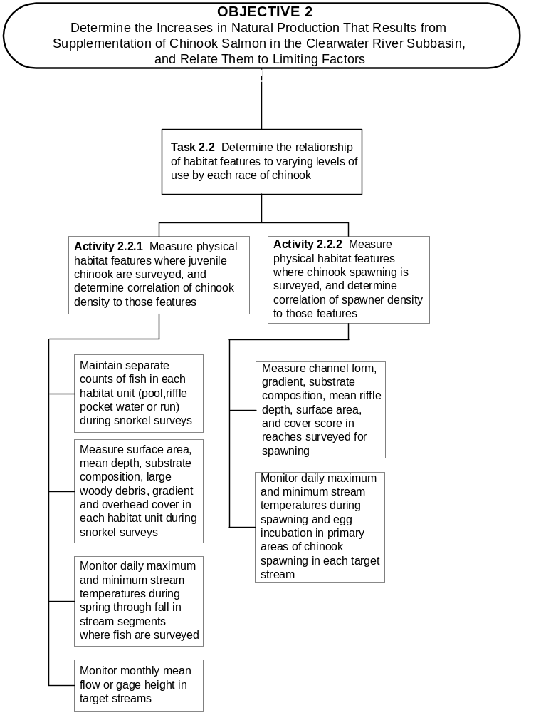

Figure 8. Step-down diagram of activities for Task 2.2 .
All habitat will be defined as riffle, pocket water, run, or pool following descriptions in Bisson et al. (1982), and the length and width of each unit will be measured. Measurement will be made to the closest 0.1 m, with a metric Hip-Chain line on smaller streams, or a laser range finder on larger streams. Maximum pool depth will be measured with a 2-m long marked wading staff. A single length measurement will be made near the thalweg or, if safety was an issue, along a bank. One to five width measurements will made and the average recorded for each habitat unit.

Other features to be recorded include pieces of large woody debris (LWD), undercut banks, substrate composition, riffle gradient and surface cover. Pieces of large woody debris (LWD; > 20 cm diameter and 1 m length) will be counted only for those pieces at least partially in contact with the water. Undercut banks will be estimated as the percentage of the wetted channel edge. Substrate in each habitat unit will be estimated visually as the percentage that is composed by each of five size classes: sands or silt, gravel, cobble, boulder, and bedrock. The gradient of each riffle will be measured with a clinometer. A cover score of low, medium, or high will be determined visually for each habitat unit. This cover rating will include all types of overhead cover that a fish might use within a unit, including bank vegetation, woody debris, and surface turbulence.

Data from this and the previous subactivity will be combined for analysis to determine the quantitative relationship between parr densities and habitat features. Multiple regressions of parr density on various habitat features will be explored for each unit type, either within or across streams. Spawner density will also be included as an independent variable in this analysis. Depth, cover and substrate have each been demonstrated in other studies to influence the density of fish that use a given unit, so we expect similar relationships will be evident in the NPTH streams.

Product: Multiple regressions for each habitat unit type that account for variation in parr density per unit based on physical features and spawner density.

Subactivity 2.2.1.3 Monitor daily maximum and minimum stream temperatures in stream segments where fish are surveyed. Water temperatures may limit juvenile production, both when temperatures are too low or too high. Temperature limitation may not be apparent on the days that snorkel surveys are performed, so thermographs will be installed to measure water temperatures year-round at a minimum of one upstream and one downstream site in each treatment and reference stream. Additionally, temperatures will be measured by hand-held thermometers during field sampling activities, and special attention will be given to detecting microhabitats where cold water inputs in summer or warm water inputs in winter might attract juvenile salmonids.

Product: Comparison of weekly water temperatures within and between streams. These data will be used as independent variables in analyses of growth, migration timing and survival.

Subactivity 2.2.1.4 Monitor monthly mean flow or gage height in target streams. An index of flow is needed for each stream surveyed so that differences in flow between years can be incorporated into the analysis of factors affecting fish densities. The index of flow may either be the daily estimates of flow obtained from USGS gages, or gage height readings at a standard location with consistent cross-section features. In streams where gages are used, stream discharge will be measured across a range of flow conditions to develop a discharge to gage height relationship. Approximate seasonal flows can also be estimated by multiple regression on watershed features. This predictive multiple regression would be developed from nearby watersheds that have flow gages.

Product: Comparison of weekly stream flows between years. These data will be used as independent variables in analyses of parr density, growth, migration timing, and survival.

Activity 2.2.2 Measure physical habitat features where chinook salmon spawning is surveyed, and determine correlation of spawner density to those features.

The availability of physical habitat features that chinook salmon prefer for spawning is likely to have a strong influence on the distribution of spawners in some streams. Measurements of habitat features where chinook salmon are spawning can be compared to the availability of those features throughout the stream to determine if habitat availability is influencing spawner distribution. The features of habitat throughout treatment and reference streams has been determined by detailed habitat surveys and areal photographs.

Subactivity 2.2.2.1 Measure channel form, gradient, substrate composition, mean riffle depth, surface area, and cover score in reaches surveyed for spawning. Chinook salmon prefer a limited range of substrate features and water velocities for spawning, and those features in turn, are strongly influence by geomorphic features, such as channel form and gradient. Because of this relationship, chinook salmon are typically found spawning in C type channels (Rosgen 1985). Channel and habitat unit features will be measured during spawning surveys, and numbers of spawners will be recorded separately for each habitat unit. Habitat unit measurements will be the same as described for snorkel surveys under Subactivity 2.2.1.2. These data will be used in multiple regression analysis of spawner density, along with data on total spawner abundance and stocking locations, to determine the influence of habitat features on spawner distribution.

Product: Multiple regressions that account for variation in spawner density per stream reach, based on physical features, spawner abundance, and stocking locations.

Subactivity 2.2.2.2 Monitor daily maximum and minimum stream temperatures during spawning and egg incubation in primary areas of chinook salmon spawning in each target stream. Because the spawning timing of chinook salmon in the Clearwater River subbasin is fixed by the founding source stock, rather than by selection for adaptation to the temperature regime of each stream, it is likely that stream temperatures during spawning and incubation will limit egg survival. Therefore, thermographs will be placed in primary spawning areas through the fall and winter so that exceedance of thermal tolerance limits can be identified. Further, the temperature data can be used to estimate the probable optimal spawning time for chinook salmon in various reaches of each stream.

Product: (1)Weekly water temperatures at the time and location of spawning and egg incubation within each stream.
(2)Comparison of spawning time and indices of adult to parr survival in terms of thermal tolerance limits.

Task 2.3 Measure life history traits that may reflect limitations to natural production .

We will sample to detect two types of mechanisms that limit natural production: density dependence and genetic fitness (Figure 9). As chinook salmon fill the habitat to capacity, density-dependent mechanisms should begin functioning and reveal that capacity limits are being approached. Life history traits that are known to be influenced by fish density include growth, migration timing, and survival. Accordingly, we will conduct sampling to detect changes in these parameters within each treatment stream. The key, however, will not be simply to detect change, but to detect when the density-dependent changes are sufficient that no more adults are produced per spawner.

Evidence of limitations from genetic fitness should be expressed by differential survival of inherited life history strategies, such as egg-to-fry survival for different spawning times, parr-to-adult survival for fish that smolt as either subyearlings or yearlings, and survival to ocean entry for fish that move downstream from natal areas in the first summer-fall compared to those that hold until they are yearling smolts. Because the stocks used to initiate NPTH are not specifically native to the target streams, there is likely to be some change in life-history traits that will gradually result over time from natural selection. In particular, spawning time of early-fall chinook salmon is likely to become earlier, because temperature regimes indicate that mid-October spawning would produce greater survival than November spawning at lower elevations of the Clearwater River subbasin. The unique balance of habitat quantity and quality for summer rearing and over-winter refuge is likely to vary between streams, so natural selection may gradually alter the proportion of fish that drift downstream for rearing, and the proportion that smolt as either subyearlings or yearlings. We expect that both early-fall and fall chinook salmon will survive best as subyearling smolts, but that deduction needs to be evaluated.

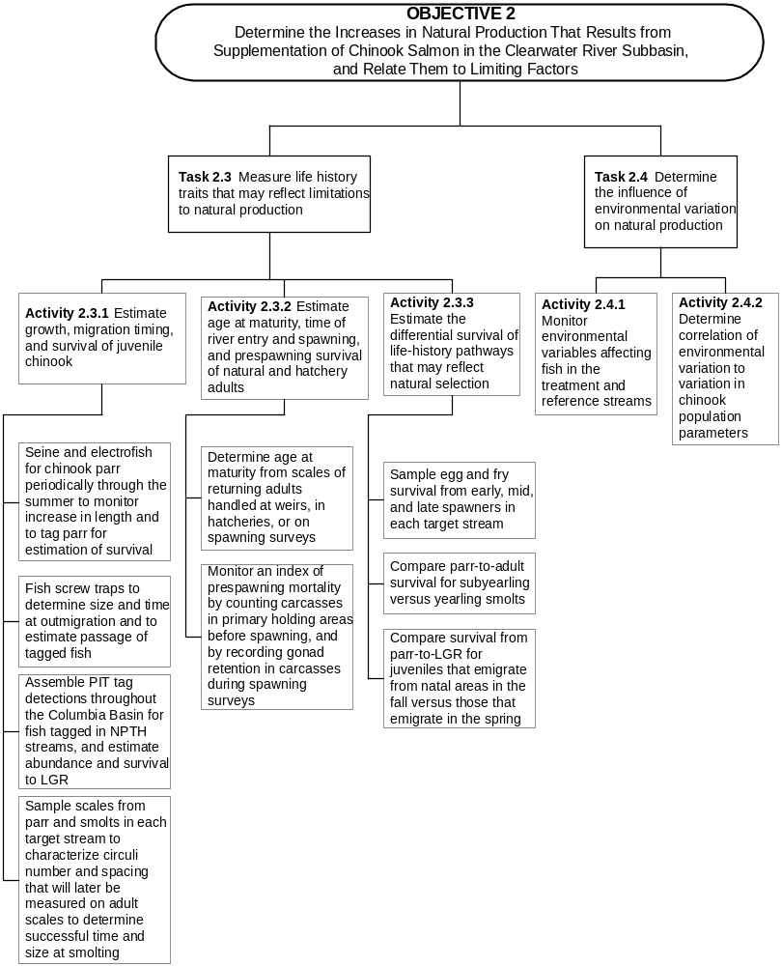

Figure 9. Step-down diagram of activities for Task 2.3 and 2.4 .
Activity 2.3.1 Estimate growth, migration timing, and survival of juvenile chinook salmon.

Under this activity, wild chinook salmon will be captured in rearing areas to measure their growth and tag them for survival estimates, captured in screw traps to determine size and time at emigration, scale sampled to establish circuli patterns reflecting growth rate, and interrogated for PIT tags as they pass mainstem dams.

Subactivity 2.3.1.1 Seine for chinook salmon parr periodically through the summer to monitor increase in length and to tag parr for estimation of survival. Expression of density-dependent growth is most likely to occur during summer low flow, so we will have to capture rearing parr to measure their lengths. Further, fish will have to be captured and measured periodically throughout the summer to establish the rate of increase in length. Density-dependent limitations on growth are generally revealed by comparing growth rates between years, and this effect is a measurable indicator that carrying capacity for rearing is being reached (Cramer et al. 1985).

Age 0+ chinook salmon will be captured by beach seines (100' x 6' x 3/16" mesh and 50' x 4' x 3/16" mesh) and electrofishing once a month from May through September in each treatment and reference stream. Catch rates by seine in all streams except the lower Selway and mainstem Clearwater River will not be used as an indicator of fish abundance, so seining methods and locations may vary between sample dates for the purpose of efficiently capturing juvenile chinook salmon. A snorkelers will frequently be used to locate concentrations of fish that can be captured by seine. Length measurements (50 fish per sample date) and scale samples (20 fish per sample date) will be dispersed among several sites, to insure that a representative sample of the population is obtained.

In the lower Selway and Clearwater mainstem, at least 10 predetermined sites will be sampled, so that catch per seine haul averaged across those sites may also be used as an index of juvenile abundance. A jet boat will be used to gain access to suitable sampling sites in the Clearwater mainstem, and a raft may be needed in the Selway River. The large size of the Selway and Clearwater rivers makes use of screw traps problematic. Patterns of change in catch per seine haul during a season will also be used to estimate migration timing. Those patterns may later be confirmed by detection of PIT tagged fish from this effort as they pass Snake River dams.

All fish captured will be scanned for PIT tags and CWT’s. Previously PIT-tagged fish will be recorded and measured.

The timing and survival of out-migrants can be estimated for PIT-tagged fish as they are detected passing Snake River dams (1.2.2.3). Survival to LGR can all be estimated fairly accurately even with only 200 PIT-tagged smolts per stream. This small number of fish is useful, because detection probabilities at LGR can be estimated from PIT-tagged fish released throughout the Snake River Basin, as was demonstrated by Cramer (1996a and 1996b).

This subactivity deals with tagging of wild parr, so enough parr must be tagged to have 200 or more survive to the smolt stage. Walters et al. (1999) reported that detection rates of parr and pre-smolts (fall migrants) from the Clearwater River subbasin were about one fourth and one half, respectively, of that for chinook salmon PIT-tagged as smolts. Based on these expected recovery rates, we set tagging goals for PIT tags of 1000 parr, 500 pre-smolts or 250 smolts per treatment or reference stream each season. If double or triple this base number can be tagged, then survival could be estimated separately for different periods of tagging. In order to achieve these tagging minimums, up to 150 fish per sample date (8-10 sample dates) will be PIT tagged. Each fish >60 mm will be tagged as described by Prentice et al. (1990), and will be measured and weighed. PIT tagged fish will be placed in net pens or aerated buckets and allowed to recover 30-60 minutes before release.

Product: (1) Regression of mean length on Julian Day for each stream each year.
(2) Multiple regression accounting for variation between years in mean length by July 1(parr) or September 1 (presmolt) as a function of parr density, stream temperature, and flow.
(3) PIT tagged parr to be used for estimating timing of passage and survival to passage to the screw trap and mainstem dams.

Subactivity 2.3.1.2 Fish screw traps to determine size and time at emigration and to estimate passage of tagged fish. Operation of screw traps to estimate size, timing and abundance of emigrants was described under subactivity 1.2.2.1. Here, we add the element of recapturing the fish that were PIT tagged as parr from the previous subactivity. There is no change in sampling with the traps for this subactivity, only the identified need to scan all fish captured for the presence of PIT-tags.

Recoveries of PIT-tagged parr will enable estimation of survival to smolting, and abundance of parr. Survival to smolting will be determined by estimating total passage of PIT-tagged fish at the screw trap (PIT tag catch/trap efficiency). Then, survival can be estimated as the fraction that PIT-tagged smolts represents of total fish PIT-tagged as parr. If tagging and recapture rates are sufficient, it may be possible to estimate survival from different periods of the summer in which parr were tagged. Captures of all chinook salmon in the traps will also be used to establish the proportion of fish that were PIT-tagged, and that in turn can be used to estimate the abundance of parr, based on the known number of fish that were PIT tagged.

Product: (1) Estimate of parr abundance, based on marked-to-unmarked ratio of fish arriving at the screw trap.
(2) Estimate of survival from parr to smolting in each treatment stream.
(3) Multiple regression accounting for variation between years in mean length of fall presmolts or spring smolts as a function of parr density, stream temperature, and flow.
(4) Multiple regression accounting for variation between years in ratio of presmolt to smolt migrants as a function of parr density, stream temperature, and flow.

Subactivity 2.3.1.3 Assemble PIT tag detections throughout the Columbia Basin for fish tagged in NPTH streams, and estimate abundance and survival to Lower Granite Dam (LGR). Numbers of PIT-tagged fish reaching LGR will be estimated by two methods; the SURPH model (Smith et al. 1994) used by NMFS, and the methods of Cramer (1996a and 1996b). PIT tag detections at mainstem dams will be downloaded from the PTAGIS database. Methods are described under Subactivity 1.2.2.3.

PIT tag recoveries at mainstem dams will enable estimation of smolt migration rates, survival rates from the natal stream to LGR, and total smolts reaching LGR from those streams with rotary screw traps. Migration rates will be calculated as days of travel from release to detection at LGR. Arrival timing at each dam will be summarized by each release group where a minimum of 30 observations are obtained. Survival rate to LGR will be calculated as number reaching LGR divided by the number leaving each rotary screw trap. Those leaving the screw trap will be the sum of fish tagged at the screw trap, and those previously tagged fish that are estimated to pass the screw trap. In study streams without screw traps, the survival rate will be estimated for parr to LGR based on the number of parr that were PIT tagged. In the case of streams with a screw trap, the estimated fraction of the population tagged at the screw trap can be used along with the estimate of PIT tags reaching LGR to estimate total smolts from the study stream that reached LGR.

Product: (1) Estimate and 95% confidence interval for the number of smolts from each stream that reach LGR or other mainstem dams.
(2) Estimate and 95% confidence interval of survival from parr or tributary mouth to LGR or other mainstem dams.
(3) Median, 20th percentile, and 80th percentile travel times (days) and arrival times from the screw traps to LGR.

Subactivity 2.3.1.4 Sample scales from parr and smolts in each target stream to characterize circuli number and spacing that will later be measured on adult scales to determine successful time and size at smolting. Because new scale circuli are laid down at a consistent rate of about one every 2 weeks, a regression of circuli number on Julian day can be used to estimate dates of life history events that cause a distinct change in growth rate. Date at ocean entry and age at ocean entry are such events that can be determined from scales. Further, scale radius is highly correlated to fish length at a distinct event, such as ocean entry or annulus formation, and can be used to estimate the size of the fish at that event.

In addition to scales collected during seining, scales will be randomly collected from 25 chinook salmon of each age, and 25 steelhead juveniles of each 5 cm size interval for each trap and each month. These scales will be used to establish the relationship of fish length to scale radius, and of date to circuli number. They will also distinguish yearling and subyearling chinook salmon during June or July when there may be some overlap in size. Steelhead are included under Activity 3.2.1.

Product: (1) Regressions of circuli number on Julian Day for each stream each year. This will enable estimation of dates corresponding to a distinct change in scale patterns, like spring growth or ocean entry.
(2) Regression of length on scale radius, so that size at ocean entry can be estimated on adult scales.

Activity 2.3.2 Estimate age at maturity, time of river entry and spawning, and prespawning survival of natural and hatchery adults.

Subactivity 2.3.2.1 Determine age at maturity from scales of returning adults handled at weirs, in hatcheries, or on spawning surveys. Adult chinook salmon collected at weirs, hatcheries, or carcass surveys will be scale sampled, examined for any marks/tags, and measured to the nearest 0.5 cm for fork and hypural lengths. Scales will be read to determine freshwater, ocean, and total age, so each fish can be assigned to its brood year. Age composition within size strata (primarily jack vs adult) will be applied to population estimates for those strata to determine total escapement from each brood in each run year.

Product: Percentage that each age composes of the returns, by sex, to each stream.

Subactivity 2.3.2.2 Monitor an index of prespawning mortality by recording gonad retention in carcasses during spawning surveys. Prespawning mortality is an important life history parameter, but is difficult to monitor until adult returns increase. The only index of prespawning mortality that can be obtained with the present low fish densities will be the percentage of fish recovered on spawning surveys that have retained a majority of their gonads. The focus will be on the percentage spawned in females, as determination of percentage spawned in males is difficult to assess. This will be measured by cutting open each carcass and recording the approximate percentage of gonad that has been retained. The percentage of fish with retained gonads should be nominal when prespawning survival is high, but can increase to a high percentage in years and locations where prespawning mortality is high.
Product: Annual estimates of the percentage of carcasses that are less than 80% spawned in each stream.

Activity 2.3.3 Estimate the differential survival of early fall chinook salmon life-history pathways that may reflect natural selection.

The founding brood sources for NPTH early-fall chinook salmon are probably not optimally adapted for natural reproduction in Clearwater River subbasin streams. If this is true, survival from spawner to recruit may be reduced in initial years of the program. It will be important for program planning of stocking rates to understand the magnitude of any differential mortality between population segments, and to detect when survivals are optimal (no differential between run segments). Survival differentials between life history pathways may be detected by monitoring egg survival of early, middle and late spawners, examining changes in percentage of emigrants that are subyearling versus yearling, and from comparing parr-to-LGR survival for juveniles that do or do not emigrate in the fall.

Subactivity 2.3.3.1 Sample egg and fry survival from early, mid, and late fall chinook salmon spawners in each target stream. It is expected that spawning time for the founding brood of early-spawning fall chinook salmon may be later than optimal. If this is the case, we would expect to see highest survival from eggs to fry for the earliest segment of spawners, and lowest survival for the latest spawners.

Differential egg survival between early, middle and late spawners will be examined for early-fall chinook salmon by placing separate egg boxes with early, middle, and late- spawned eggs from Lyons Ferry Hatchery brood in the lower South Fork Clearwater River. Three boxes taken from separate spawnings will be used of each of the three segments of the spawning period. Egg survival in the boxes will be checked at 1-month intervals by counting the percentage of dead eggs. This experiment will be replicated for three years. If stream conditions prohibit adequate sampling a controlled temperature survival study will be conducted in the hatchery using simulated South Fork Clearwater River temperatures.

Product: Comparison of mean egg survival between early, mid, and late spawnings of the founding brood for early-fall chinook salmon.

Subactivity 2.3.3.2 Compare parr-to-adult survival for subyearling versus yearling smolts. This comparison may be possible for fall or early-fall chinook salmon if a substantial percentage of parr wait to emigrate as yearlings. The comparison would be made in a two stage process. First, the number of subyearling and yearling migrants reaching LGR would be estimated from detections of PIT tags. PIT tag release groups are determined with the assumption of subyearling smoltification. If yearling smoltification appears to be significant, size of release groups will be adjusted. This would enable estimation of the percentage of smolts that were either subyearlings or yearlings from each study area. Detections at any Snake or Columbia River dam can be combined for this analysis, because the only juvenile criteria is whether the fish migrated to sea during its first summer or its second spring. Second, the scales of adults returning from that brood would be read to estimate the percentage of surviving adults that were either subyearling or yearling smolts. These two estimates, one from PIT tag detections of smolts and one from scales of adults, would be compared across several broods to determine magnitude of difference in the ratios, and estimate the differential survival rate that would be necessary to create that difference in ratios.

Product: Differential survival rate between subyearling and yearling smolts for fall and early-fall chinook in each treatment stream.

Subactivity 2.3.3.3 Compare survival of spring chinook salmon from parr-to-Lower Granite Dam for juveniles that emigrate from natal areas in the fall versus those that emigrate in the spring. With PIT tag detection at both the rotary screw traps and LGR, survival estimates for different segments of the journey to LGR can be pieced together. These pieces can even be used to compare survival of different life history pathways followed by fish that start at the same time and place (parr in the treatment stream) and eventually come back together as smolts at the same time and place (LGR). Between these two intersections, some fish overwinter in the treatment stream, while others migrate and overwinter in the Clearwater or Snake rivers. In the study streams where we fish screw traps, a sample of fish captured in the traps will be PIT tagged in both the spring and the fall so that survival from the trap to LGR can be estimated. As previously described, the goal for minimum number of fish to be tagged would be 500 pre-smolts (fall migrants) or 250 smolts (spring migrants) per treatment stream. The fall migrants will generally not pass the mainstem dams until the following spring, along with the fish that migrate from study streams as yearlings (interrogation facilities are not operated during the winter). Detections of PIT tags at LGR will enable us to estimate overwinter (presmolt- to-smolt) survival of fish that migrate from treatment streams in the fall, while the spring detections of PIT tags at the screw traps will enable us to estimate overwinter survival within the treatment stream. These two estimates can be compared, after the survival from screw trap to LGR is factored in for those fish that stayed in the treatment stream overwinter. We want to determine if survival differs between these two pathways, and whether increasing rearing density may influence the proportion of fish that move out of the treatment stream as presmolts. The advantage to overwintering (in either the natal stream or in the Clearwater or Snake River) might change between years, so this experiment would need to continue through winters of different severity before a firm conclusion could be drawn.

Product: (1) Estimate of difference in survival to Lower Granite Dam between spring chinook salmon presmolts that overwinter in the treatment stream and presmolts that overwinter in the Clearwater or Snake rivers.
(2) Estimate of the ratio of spring chinook salmon presmolt to smolt migrants passing the rotary-screw trap from each brood.

Task 2.4 Determine the influence of environmental variation on natural production.

Growth, survival and carrying capacity for chinook salmon in streams are each likely to vary between years as the environment varies. Accordingly, the influence of environmental variables on the previously estimated parameters of rearing densities, juvenile growth rates, migration timing, and survival rates need to be determined, so that any observed changes in those parameters can be assigned to the proper cause (Figure 9).

Activity 2.4.1 Monitor environmental variables affecting fish in the treatment and reference streams.

Temperature, flow, and sedimentation rate are each environmental variables that have been demonstrated to influence chinook salmon, and which may vary substantially between years. Each of these parameters will be monitored in each treatment and reference stream, so they can be used in analyses of cause-effect relationships.

Product: Data set of daily flow and temperature, and seasonal sedimentation rates in each study stream.

Activity 2.4.2 Determine correlation of environmental variation to variation in chinook salmon population parameters.

Because environmental factors vary in ways beyond our control, their effects on life-history parameters of salmonids are generally only detectable after a long time series (10-15 years) of data has been assembled. Each of these variables have distinct mechanisms by which they can influence chinook populations, but there is a high degree of covariance in these factors that may confound attempts to distinguish their separate effects in a natural stream. These three environmental variables will be examined as independent variables in multiple regression analysis of most population parameters estimated in this M&E plan, but information from studies elsewhere will be needed to deduce the separate effects of these three variables.

Product: Multiple regressions or analyses of covariance for various life history parameters, with environmental variables included as independent variables.

Task 2.5 Conduct stocking density experiments to determine the capacity for spring chinook salmon rearing parr in defined reaches of a test stream .

We can use stocking densities to intentionally manipulate parr densities in a given stream segment, and determine how the density-dependent responses of migration or reduced growth are affected as parr density changes (Figure 10). These manipulations can be of controlled magnitude and achieved in a single year, so they will yield information far more quickly than waiting for environmental variation to provide a range of circumstances.

Activity 2.5.1 Stock parr during early summer at high, medium, and low densities in three similar reaches of Meadow Creek.

Meadow Creek is a treatment stream that has a rotary screw trap near its mouth, so it is suited to conducting this experiment. Three stream sections 500 m long and separated by at least 500 m will designated to receive parr releases that are 200%, 100% and 20% of capacity, as estimated by the Power Planning Council’s Smolt Density Model. These densities will include consideration of fish that are naturally present, as estimated from a snorkel count prior to stocking. All fish released will have a panjet dye mark in a fin, so the fish can be identified by a snorkeler. The mark will differ between each of the treatments, and the test sections will not be fenced off. Test fish will be distributed equally among the pools in the test section. This experiment will be repeated in three sequential years with stocking densities rotated between 500 m sections each year, such that after 3 years, each section has been stocked once with each the high, medium and low density treatments.

Activity 2.5.2 Complete snorkel surveys of each experimental reach one week after stocking and again at the conclusion of the summer rearing period.

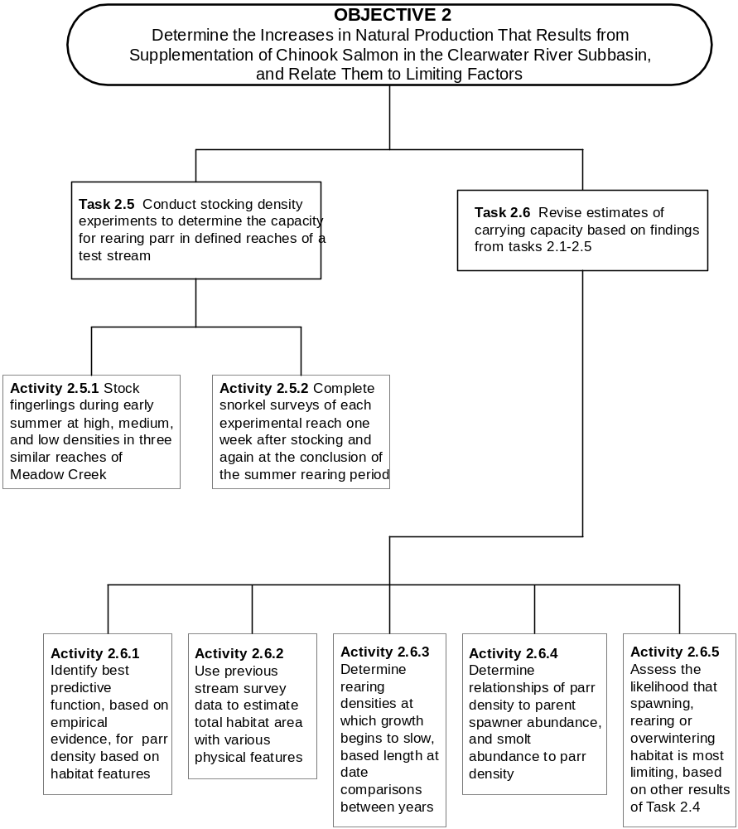

Figure 10. Step-down diagram of activities for Task 2.5 and 2.6.

Snorkel surveys will be completed in each test section one week prior to treatment, one week after treatment, and at the end of August. Methods will be as described for other snorkel surveys. The first survey will be used to determine the number of fish that should be stocked. The second survey will identify the densities the fish sustain for the first week, and the final survey will determine the densities the fish sustain for the summer. If densities remain different in the three test sections for the summer, fish will be seined in each section after the last snorkel survey so that samples can be measured, scale sampled, and PIT tagged.

Product: (1) Comparison of the mean number of parr/m², by habitat unit type, between test reaches and between sample dates.
(2) Comparison of the number of migrants captured in the screw trap from each density treatment.
(3) Comparison of mean fork length achieved by September 1 between test reaches.

Task 2.6 Revise estimates of carrying capacity based on findings from tasks 2.1-2.5 .

The stream carrying capacities that were used to determine stocking rates, were estimated largely from professional judgement through the Smolt Density Model (SDM). Carrying capacity is not fixed over time but varies with nutrient inputs (carcass deposition), temperature, and life history traits (diverse emigration from natal streams). Definition and application of carrying capacity thresholds must be dynamic and account for utilization of all available habitats (ie. mainstem Clearwater River). Observations from this M&E plan will provide empirical data to better estimate the rearing densities at which density dependent mechanisms limit production.

Activity 2.6.1 Identify best function from empirical evidence, to predict parr density based on habitat features.

Activity 2.6.2 Use previous stream survey data to estimate total habitat area with various physical features.

Activity 2.6.3 Determine rearing densities and temperatures, at which growth begins to slow, based on length-at-date comparisons between years.

Activity 2.6.4 Determine relationships of parr density to parent spawner abundance, and smolt abundance to parr density.

Activity 2.6.5 Assess the likelihood that spawning, rearing or overwintering habitat is most limiting, based on other results of Task 2.4.

Objective 3. Estimate ecological and genetic impacts to fish populations .

This objective deals with effects on non-target fish populations, which includes species other than chinook salmon within the treatment streams, plus other chinook salmon populations in non-treatment streams. All chinook salmon populations in the Clearwater River subbasin have been founded in the last few decades from other Snake River stocks, and repeated introductions of hatchery fish have contributed a majority of natural spawners in recent years. Therefore, NPTH is not designed to prevent genetic change in the chinook salmon stocks of treatment streams, but rather to foster opportunity for natural selection to guide genetic change by gradually eliminating the genotypes least fit for survival in each stream. However, release strategies for NPTH must also minimize straying of hatchery fish to non-target streams, so that genetic identity of other chinook salmon populations is protected. Thus, genetic sampling under this objective is designed to monitor gene frequencies of each NPTH stock, so that genetic effects of straying, if it occurs, can be assessed from the changes in gene frequencies of non-target populations where NPTH strays are found.

This objective also addresses the effects on other fish populations in the treatment streams that may occur due to interactions with the hatchery fish. The proposed stocking rates in all of the NPTH target streams are designed to keep numbers of rearing fish within the estimated carrying capacity of those streams. This constraint was intended to reduce the risk of displacing natural juveniles, but release practices must still deal with the logistical problems of dispersing hatchery fish into the spatial and temporal pattern of available habitat. Accordingly, sampling is designed to detect gross movement, changes in growth, or predation on or by other species of fish in the treatment streams. Sampling under this objective is designed to resolve the following management questions:

- Does the NPTH program foster genetic adaptation in target populations?

- Are intra- and inter-species specific abundance and behaviors altered by the NPTH program?

Task 3.1 Determine if there is evidence of genetic change through introgression into chinook salmon populations in non-target streams .

Genetic introgression can only occur if hatchery chinook salmon stray into other streams, and then successfully interbreed with chinook salmon in those streams. Therefore, to detect genetic introgression, straying into other streams must be monitored, and where straying is found, genetic change must be assessed (Figure 11).
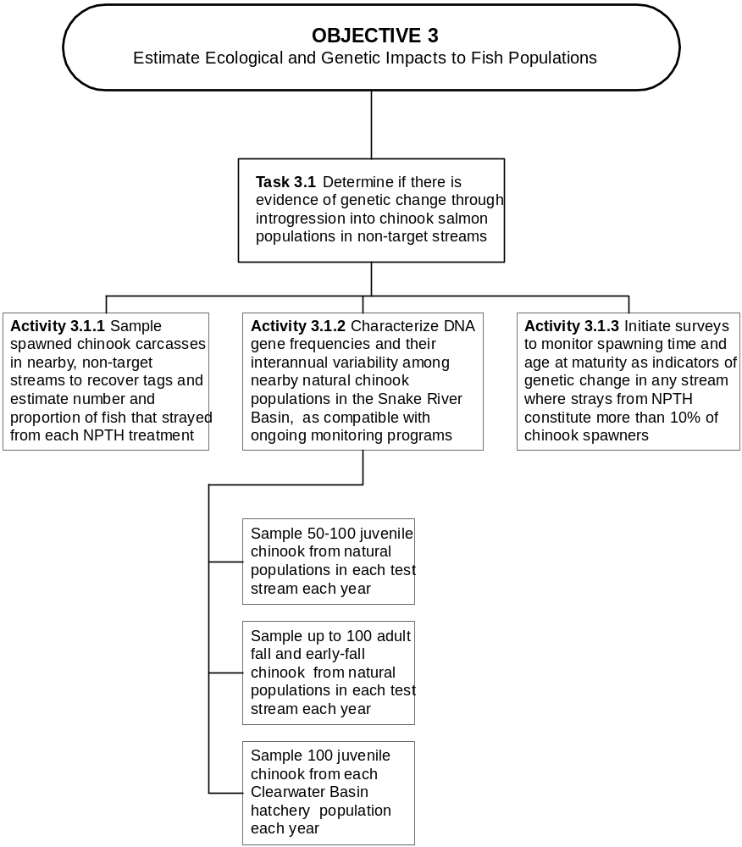

Figure 11. Step-down diagram of activities for Task 3.1.
Activity 3.1.1 Sample spawned chinook salmon carcasses in nearby, non-target streams to recover tags and estimate number and proportion of fish that strayed from each NPTH treatment.

The NPT will conduct systematic spawning surveys by foot in all of its study streams, and IDFG and USFWS will survey another 12 streams in the Clearwater River subbasin as part of the Idaho Supplementation Studies (see Table 5). The Tribe participates in the ISS and will obtain spawner survey data needed to estimate the number of NPTH strays. Spawning surveys do not cover all streams where chinook salmon might spawn, but they do cover most spawning areas for chinook salmon in the Snake River basin. Additionally, strays will be detected wherever they enter hatcheries.

Estimates of carcass sampling rates in each stream surveyed will be used to estimate total NPTH strays present in any stream where they are detected. The expanded number of strays will be summed across all recovery areas to provide a minimal estimate of total strays. This total will be compared to the number returning to the target stream in order to estimate the minimum percentage straying. This percentage of strays will be calculated for each release strategy in each stream. If an unusual number of strays are detected in any area, additional spawning surveys may be initiated to improve the estimate of straying.

Product: (1) Estimates of the minimum percentage of spawners that strayed from their home stream for each release strategy in each stream.
(2) Percentage of NPTH stray spawners in non-target streams.

Activity 3.1.2 Characterize DNA gene frequencies and their inter-annual variability among nearby natural chinook salmon populations in the Snake River basin, as compatible with ongoing monitoring programs.

Recently developed techniques for analyzing DNA genotypes have provided greater discrimination of stock differences than was possible using allozyme electrophoresis. Further, DNA can be sampled without harming fish. Therefore, no fish will be sacrificed for allozyme samples, and all genetics sampling will be accomplished with fin tissues.

Subactivity 3.1.2.1 Sample 50-100 juvenile chinook salmon from natural populations in each test stream each year.

Partial fin clips will be used to obtain tissue for DNA analysis, and the fish sampled will be returned alive to the stream. Care will be taken to disperse the number of fish sampled across time and space of sampling in each stream, so that the entire population is represented. For spring chinook salmon, these samples will be collected in screw traps, with no more than 10 fish sampled in any one day. In the fall and early-fall chinook salmon streams, fish will be captured by seining. Standard protocols for DNA analysis will be followed, such that gene frequencies in the treatment streams can be compared to those for chinook salmon being sampled by state and federal agencies in other streams of the Snake River basin.
Product: Annual gene frequencies for populations of natural juveniles in each study stream.
Subactivity 3.1.2.2 Sample up to 100 adult fall and early-fall chinook salmon from natural populations in each test stream each year.

These samples will be collected from naturally-produced fish wherever they are encountered; during carcass surveys, entering hatcheries or at weirs. Analysis will proceed as for juveniles. Genetic sampling of adults is necessary for fall and early-fall chinook salmon, because the juveniles of these races may be mixed with juvenile spring chinook salmon that have moved downstream. Such mixing will be detectable from the genetic analyses, because there are substantial genetic differences between spring and fall chinook salmon. If mixing of juveniles is not detected, then sampling of adults is unnecessary and will be discontinued.

Product: (1) Annual gene frequencies for populations of natural spawners in each study stream
(2) Difference in gene frequencies between natural juveniles and natural adults of the same brood in each study stream.

Subactivity 3.1.2.3 Sample 100 juvenile chinook salmon from each Clearwater River subbasin hatchery, including Lyons Ferry, population each year.

Each hatchery population will be sampled. Care will be taken to collect a representative sample from all holding containers, so that the entire population is represented. Standard protocols for DNA analysis will be followed.

Product: Annual gene frequencies for populations of chinook salmon in each NPTH hatchery treatment, including Lyons Ferry Hatchery.

Activity 3.1.3 Initiate surveys to monitor spawning time and age at maturity as indicators of genetic change in any stream where strays from NPTH constitute more than 10% of chinook salmon spawners.

This will be event-triggered monitoring, so the design and location will depend on whether any substantial straying occurs.

Product: Change in spawning time and age at maturity across generations of natural chinook in stream where NPTH strays constitute at least 10% of all spawners.

Task 3.2 Determine if there is evidence that non-target fish populations in treatment streams are influenced by competition or predation interactions with the supplemented populations .

Both predation and competition will be assessed by snorkel surveys, but direct capture will also be needed to confirm species identification and to examine stomach contents of predators (Figure 12).
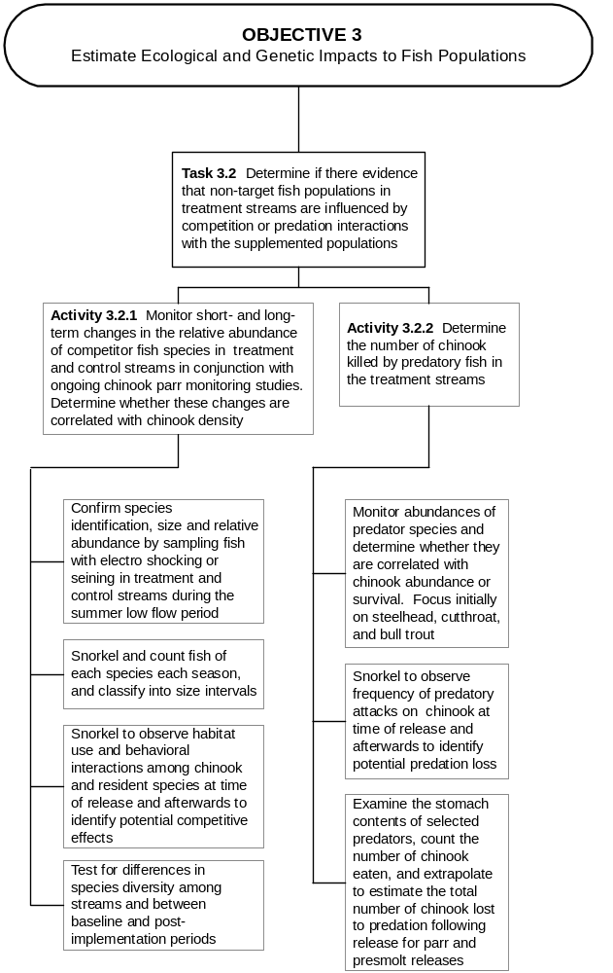

Figure 12. Step-down diagram of activities for Task 3.2.

Activity 3.2.1 Monitor short- and long-term changes in the relative density of competitor fish species in treatment and reference streams in conjunction with ongoing chinook salmon parr monitoring studies. Determine whether these changes are correlated with chinook salmon density.

The primary tool for monitoring fish populations that supplemented chinook salmon might affect is direct observation during snorkel surveys in treatment and reference streams. Snorkel surveys will enable detection of displaced fish immediately after chinook salmon have been stocked, and more subtle changes that may occur over years as supplemented chinook salmon populations gain a competitive advantage.

Subactivity 3.2.1.1 Confirm species identification, size and relative abundance by sampling fish with electro shocking or seining in treatment and reference streams during the summer low flow period. Although snorkel surveys will enable us to observe interactions of chinook salmon with other species of fish, identification of species for those fish can be difficult from a distance underwater. For example, juvenile cutthroat and steelhead cannot be distinguished by snorkeling until cutthroat are age 3 or older, which is usually when cutthroat are 8 inches or longer. Accordingly, it will be necessary to seine, and possibly electrofish, to capture the fish that are being observed and taxonomically key them out under close examination. This will be accomplished during the same seining efforts that will be used to capture and PIT tag chinook salmon parr. It may be necessary to electrofish in order to capture some species like suckers.

Product: Confirmed species identification, and percentage of fish in each sample area that are composed of each species

Subactivity 3.2.1.2 Snorkel and count fish by species each season, and classify into size intervals. Counts of all fish species will be maintained while snorkeling to count densities of juvenile chinook salmon. There may also be a need to conduct more intensive snorkel surveys to accurately count juvenile fish in stream margins, fish that prefer side channels or calm backwaters, or fish that stay closely associated with the bottom. If counting of these fish substantially increases the time required to conduct surveys for chinook salmon, then the more detailed counts will be performed in every third unit of each habitat type.

Product: Densities (fish/m²) by 2 inch size increments for each species in each study stream.

Subactivity 3.2.1.3 Snorkel to observe habitat use and behavioral interactions among chinook salmon and resident species at time of release and afterwards to identify potential competitive effects. Snorkelers will survey a treatment stream in the vicinity of the hatchery release on the day of the release, position themselves where several fish of other species can be seen, and then remain in the water for 15 minutes during each of the first three hours following release of chinook salmon. The snorkelers will observe and report to a streamside recorder the behavioral interactions of the existing fish with the stocked chinook salmon.

In order to obtain replicate observations of interactions between chinook salmon and the other fish present, these extended observations at the time of stocking will be repeated on five stocking occasions for parr releases and five occasions during presmolt releases. These occasions will include multiple years, and may include multiple streams.

Product: Frequency that specific types of competitive behaviors are observed for each species immediately following release of hatchery fish.

Subactivity 3.2.1.4 Test for differences in species diversity among streams and between baseline and post-implementation periods. It is possible that differences in species assemblages between treatment streams might influence the interactions that occur between stocked chinook salmon and other fish species. To determine if there is potential for such differences, we will use several statistical tests of homogeneity of species assemblages between streams. If substantial differences exist in species assemblages between streams, additional snorkeling observations will be necessary to determine if these assemblages respond differently to stocking of chinook salmon.

Product: (1) Test for homogeneity of percent species composition between study streams.
(2) If species compositions differ, additional sampling will be planned to repeat the previous subactivity five times for each species assemblage.

Activity 3.2.2 Determine the number of chinook salmon killed by predatory fish in the treatment streams.

Subactivity 3.2.2.1 Monitor abundances of predator species and determine whether they are correlated with chinook salmon abundance or survival. Focus initially on steelhead, cutthroat, and bull trout. This information can be gathered during the same snorkeling performed for under Activity 3.2.1.

Product: (1) Densities (fish/m²) by 2 inch size increments for each predator species in each study stream.
(2) Estimated covariance across years of predator density with juvenile chinook salmon density and survival to LGR.

Subactivity 3.2.2.2 Snorkel to observe frequency of predatory attacks on chinook salmon at time of release and afterwards to identify potential predation loss. These observations will be completed during the snorkeling performed for Activity 3.2.1.

Product: Frequency that successful and unsuccessful predatory attacks on juvenile chinook salmon are observed immediately following release of hatchery fish.

Subactivity 3.2.2.3 Examine the stomach contents of selected predators, count the number of chinook salmon eaten, and extrapolate to estimate the total number of chinook salmon lost to predation following release for parr and presmolt releases. Seining, and possibly electrofishing will be completed several hours after fish are released in areas where potential predators are common. Sampling will continue until several of the potential predators are captured. If the predators are salmonids, then their stomachs will be pumped and they will be released unharmed. If the predators are northern pikeminnow, or an introduced species, the fish will be sacrificed to examine their gut. The gut of salmonids is configured so that it is easily flushed with pumped water, but that is not true of most other predatory fishes. Numbers and sizes of chinook salmon consumed, as well as the species and length of the predators will be recorded.

This sampling will be completed on five occasions to determine if substantial predation may quickly deplete the number of fish stocked. If predation is nominal, predator sampling will be discontinued. If predation is substantial, sampling will continue as release techniques are explored to reduce the predation.

Product: Mean number and mean size of juvenile chinook salmon consumed per predator of each species on the day and at the location that hatchery fish are released.

Task 3.3 Determine if there is evidence that non-target fish populations in treatment streams are influenced by disease transmission from the supplemented populations .

Resource managers have generally agreed that disease does not usually affect population density of natural fish, so little attention has been paid to the epidemiology of pathogens and parasites in natural populations of anadromous fishes (Figure 13). However, releasing large numbers of hatchery fish into natural environments along with increasing numbers of naturally produced fish may increase stressors and trigger outbreaks of pathogens in natural fish. There is little evidence to suggest that there is widespread transmission of disease from infected hatchery to wild salmonids, but there has also been little monitoring to detect such transmission. Recent disease monitoring in the Snake River basin indicates there are high levels (over 50% occurrence) of BKD in natural chinook salmon. Infection values vary area to area, but infection values are often higher in natural chinook salmon as compared to hatchery fish in the same area.

Kinds, abundance and virulence (epidemiology) of pathogens and parasites in hatchery fish are generally known, but little is known about the epidemiology of pathogens and parasites in natural fishes. Regardless of measures taken to control pathogens, hatcheries release some fish infected with pathogens and parasites.

Activity 3.3.1 Conduct routine sampling to establish ambient levels of infectious and non-infectious diseases among free-living hatchery and wild chinook salmon under natural conditions.

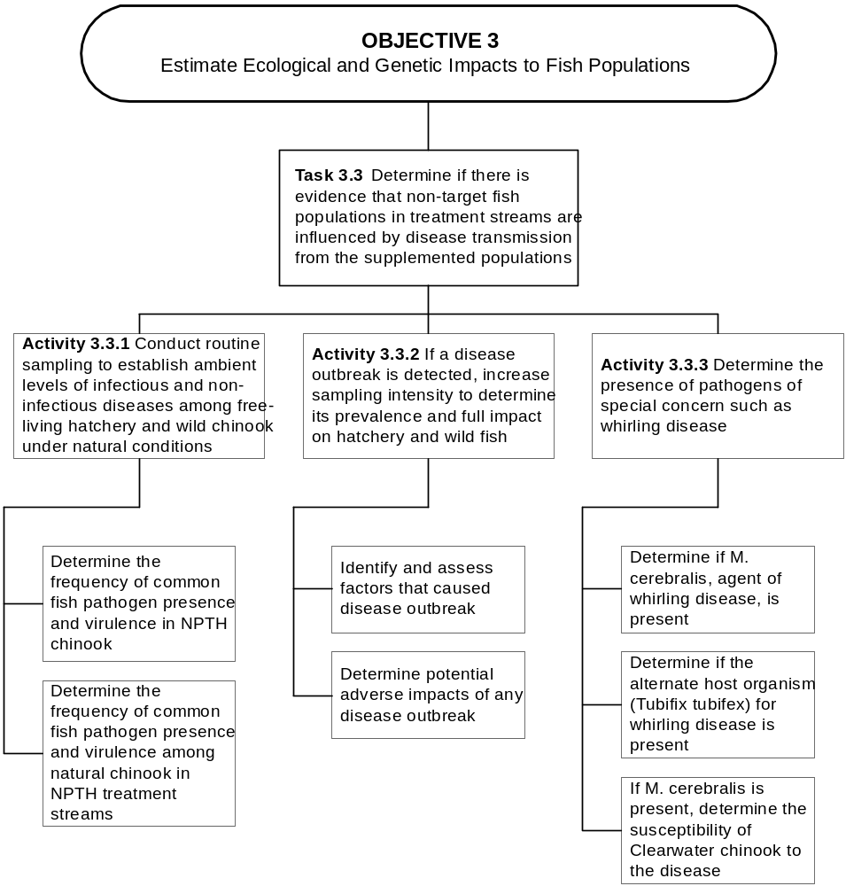

Figure 13. Step-down diagram of activities for Task 3.3.
We describe separate sampling among hatchery and natural chinook salmon. All sampling, diagnostic, and statistical analyses will conform if possible with the Integrated Hatchery Operations Team (IHOT) and the Pacific Northwest Fish Health Protection Committee. Field sampling of fish will be conducted under supervision of a certified fish health specialist, and samples be processed at a qualified fish disease laboratory. Analysis of samples will follow standard protocols defined in the latest edition of the American Fisheries Society “Fish Health Blue Book” (Procedures for the Detection and Identification of Certain Fish Pathogens).

Subactivity 3.3.1.1 Determine the frequency of common fish pathogen presence and virulence in NPTH chinook salmon. Fish that are removed from rearing facilities because they are dead or moribund will be temporarily frozen and up to 60 from each facility will be tested for common fish pathogens of the Snake River basin. In addition to routine monitoring of dead and dying fish, testing for pathogens and a histological work-up, will be conducted for up to 60 randomly selected adults of each race at each facility after spawning. For juveniles, routine bacterial, viral, and parasitic determinations will be conducted for 60 fish samples before release at each facility.

Product: Diagnosis of frequency that illness or mortality in the hatchery facilities can be linked to each type of disease.

Subactivity 3.3.1.2 Determine the frequency of common fish pathogen presence and virulence among natural chinook salmon in NPTH treatment streams. Sampling to detect diseases in wild juveniles will be conducted in one test stream per year for each race of chinook salmon. Streams to be sampled will be rotated each year for spring and early-fall chinook salmon for which there are multiple treatment streams. A sample of 60 wild juvenile chinook salmon, pooled across sampling sites within a stream, would be killed to screen for the presence of fish pathogens and parasites. Separate samples will be taken in the spring and fall. These sampling plans presume that chinook salmon are sufficiently abundant to justify sacrificing the number required for disease sampling. Disease sampling will be foregone on natural juveniles if rearing densities are less than 30% of capacity.

Spawned carcasses of naturally-produced adults will be sampled if high pathogen levels are detected among hatchery spawners. Pathogen testing would be the same as for hatchery fish.

Product: Frequency that specific diseases are detected in natural populations of chinook salmon in study streams each year

Activity 3.3.2 If a disease outbreak is detected, increase sampling intensity to determine its prevalence and full impact on hatchery and wild fish.

Subactivity 3.3.2.1 Identify and assess factors that caused disease outbreak.
Localized and intensive disease monitoring will be implemented whenever significant disease outbreaks occur among wild populations. Samples would include apparently healthy fish, moribund fish showing signs of the disease, and dead fish, if locatable. Standard necropsy, pathogen sampling, and data reporting procedures would be followed. Environmental parameters such as temperature and dissolved oxygen will be measured where mortality is observed, to determine if the disease may be stress-mediated.

Product: (1) Diagnosis of causative agent for localized epizootics in study streams.
(2) Correlation of epizootic with environmental stressors.

Subactivity 3.3.2.2 Determine potential adverse impacts of any disease outbreak. Special carcass surveys or mark-recapture experiments will be implemented on an emergency basis in any area where substantial signs of a disease outbreak are observed. The design of this sampling will be developed on a case-by-case basis, with the intent of estimating total mortality. Levels of prespawning mortality in the home stream will be monitored under subactivity 2.3.2.2).

Product: Estimate of total mortality resulting from the epizootic.

Activity 3.3.3 Determine the presence of pathogens of special concern such as whirling disease.

Three subactivities are identified specifically for whirling disease, but this sampling would be repeated for any other disease that rises to a level of special concern. Details of this sampling will be worked out with a professional pathologist.

Subactivity 3.3.3.1 Determine if M. cerebralis, agent of whirling disease, is present.

Subactivity 3.3.3.2 Determine if the alternate host organism (Tubifix tubifex) for whirling disease is present.

Subactivity 3.3.3.3 If M. cerebralis is present, determine the susceptibility of Clearwater River subbasin chinook salmon to the disease.

Objective 4. Determine how harvest opportunities on spring, early-fall, and fall chinook salmon can be optimized for tribal and non-tribal anglers within Nez Perce Treaty lands .

It is expected that the harvest of chinook salmon in the Clearwater River subbasin will occur during summer, after run sizes reach harvestable levels. It is anticipated that excess hatchery fish will be available for harvest long before natural production reaches carrying capacity. Harvest opportunities are likely to develop in different years in different streams, so the regulation of harvest seasons, locations, and methods will be managed opportunistically through an annual review process. Because fisheries will be adaptively managed, and we do not know which year they will first begin, we cannot design a specific monitoring plan for an actual fishery at this time. However, we can identify the basic types and methods by which monitoring data will be gathered to enable effective management of harvesting (Figure 14). Sampling under this objective is designed to resolve the following management questions:
- Can harvest rate and gear type be predictively managed to optimize NPTH operation?

- Can adult return be accurately predicted for NPTH streams?

The Nez Perce Tribe is likely to manage harvest by zones within the Clearwater Basin. In a strategy developed for coho salmon, the Nez Perce Tribe divided the Clearwater River subbasin into five harvest zones: Zone 1 - Mouth of the Mainstem Clearwater River to Lolo Creek at River Mile (RM) 54.1; Zone 2 - Mainstem of the Clearwater River from Lolo Creek to the mouth of the Lochsa River and to Selway Falls (RM 18.6) on the Selway River; Zone 3 - The mainstem Selway River above Selway Falls; Zone 4 - The mainstem Lochsa River; and Zone 5 - The mainstem South Fork Clearwater River. Utilization of these zones may be appropriate for chinook as well. Harvest seasons for spring, early fall, and fall chinook salmon are expected during the period June through October. Management of Tribal fisheries will provide for the release of all protected species.

Task 4.1 Estimate total harvest mortality on hatchery and natural chinook salmon from the NPTH treatment streams .

In most years, harvesting of fall chinook salmon in the ocean and in the Columbia River would probably continue and provide the most abundant catch. The collective run passing above Bonneville is supplemented by hatchery production in the middle and upper Columbia River basin, as well as in the Snake River basin. Consistent harvest is not expected from Clearwater, Kooskia, or Dworshak hatcheries until smolt-to-adult survival rates increase from improved conditions in the migration corridor and ocean.

In the short term, harvest will focus on the Columbia River harvest zones, and at existing hatcheries; in and surrounding the North Fork Clearwater, and Clear Creek. Success by the Clearwater Fish Hatchery would extend the spring chinook salmon run into sites for the satellite facilities: Walton, Colt Killed, Crooked Fork creeks in the upper Lochsa River drainage; and Red River and Crooked River in the upper South Fork Clearwater River drainage.

Activity 4.1.1 Use harvest-rate estimates for ocean and Columbia River as described in Subactivity 1.2.3.1

Harvest rates (percentage of population harvested) in the ocean and Columbia River are already estimated for Snake River spring and fall chinook salmon each year by the Pacific Salmon Commission. Because CWT recoveries of NPTH chinook salmon from ocean and river catches are likely to be low for the next decade or more, we will use data on CWT recoveries from other Snake River basin hatcheries to estimate ocean and river harvest rate. For spring chinook salmon, we will average the results for production CWT groups from Dworshak, Rapid River, and Clearwater Anadromous Fish hatcheries. For both early-fall and fall chinook salmon, we will use results of CWT groups from Lyons Ferry Hatchery. It will be desirable to separate the estimates for early-fall and fall chinook salmon as soon as recoveries of NPTH early-fall

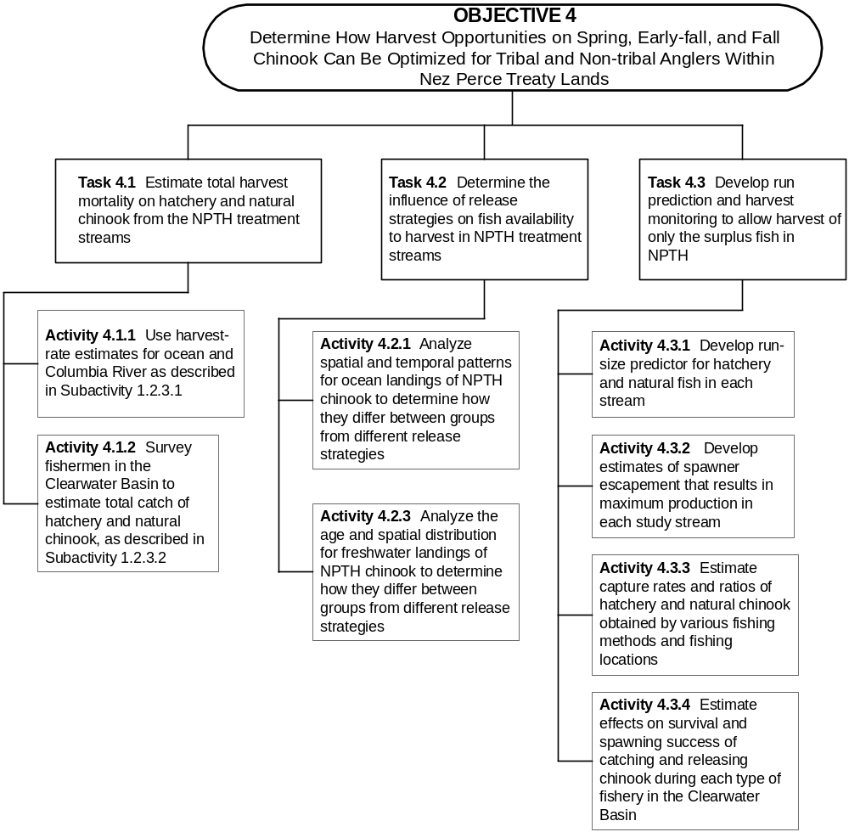

Figure 14. Step-down diagram of tasks and activities to complete Objective 4.
chinook salmon are sufficient. Until that time, the most similar stock to early-fall chinook salmon will be Lyons Ferry fall chinook salmon.

Product: Estimated fraction of chinook salmon harvested by age and race each year (1) in the ocean and (2) within the Columbia River.

Activity 4.1.2 Survey fishermen in the Clearwater River subbasin to estimate total catch of NPTH hatchery and natural chinook salmon, as described in subactivity 1.2.3.2.

Creel surveys designed to estimate total catch of hatchery and natural fish will be implemented at the time that any fishing seasons for chinook salmon are permitted. No general harvest of NPTH chinook salmon is anticipated in the Clearwater River subbasin for at least one or two chinook salmon generations (about 5 -10 years) after Phase 1 starts. Seasons will only be allowed in streams where returns are expected to exceed stream or hatchery capacity. The detailed sampling design of each creel survey will be developed when it becomes evident that a harvest season may be offered. It is difficult to predict now what time, location and gear restrictions will be applied to the initial fishing seasons.

Product: Estimated number of chinook salmon harvested by age, race, and hatchery/natural origin each year within the Clearwater River subbasin.

Task 4.2 Determine the influence of release strategies on fish availability to harvest in NPTH treatment streams .

Release strategies can influence ocean migration patterns, age at maturity, and the locations at which maturing fish congregate as they return. Each of these factors will influence harvest. Patterns of ocean and river harvest will be assessed through recoveries of CWT’s.

Activity 4.2.1 Analyze spatial and temporal patterns for ocean landings of NPTH fall chinook salmon to determine how they differ between groups from different release strategies.

When return and harvest numbers of NPTH chinook salmon reach projected capacities, the recoveries of CWT’s will provide opportunity to analyze spatial and temporal patterns of ocean landings from each cohort. Groups that reach the ocean as juveniles on different dates often show some difference in the spatial distribution of ocean harvest. Subyearling or yearling entry to the ocean can also influence the month and location in the ocean the fish reach sizes that are vulnerable to harvest. Because there are location and time closures in ocean commercial fisheries, the pattern of ocean distribution for a stock can strongly influence the rate at which it is harvested. In order to understand and plan for such effects, we will use the monthly spatial pattern of ocean recoveries, by age, and evaluate if and how those patterns relate to release strategies. Ocean recoveries of CWT’s are reported to the Pacific States Marine Fisheries Commission, so we will obtain the data on actual and expanded recoveries in the ocean from their Regional Mark Information System, which is an online database.

Product: Estimate of difference in spatial and temporal frequency distribution of chinook landings in the ocean from each age of each treatment group.

Activity 4.2.2 Analyze the age and spatial distribution for freshwater landings of NPTH chinook salmon to determine how they differ between groups from different release strategies.

When return and harvest numbers of NPTH chinook salmon reach projected capacities, the recoveries of CWT’s will provide opportunity to analyze proportionate age composition of the catch from a particular brood, and the spatial distribution of catches in freshwater. Chinook salmon released as subyearlings tend to return at an earlier age than fish released as yearlings, so age at release will influence the age composition of the freshwater catch. Recoveries of CWT’s will enable estimation of the magnitude of this difference.

The location at which chinook salmon are released influences the location at which adults will hold upon their return to the river. Manipulation of release locations is an often used tool to enhance fisheries in a particular area. Creel surveys in the Clearwater River subbasin will be structured to record catch locations so that influences of release practices on local distribution of adult catch can be analyzed. Such information may be useful to the Nez Perce Tribe in balancing their desire to harvest chinook salmon with their desire to enhance natural production.

Product: (1) Estimate of difference between treatment groups in the age composition of fish landed in Columbia River fisheries.
(2) Estimated differences between treatment groups in spatial distribution of catches within the Clearwater River subbasin.

Task 4.3 Develop run prediction and harvest monitoring to allow harvest of only the surplus fish in NPTH .

Given that harvest will be managed to take only the fish that are excess to spawner escapement goals, it will be necessary to predict run sizes and manage harvest to target only those fish that are excess.

Activity 4.3.1 Develop run-size predictor for hatchery and natural fish in each stream.

Analysis of data gathered under other monitoring activities will be used to evaluate alternative approaches to predicting run sizes for each harvest area. Predictors to be evaluated include estimated smolt number passing LGR or JDD, estimated number of jacks returning from the same cohort, number of age three fish landed in ocean fisheries, and in-season counts of adult chinook salmon passing mainstem dams. Development of a runsize predictor will be an ongoing process, in which the predictive function will be upgraded each year with the new information available.

Product: Procedure for predicting runsize separately for hatchery and natural chinook salmon returning to NPT streams one year in advance.

Activity 4.3.2 Develop estimates of spawner escapement that result in maximum production in each study stream.

The harvest rate that a natural population of chinook salmon is capable of withstanding is dependent on the number of recruits per spawner the population is capable of producing. The number of recruits per spawner, in turn, is influenced by density-dependent mechanisms as the population approaches carrying capacity. These relationships are generally expressed in the form of a stock-recruitment curve. The monitoring plan for juvenile and adult production will provide the data needed for inputs to a stock-recruitment curve, but a long-term data set (at least 10 yr and preferably 20 yr) is needed to demonstrate the stock-recruitment relationship for a given spawning aggregate.

During the first 10 years of hatchery operation, the two parameters of the stock-recruitment curve (productivity and capacity) will be estimated by separate data sets rather than the traditional plot of recruits per spawner. The productivity of natural populations, in terms of recruits produced per spawner, will be estimated from the median of observed values for adult recruits from each cohort. Stream carrying capacities will be estimated from independent data on observations of spawner densities (redd superimposition), and size and abundance of smolts. Although initial estimates of stock-recruitment parameters are likely to be weak, harvest is also likely to be low, with little need for an accurate estimate of optimum harvest rates.

Product: (1) Estimate of the Ricker  parameter (recruits/spawner) based on median recruits/spawner observed for recent 5 broods
(2) Estimate of the Ricker  parameter (carrying capacity) based on parr capacity estimated under Task 2.6
(3) Estimates of harvest rates that will allow spawner escapement to sustain maximum production (not MSY), as derived from the Ricker curve.

Activity 4.3.3 Estimate capture rates and ratios of hatchery and natural chinook salmon obtained by various fishing methods and fishing locations.
Within the Clearwater River subbasin, there will be more frequent opportunities to harvest excess hatchery fish than there will be to harvest natural fish. Harvest experiments are likely to be performed to develop techniques for harvesting hatchery fish with a minimum of disturbance to natural fish. NPTH fish will not be externally marked and therefore not readily identifiable in the harvest. Whether or not there are harvest experiments, creel data will be analyzed to determine if certain time, area, or gear restrictions would allow harvest of hatchery chinook salmon while minimizing capture of natural fish.

Product: Estimated difference in hatchery:natural ratios in the catch for specific times, locations or gears within the Clearwater Basin.

Activity 4.3.4 Estimate effects on survival and spawning success of catching and releasing chinook salmon during each type of fishery in the Clearwater River subbasin.

It is likely that some fisheries within the Clearwater River subbasin on fall chinook salmon may require the release of unmarked fish, so we need to determine the extent that capture and release of chinook salmon within the subbasin affects their spawning success. If such regulations are implemented, then mark-recapture experiments will be designed and carried out to evaluate post-release survival and spawning success. The experiment would likely include radio tracking, but may rely on an externally visible tag, such as a Peterson disc or visible implant (VI) tag, for identifying caught-and-released fish.

Product: Estimated mortality rate prior to spawning on fish that are caught and released by fisheries in the Clearwater Basin.

Objective 5. Effectively communicate monitoring and evaluation program approach and findings to resource managers .

Timely and thorough communication of the program’s status and performance is critical in the adaptive management process at the project level. Adaptive management program framework involves elements of communication throughout the entire M&E program. Common to all M&E plan infrastructure elements are information sharing, information management, and summary reporting (RME in progress). This process will be conducted by the NPT, so those most familiar with the facility, its design, and the characteristics of the fish being produced will guide the process. This information will then be shared with co-managers through several ongoing regional communication and review processes such as ESA consultation, performance review symposia, and co-management meetings.

Task 5.1 Facilitate effective data management and dissemination .

We will utilize region-wide data bases that have been developed to centralize dataassociated with widely used and standardized activities (Figure 15).

Activity 5.1.1 Provide data summary to StreamNet.

The NPT will provide data summaries of fish population status and select environmental/habitat conditions (adult escapement, juvenile density, stream temperature) to StreamNet on an annual basis. The NPT database will be structured to be compatible with StreamNet. The NPT is currently contributing to the StreamNet database.

Activity 5.1.2 Send PIT tag files to the PIT Tag Information System (PTAGIS).

All PIT tag files will be validated and electronically submitted to the Pacific States Marine Fisheries Commission (PSMFC). PTAGIS will be used to organize tagging and interrogation data from fish marked with PIT tags. Interrogation summary reports will be downloaded and utilized in NPTH data analysis.

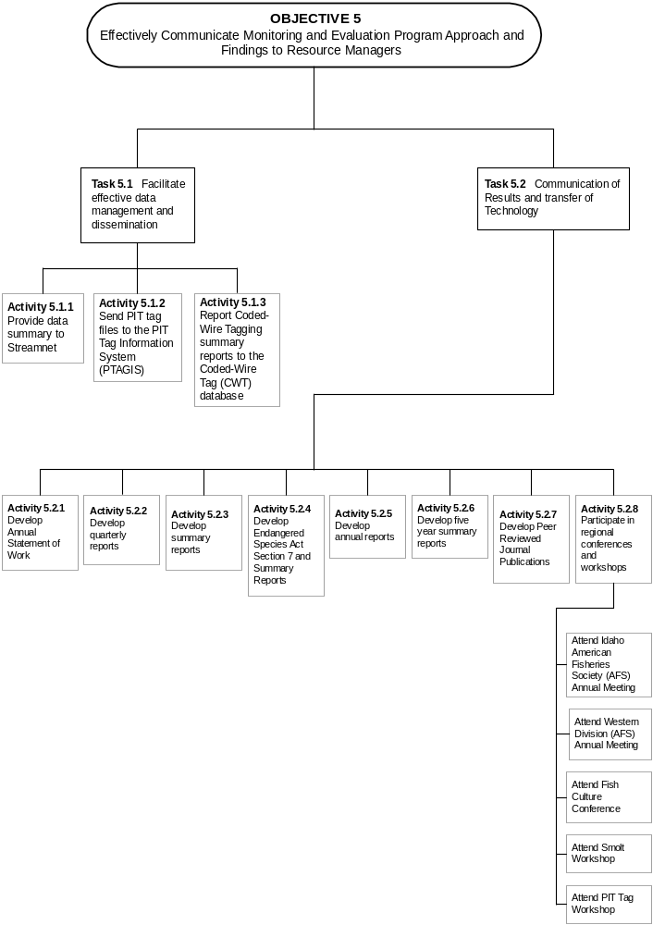
Figure 15. Step-down diagram of activities for Task 5.1 and 5.2 .
Activity 5.1.3 Report Coded-Wire Tagging summary reports to the Coded-Wire Tag (CWT) database.

We will provide fish marking summaries and CWT tag information to the Columbia River Intertribal Fish Commission staff for incorporation into the CWT database. The Coded-Wire Tag database is operated by the PSMFC for the tracking of CWT marking and recovery.

Task 5.2 Communication of Results and Transfer of Technology .

Activity 5.2.1 Develop Annual Statement of Work.

A Statement of Work (SOW) will guide annual activities and will be based on the M&E Plan (Steward 1996) and M&E Action Plan (Hesse and Cramer 2000, this document). Activities detailed in the SOW for the NPTH M&E program will be reviewed by the NPT for scientific validity, programmatic need, and compliance with project objectives. BPA will also review and approve annual SOW’s for contractual compliance and obligations.

Activity 5.2.2 Develop quarterly reports.

The Nez Perce Tribe will communicate NPTH M&E status and results through quarterly reports to Bonneville Power Administration. The quarterly reports are a listing of activities conducted and general summary of data collected during the reporting period. Activities are identified by the Statement of Work’s objective and task numbers.

Activity 5.2.3 Develop summary reports.

Summary reports will provide brief results of population status or supplementation activities that occur on a regular basis that do not require statistical analysis or detailed interpretation. Production/stocking reports will include species, brood source, rearing location, brood year, number released, life stage at release, size at release, release location, release date, and type and number of marks applied. This summary will be updated as fish are released through out the year and final version distributed in November annually. Adult escapement will also be communicated through summary reports (weir capture and redd counts). In-season adult salmon weir capture reports will be produced on a weekly basis and with a final report distributed in October annually. Weir reports will include totals of natural and hatchery fish captured by sex and the numbers and makeup of fish keep for broodstock and released for natural production. Redd counts summaries will be included within the NPT DFRM spawning ground summary report distributed in January annually. Estimates of natural juvenile production in relation to overall carrying capacity in Lolo/Yoosa, Newsome, and Meadow creeks will be prepared for use in determining quantity of NPTH production to be outplanted annually. Summary reports will be developed and distributed to fisheries co-managers in the Clearwater River subbasin and interested parties. These reports will be posted electronically.

Activity 5.2.4 Develop Endangered Species Act Section 7 and 10 Summary Reports.

Endangered Species Act Section 7 and 10 permits require annual summary reports. These reports are required to provide summaries of collection methods used and total number of fish “taken”. Take of fall chinook, steelhead, bull trout by all NPT Department of Fisheries Resources Management research and production projects are covered. Take of spring chinook in the Clearwater River subbasin is not a component of the ESA permit. Deviations from the permitted activities are highlighted.

Activity 5.2.5 Develop annual reports.

Annual reports will be developed that provide data summary, data analysis, and data interpretation in relation to NPTH M&E program objectives and tasks. The report will include a summary and analysis of all data collected as part of the NPTH M&E program with recommendations for NPTH operations. Specific questions to be evaluated are:

* Are the methods being used to collect data appropriate and the most effective to meet M&E objectives?

* Is the quality (level of statistical power) of data being collected sufficient for management recommendations?

* Has any of the uncertainty been removed and can any M&E activities be discontinued.

* Are the M&E findings sufficient to recommend program operation modification prior to five-year review?

Information provided in summary and technical reports will be also be included in the annual report. Recommendations will be developed to address critical uncertainties and hypotheses. These reports will be posted electronically.

Activity 5.2.6 Develop five year summary report.

The 5-year report will include a summary of annual M&E results, annual recommendations and prescribed actions, analysis of multi-year (time series) data across all cohorts within a generation, an updated analysis of critical uncertainties, and recommendations about operation of NPTH and monitoring activities. The information will be presented in relation to M&E program goals, objectives, and hypotheses. These reports will be posted electronically.

Activity 5.2.7 Develop Peer Reviewed Journal Publications

Professional journal publications will be developed. The complexity and scope of the NPTH M&E project prohibits a single publication. Publications will focus on analysis of critical uncertainties that have regional application. Documentation of NATURES reared fish performance is the highest priority.

Activity 5.2.8 Participate in regional conferences and workshops.

NPT staff will attend and present results of NPTH M&E at regional workshops. The information summarized in annual reports and other NPTH documents will be presented as appropriate at American Fisheries Society meetings. Information on specific components of NPTH monitoring and fish population status will be summarized in short presentations (15 to 20 minutes long). Staff will attend technical workshops in order to maintain professional skills, knowledge, and relationships.

Subactivity 5.2.8.1 Attend Idaho American Fisheries Society (AFS) Annual Meeting

Subactivity 5.2.8.2 Attend Western Division (AFS) Annual Meeting.

Subactivity 5.2.8.3 Attend Fish Culture Conference.

Subactivity 5.2.8.4 Attend Smolt Workshop.

Subactivity 5.2.8.5 Attend PIT Tag Workshop.

Task 5.3 Develop and maintain open communications with all resource managers (Coordination and Meetings).

Coordination of the NPTH M&E program activities is a continual process within the NPT and with co-managers in the Columbia River basin. Annual and semi-annual meetings with co-managers in the Clearwater subbasin will be facilitated and attended to coordinated production and research activities (Figure 16).

Activity 5.3.1 Facilitate NPTH annual review and operating plan modification.

Annual NPTH management review will be facilitated by the Research and Production divisions of NPTH Department of Fisheries Resources Management and utilize information in the NPTH M&E reports (summary, technical, and annual). Annual review will address:
*Assessment of data and recommended changes to the risk levels assigned to all of the critical uncertainties.

* Assessment of NPTH performance in relation to set biological triggers.

* Evaluation of NPTH performance in relation to NPTH goals and objectives.

* Review of recommendations made in the NPTH M&E annual report.

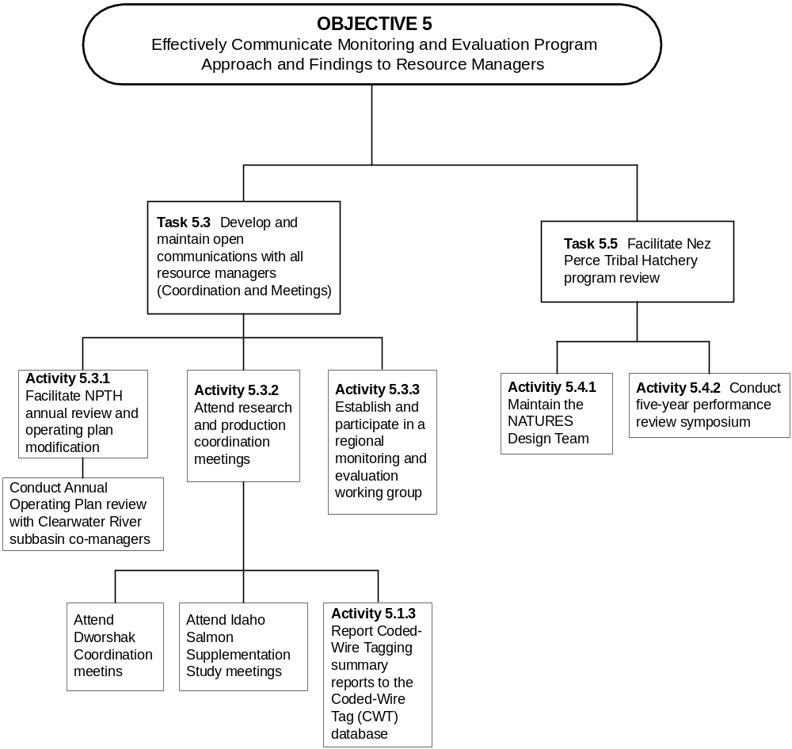

Figure 16. Step-down diagram of activities for Task 5.3 and 5.4 .
Subactivity 5.3.1.1 Conduct Annual Operating Plan review with Clearwater River subbasin co-managers. Results and recommendations developed from the NPTH annual review will be presented at the Annual Operation Plan (AOP) meeting. A draft AOP for NPTH will be coordinated and reviewed with co-managers. This process will be similar to the AOP review conducted for the Lookingglass Hatchery in Northeast Oregon and will include presentations of M&E results and planned activities.

Activity 5.3.2 Attend research and production coordination meetings.

NPTH M&E staff will participate in the meetings between NPT, IDFG, USFWS which plan the production management and outplanting of the Clearwater Anadromous Fish Hatchery, Dworshak and Kooskia National Fish Hatcheries and the Rapid River Fish Hatchery and research within the Clearwater River subbasin.

Subactivity 5.3.2.1 Attend Dworshak coordination meetings.

Subactivity 5.3.2.2 Attend Idaho Salmon Supplementation Study meetings.

Subactivity 5.3.2.3 Attend Forest Service coordination meeting.

Activity 5.3.3 Establish and participate in a regional monitoring and evaluation working group.

We plan to coordinate the establishment of a regional technical M&E working group. This would be a group of researchers actively involved with the collection of supplementation program monitoring data. The main purpose of this working group would be to share and coordinate methods utilized in collection of data used in supplementation studies. Many of the parameters being recommended for long term monitoring are difficult to measure over long time periods and across wide ranges of stream types/conditions. This group would meet on annual basis, with subgroups meeting more frequently to adequately address key issues of concern (for example, quantification of juvenile production or survival involving multiple life history strategies and various life stages). The Regional Monitoring and Evaluation (RME) plans now being developed in several arenas will help guide the working group.

Task 5.4 Facilitate Nez Perce Tribal Hatchery program review .

We will implement a five-year review process for incorporating NPTH M&E information into the adaptive management process.

Activity 5.4.1 Maintain the NATURES Design Team.

The NATURES Design Team will be utilized to guide the evaluation of NATURES rearing techniques. Using the established review processes and the expertise of the NATURES Design Team will provide cost-effective independent review of the program activities. Tasks of the NATURES Design Team will included:

* Identify components of NPTH NATURES rearing that have the highest level of critical uncertainty. Update with new study results.

* Assist in the development of monitoring and controlled (lab) experiments to evaluate NPTH NATURES rearing.

* Identify new NATURES techniques that have been determined to be beneficial.

* Identify NATURES results sufficient to recommend program operation modification prior to five year review.

Activity 5.4.2 Conduct five-year NPTH performance review symposium.

Every five years NPT management and technical staff will facilitate a symposia to review NPTH performance and status. The five year review will be initiated with the development of a 5-year report (see report section above) of the NPTH M&E and NPTH production program. The 5-year report will serve as the framework for the symposia. The purpose of the performance review will be to:

* Ensure adequate monitoring and evaluation is being conducted to evaluate both whether production is meeting its defined purpose and how well its operations improve survival and minimize adverse impacts.

* Evaluate the NPTH program for consistency with policies.

* Evaluate the NPTH program in terms of performance standards and identification of deficiencies.

In addition to the NPT directed review of the NPTH program, information from several regional processes will be considered in the adaptive management of NPTH. Information from independent audits of anadromous fish hatchery performance initiated by the Council, using performance measures developed by Independent Hatchery Operations Team (IHOT) and Artificial Production Review (NPPC) will be utilized in the review process. The NPTH M&E program will also be coordinated with the Regional Monitoring and Evaluation program currently being developed.

REFERENCES CITED

Arnsberg, B. D., and W. P. Connor and E. Connor. 1992. Mainstem Clearwater River study: Assessment for salmonid spawning, incubation, and rearing. Final Report by the Nez Perce Tribe, Contract DE-AI79-87-BP37474 to Bonneville Power Administration, Portland, Oregon.

Ashe, B.L., A. C. Miller, P. A. Kucera, M. L. Blenden. 1995. Spring outmigration of wild and hatchery chinook salmon and steelhead trout smolts from the Imnaha River, March 1 - June 15, 1994. Bonneville Power Administration, Portland, OR., DOE/BP-38906-4.

Beacham, T.D. and C.B. Murray. 1990. Temperature, egg size, and development of embryos and alevins of five species of pacific salmon: a comparative analysis. Trans. Am. Fish. Soc. 119:927-941.

Beamesderfer, R. C. P., H. A. Schaller, M. P. Zimmerman, C. E. Petrosky, O. P. Langness, and L. LaVoy. 1997. Spawner-recruit data for spring and summer chinook salmon populations in Idaho, Oregon, and Washington. Draft report to: Marmorek, D. R., and C. N. Peters (eds.). J. Anderson, R. Beamesderfer, L. Botsford, J. Collie, B. Dennis, R. Deriso, C. Ebbesmeyer, T. Fisher, R. Hinrichsen, M. Jones, O. Langness, L. LaVoy, G. Matthews, C. Paulsen, C. Petrosky, S. Saila, H. Schaller, C. Toole, C. Walters, E. Weber, P. Wilson, M. P. Zimmerman. 1998. Plan for Analyzing and Testing Hypotheses (PATH): Retrospective and Prospective Analyses of Spring/Summer Chinook Reviewed in FY 1997. Compiled and edited by ESSA Technologies Ltd., Vancouver, B. C.

Berejikian, B.A. 1995. The effects of hatchery and wild ancestry and experience on the relative ability of steelhead trout fry (Oncorhychus mykiss) to avoid a benthic predator. Can J. Fish. Aquat. Sci 52: 2476-2482.

Berejikian, B.A. S. B. Mathews, and T.P. Quinn. 1996. Effects of hatchery and wild ancestry and rearing environments on the development of agonistic behavior in steelhead trout (Oncorhynchus mykiss) fry. Can. J. Fish. Aquat. Sci. 53: 2004-2014.

Berkson, J. 1991. Lyons Ferry fall chinook coded wire tag analysis. Columbia River Inter-tribal Fish Commission, File report, October 30, 1991. Portland, Oregon.

Bisson, P.A., J.L. Nielsen, R.A. Palmason, and L.E. Grove. 1982. A system of naming habitat types in small streams, with examples of habitat utilization by salmonids during low streamflow. Pages 62-73 in N.B. Armantrout, editor. Proceedings of a symposium on acquisition and utilization of aquatic habitat inventory information, October 28-30, 1981, Portland, Oregon. Western Division, American Fisheries Society, Bethesda, MD. 376p.

Bjornn, T.C. 1978. Survival, production, and yield of trout and chinook salmon in the Lemhi River, Idaho. Univ. of Idaho, College of Forestry, Wildlife and Range Sciences, Bulletin No. 27, Final Report, Moscow.

Bonneville Power Administration (BPA), U.S. Department of Energy, Bureau of Indian Affairs, U.S. Department of Interior, and Nez Perce Tribe. 1997. Final environmental impact statement Nez Perce Tribal Hatchery program. Bonneville Power Administration, Portland, Oregon, Report DOE/EIS-0213.

Bugert, R., P. LaRiviere, D. Marbach, S. Martin, L.Ross, and D. Geist. 1989. Lower Snake River compensation plan salmon hatchery evaluation program 1989 annual report.

Busack, C.1991. Letter to Merritt Tuttle for inclusion in the ESA Administrative Record for Snake River fall chinook salmon re: ocean distribution of Snake and Columbia River fall chinook salmon, May 1991, 2 p+ table. Available Environmental and Technical Services Division, NMFS, 911 N.E. 11th Ave., Room 620, Portland, OR 97232.

Chapman, D. and ten others. 1991. Status of Snake River chinook salmon. Report to the Pacific Northwest Utilities Conference Committee, 531 p. + appendices.

CRITFC. 1999. Nez Perce Tribal Hatchery benefit risk analysis, draft final report (24 February, 1999). Production and Restoration Research Group, Columbia River, Inter-Tribal Fish Commission. Report to the Nez Perce Tribe

Cramer, S.P. 1990. Contribution of Sacramento Basin hatcheries to ocean catch and river escapement of fall chinook salmon. S.P. Cramer & Associates, contract report to California Department of Water Resources, Sacramento, 113 p. + appendices.

Cramer, S.P. 1995. Selway genetic resource assessment, supplement to Nez Perce Tribal Hatchery genetic risk assessment. S.P. Cramer & Associates, Inc. contract report to Nez Perce Tribal Executive Committee, Lapwai, Idaho.

Cramer, S.P. 1996a. Seasonal changes during 1996 in survival of yearling chinook smolts through the Snake River as estimated from detections of PIT Tags. S.P. Cramer & Associates Report submitted to Direct Service Industries, Portland, Oregon.

Cramer, S.P. 1996b. Seasonal changes in survival of yearling chinook smolts emigrating through the Snake River in 1995 as estimated from detections of PIT Tags. S.P. Cramer & Associates report submitted to Direct Service Industries, Portland, Oregon.

Cramer and Neeley. 1992. Genetic risk assessment of the Nez Perce Tribal Hatchery master plan. Prepared for Nez Perce Tribe Department of Fisheries Resources Management. Lapwai, Idaho 83540.

Cramer, S.P. and D. Neeley. 1993. Evaluation of delisting criteria and rebuilding schedules for Snake River spring/summer chinook, fall chinook, and sockeye salmon. Recovery issues for threatened and endangered Snake River salmon. Tech. Report 10 of 11. Prepared for Bonneville Power Administration, Portland, OR. (Contract No. DE-AM79-93BP99654, Project No. 93-013).

Cramer, S.P. and S. Vigg. 1996. Quantification of the probable effects of alternative in-river harvest regulations on recovery of Snake River fall chinook salmon. S.P. Cramer & Associates, Final Report to Bonneville Power Administration, Portland, Oregon, BPA Report DOE/BP-99654-14.

Cramer, S.P., T. Satterwaite, R. Boyce, B. McPherson. 1985. Impacts of Lost Creek Dam on the biology of anadromous salmonids in the Rogue River" Volume 1. Oregon Department of Fish and Wildlife, Portland, OR., submitted to U.S. Army Corps of Engineers.

DeHart, M. 1999. Fish Passage Center of the Columbia Basin Fish and Wildlife Authority, 1998 Annual Report. Contract Report submitted to Bonneville Power Administration, Portland, Oregon, BPA Report DOE/BP-15377-1.

Don Chapman Consultants. 1989. Summer and winter ecology of juvenile chinook salmon and steelhead trout in the Wenatchee River, Washington. Chelan County Public Utility, Wenatchee, WA. 301 p.

Evermann, B.W. 1896. A preliminary report upon salmon investigations in Idaho in 1894. Bulletin of the U.S. Fish Commission, Volume 15 for 1895, pp 253-284.

Fulton, L.A. 1970. Spawning areas and abundance of steelhead trout and coho, sockeye and chum salmon in the Columbia River Basin - past and present. USFWS, Special Scientific Report. Fisheries No. 618. Washington, D.C.

Garcia, A.P., R.D. Waitt, C.A. Larsen, S.M. Bradbury, B.D. Arnsberg, M. Key, and P. A. Groves. 1999. Fall chinook salmon spawning ground surveys in the Snake River Basin upriver of Lower Granite Dam, 1998. In A.P. Gracia, ed. Spawning distribution of fall chinook salmon in the Snake River. Annual Report 1998. US Fish and Wildlife Service, submitted to Bonneville Power Administration, Portland, Oregon, Contract 98 AI 37776.

Garcia, A.P., R.D. Waitt, C.A. Larsen, D. Burum, B. Arnsberg, M. Key, and P.A. Groves. 2000. Fall chinook salmon spawning ground surveys in the Snake River basin upriver of Lower Granite Dam, 1999. In A.P. Garcia, ed. Spawning distribution of fall chinook salmon in the Snake River. Annual Report 1999. US Fish and Wildlife Service, submitted to Bonneville Power Administration, Portland, Oregon, Contract 98AI 37776.

Hankin, D. G. and G. H. Reeves. 1986. Estimating total fish abundance and total habitat area in small streams based on visual estimation methods. Canadian Journal of Fisheries and Aquatic Sciences 45:834-844.

Hesse, J.A., P.J. Cleary, and B.D. Arnsberg. 1995. Salmon supplementation studies in Idaho Rivers. Annual Report 1994. Prepared for Bonneville Power Administration, Project no. 89-098-2.

Hillman, T.W., J.S. Griffith, and W.S. Platts. 1987. Summer and winter habitat selection by juvenile chinook salmon in a highly sedimented Idaho stream. Trans. Am. Fish. Soc. 16:189-195.

Holtby, L.B., D. P. Swain, and G.M. Allan. 1993. Mirror-elicited agonistic behavior and body morphology as predictors of dominance status in juvenile coho salmon (Oncorhynchus kisutch). Can. J. Fish. Aquat. Sci. 50: 676-684.

Hoss, S. 1970. Evaluation of salmon and steelhead reintroductions into the Clearwater River drainage, Idaho. Annual Project Closing Report, State of Idaho, Fish and Game Department for the Columbia River Fisheries Development Program.

IHOT (Integrated Hatchery Operations Team). 1995. Policies and procedures for Columbia Basin anadromous salmonid hatcheries Annual Report 1994. Bonneville Power Administration. Project 92-043, January 1995. DOE/BP-60627.

Johnson, D.J, R.E. Larson, and CR. Steward. 1995. Supplement to the Nez Perce Tribal Hatchery Master Plan. Report prepared for the U.S. Department of Energy, Bonneville Power Administration, Division of Fish and Wildlife, Portland, Oregon. 33pp.

Kincaid. 1998. Hatchery Genetic Management Plan. Nez Perce Tribe. 30 January, 1997. 50pp.

Larson and Mobrand. 1992. Nez Perce Tribal Hatchery Master Plan and Appendices. Report to the U.S. Department of Energy, Bonneville Power Administration, Division of Fish and Wildlife, Portland, Oregon. Contract No. DE-A179-BP36809, Project 83-350.

Matthews, G.M. and R.S. Waples. 1991. Status review for Snake River spring and summer chinook salmon. U.S. Department of Commerce, NOAA Technical Memorandum NMFS F/NWC-200, Seattle, WA., 75 p.

McIntyre, J.D. and R. R. Reisenbichler. 1988. Temperature in Idaho’s salmon and steelhead streams. U.S. Fish and Wildlife Service, National Fishery Research Center, Seattle, Wa.

Muir, W.D., S.G. Smith, E.E. Hockersmith, M.B. Eppard, W.P. Connor, and B.D. Arnsberg. 1998. Passage survival of hatchery subyearling fall chinook salmon to Lower Granite, Lower Monumental dams, 1996. Annual Report to Bonneville Power Administration for Project 9102900, Portland, OR.

Muir, W.D., S.G. Smith, E.E. Hockersmith, M.B. Eppard, W.P. Connor, T. Anderson and B.D. Arnsberg. 1999. Fall chinook salmon survival and supplementation studies in the Snake River and Lower Snake River Reservoirs, 1997. Annual Report (DOE/BP-10891-8) to Bonneville Power Administration, Portland OR.

NPPC. 1999. Artificial Production Review. Report and Recommendations of the Northwest Power Planning Council. Council document 99-15. Northwest Power Planning Council. Portland, Oregon.

NPT and IDFG (Nez Perce Tribe and Idaho Department of Fish and Game). 1990. Columbia Basin System Planning. Salmon and Steelhead Production Plan. Clearwater River Subbasin. September 1, 1990. Prepared by the Nez Perce Tribe of Idaho and Idaho Department of Fish and Game. Prepared for the Northwest Power Planning Council and the Columbia Basin Fish and Wildlife Authority.

PNNL (Pacific Northwest National Laboratory Ecology Group). 1997. A review of "Response to Questions fo the Three-Step Process Review of the Nez Perce Tribal Hatchery". Document prepared for Northwest Power Planning Council Staff dated December 5, 1997.

Prentice, E.F., T.A. Flagg, and C.S. McCutcheon. 1990. Feasibility of using implantable passive integrated transponder (PIT) tags in salmonids. Am. Fish. Soc. Symp. 7:317-322.

Richards, C. and P.J. Cenera. 1989. Dispersal and abundance of hatchery reared and naturally spawned juvenile chinook salmon in an Idaho stream. N. Am. J. Fish. Manag. 9:345-351.

Richards, M. 1968. Appraisal of project results for salmon and steelhead reintroductions into the Clearwater River drainage, Idaho. Annual Project Closing Report, State of Idaho, Fish and Game Department for the Columbia River Fisheries Development Program.

Ricker, W. E. 1975. Computation and Interpretation of biological statistics of fish populations. Bulletin of the Fisheries Research Board of Canada 191: 1-382.

RME. in progress. Planning steps for the Research, Monitoring, and Evaluation Modules of the Regional Multi-species Framework. Draft RME modules October 20, 1999. Northwest Power Planning Council. Portland, Oregon

Rosenau, M.L., and J.D. McPhail. 1987. Inherited differences in agonistic behavior between two populations of coho salmon. Trans. Am. Fish. Soc. 116:646-654.

Rosgen, D.L. 1985. A stream classification system. Pages 91-95 in Riparian ecosystems and their management: reconciling conflicting uses. First North American Riparian Conference, Arizona.

Skalski, J.R., R.L. Townsend, R.F. Donnelly, and R. W. Hilborn. 1996. The relationship between survival of Columbia River fall chinook salmon and inriver environmental factors; analysis of historic data for juvenile and adult salmonid production: Phase II. University of Washington Center for Quantitative Science, Final Report to Bonneville Power Administration, Portland, BPA Report DOE/BP-35885-10.

Smith, G.S., J.R. Skalski, J.W. Schlechte, A. Hoffmann, and V. Cassen. 1994. Statistical Survival Analysis of Fish and Wildlife Tagging. Contract DE-BI79-90BP02341. Project 89-107. Bonneville Power Administration. Portland, Oregon.

Smith, S.G., W.D. Muir, E.E. Hockersmith, S. Achord, M.B. Eppard, T.E. Ruehle, and J.G. Williams. 1998. Survival estimates for the passage of juvenile salmonids through Snake River dams and reservoirs, 1996. National Marine Fisheries Service report to Bonneville Power Administration, Portland, Oregon, Contract DE-AI79-93BP10891.

Steward, C.R. 1996. Monitoring and evaluation plan for the Nez Perce Tribal Hatchery. Contract report to Bonneville Power Administration, Portland, Oregon, BPA Report DOE/BP-36809-2.

Taylor, E.B. 1988. Adaptive variation in rheotactic and agonistic behavior in newly emerged fry of chinook salmon, Oncorhynchus tshawytscha, from ocean-and stream-type populations. Can.J.Fish. Aquat. Sci. 43: 565-573.

Van Dusen, H.G. 1903. Annual reports of the Department of Fisheries of the State of Oregon for the years 1901 and 1902 to the Twenty-Second Legislative Assembly [Regular Session]. 183 p.

Van Dusen, H.G. 1905. Annual Reports of the Department of Fisheries of the State of Oregon for the years 1903 and 1904 to the Legislative Assembly, Twenty-Fourth Regular Session. 197p.

Walters, J., J. Hansen, J. Lockhart, C. Reighn, R. Keith, and J. Olson. 1999. Draft Idaho supplementation studies five year report 1992-1996. Project Report, Idaho Department of Fish and Game Report 99-14, to Bonneville Power Administration, Contract DE-BI19-89BP01466, Portland, Oregon.

